Vidhi (CS, LLB, B.com)

Vidhi.84318@2freemail.com

Core | Company formation & business setup
experience | Dealing with government authorities
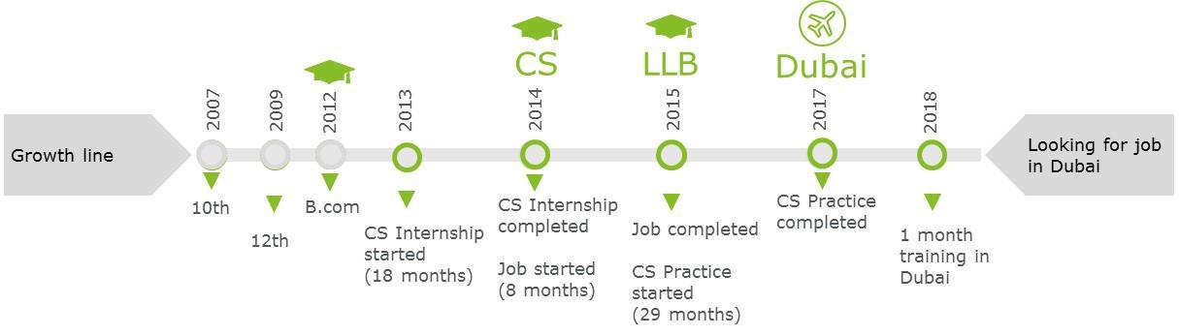

A qualified Company secretary (CS), graduated`` in Law (LLB) and Commerce (B.com) with total experience of 4.5+ years in India and UAE in the field of company formation, business setup and corporate compliance. Immediately available for a long term career opportunity in Dubai in the field of business setup and corporate compliance.

Legal drafting & documentation Corporate compliance MIS Reporting

Dealing with clients Team management Corporate governance

Dubai – Jan 18 - Adam Global - Intern

India – Jun 15 to Oct 17- Practicing CS (Rajkot, Gujarat)

- 80+ Company formation which includes Public limited, Private limited, Joint stock company, One person company, Limited liability partnership

- Conducted 2 secretarial audit of stock exchange listed companies which includes compliance of all applicable laws like Company law, Security law, Labour law, Factories law, Environmental law, and Tax laws with submission of signed secretarial audit reports to client and government authority

- 300+ corporate Annual returns filed with competent authority (Registrar of Companies)

- Successfully drafted memorandum of association, articles of association, agreements, minutes of meetings, resolutions, XBRL reporting, corporate governance reports, legal letters, search reports, due diligence reports
- Meetings with government authorities on client matters and managing clients

- Concluded Striking off process and Liquidation process of companies

- Successfully handled the processes of appointment and resignation of auditors and directors, increase/ decrease in share capital, share transfers and transmission
- Managed team of 5 trainees including work allocation, review of work, guidance and mentoring.

- Company incorporation - offshore and free zone in RAKICC, AFZ, JAFZA – Independently completed 3 business setups and assisted in 2 mainland company formation

- Independently completed renewal process of 10 companies

- Performed re-registration and change of registered agent of 3 companies

- Assisted in company liquidation process

- Assisted in share transfer process

- Prepared memorandum and articles of association

- Applied for good standing certificate

- Maintained KYC records and MIS reports

IT applications knowledge

MS Word, Excel, Powerpoint

Tally ERP 9

Zen ROC, XBRL

India – Oct 14 to May 15- M/s. Piyush Jethva & Associate – Assistant Officer

- Assisted in company formation process

- Witnessed e-voting in shareholder’s meeting

- Prepared statutory registers

- Assisted in secretarial audit of 4 companies

- Prepared KYC and client follow-ups.

India – Apr 13 to Sep 14- M/s. Piyush Jethva & Associate – Intern (Rajkot)

- Assisted in company formation process

- Obtained Digital signatures and Director’s identification numbers

- Annual filings with Registrar of companies

- Assisted in issuance of compliance certificates

Personal details

Date of birth: 31-May-1992

Marital status: Married

Languages: English, Hindi and Gujarati

Address: Bur Dubai, Dubai, UAE

Visa status: On family visa in UAE (Flexible for status change, if required)

