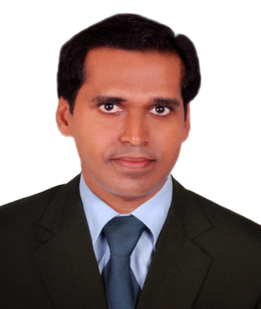
MOHANA
Dubai UAE
Email: mohana.85518@2freemail.com

OBJECTIVE
Seeking a good career and holding a responsible position in the reputed organization and ensure credible performance to work towards exceeding the set goals contributes for the organization.

PROFILE
- Work experience as Accountant , Cashier
- Resigned Alan technology LLC 28th February 2018
- Good knowledge of accounting packages like Tally, Navision & Odoo
- Wide exposure of working in various industries like computer hardware trading and FMCG retail sector
- Seasoned professional, with ability of work well in team as well as handle multiple functions and activates in high pressure environments.
- Multilingual with proficiency in English, Hindi and Malayalam
- Hard working and dedicated, Sincere and result oriented
- Good communication and analytical skills

POSITION OF INTEREST
- Accountant & Cashier

EDUCATIONAL ATTAINMENT
- M.Com Kerala University (1996-98) Course Completed.
- B.Com Kerala University (1992-95)

TECHNICAL QUALIFICATION
- Computers: Tally, Odoo, Data Entry , Internet , Navision

WORK EXPERIENCE
- Worked as an Accountant in Alan technology LLC Bur Dubai from 23rd Oct 2013 to 28th February 2018
Dealing with: Sales Invoicing, and Purchase Invoice, to assist Finance Manager making monthly financial reports, Account Receivables & Payables Processing,pass Journal entries, Payroll , Petty Cash and Bank Reconciliation.

- Worked as a Payable Accountant in Al Manama Group Head Office Ajman UAE from Feb 2010 to March 2013
- To monitor process invoices and data verification along with payables.
- Verification and processing of payments including cheque preparation of key suppliers for 16 branches of Manama hypermarket.

- Worked as a Accountant in Gujarat Shipping Company, India from Nov 2007 to June 2008

- Worked as a Accountant cum Cashier and Logistics Follow up in Computer World Trivandrum, India from June 1999 to Oct 2007
Job Responsibilities

- Maintaining the cash register of the showroom & tallying the cash book on a daily basis.
- Maintaining the Bank accounts and transactions (Cheque clearing Banks, Chq Deposits, Bank Reconciliation) of 2 Branches of the groups.
- Maintaining the Stock and tallying the stock on weekly & Monthly basis
- To receive the documents of incoming stocks , despatching the defective accessories for service and follow up.

PERSONAL DETAILS
Date of Birth : 20/05/1975
Nationality : Indian
Gender : Male
Marital Status : Married
Languages Known : English, Hindi & Malayalam
PASSPORT DETAILS
Date of Expiry : 18/04/2022
Visa Status : Cancelled, Exiting 29/12/2018

