First Name of Application CV No539238
Whatsapp Mobile: +971504753686

To get contact details of this candidate Purchase our CV Database Access on this link.
http://www.gulfjobseeker.com/employer/services/buycvdatabase.php
Curriculum Vitae

 | Diploma  Job Title  Nationality  Date of birth  Gender  Desired Job  Marital Status | Graphic Designing  Graphic Designer  Indian  19.05.1984  Male  Graphic  Married
Personal Summary

To obtain a Graphic Designer position at Sign Off in order to provide the company’s clients with excellent in graphical solutions

Offering excellence in working with print media, knowledge of prepress requirements and the ability to venture into multimedia systems

My Skills Summary

Technical Skills
- Adobe Illustrator [CS6]
- Adobe Photoshop [CS6]
- Adobe In-Design [CS6]
- Corel DRAW [X7]
- MS OFFICE

Personal Skills
- Exceptional creative, flexible skill with good sense of humour.
- Able to produce the best result in pressure situation.
- Good communication skills in written and verbal both.
- Excellent presentation
- Excellent knowledge in prepress

Responsibilities Handled
- Work closely with clients on concepts and business direction to derive the right type of creative.
- Prepare proposals for clients.
- Worked with extreme ability to create a wide range of products including business cards, newsletters, letter heads along with a number of different training equipments.
- Prepare mock-ups for clients’ perusal.
- Established a portrait and event graphic design business.
- Developed client relationships throughout the course of each project.
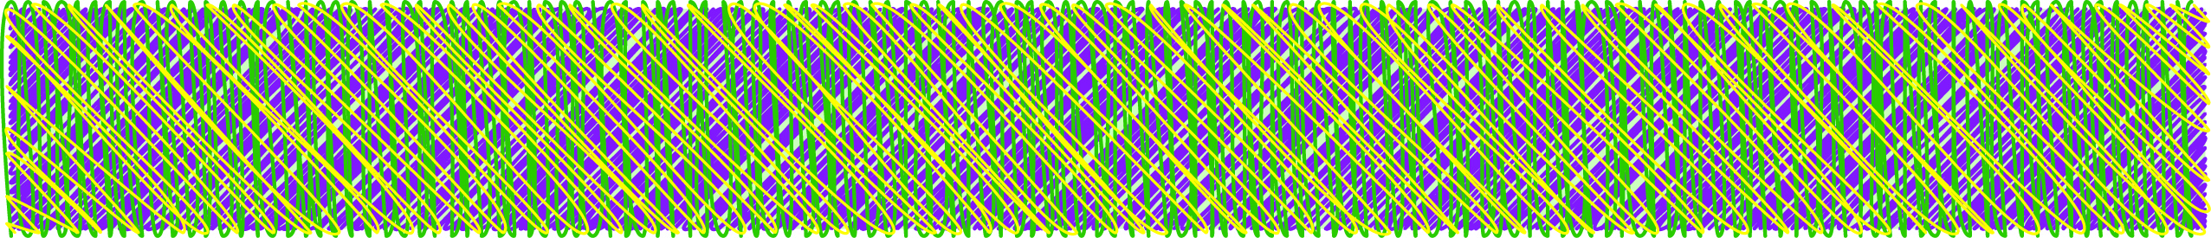

 | Work Experience
2008 May to  2015 July | Graphic Designer cum Prepress Operator  Arabian Technical Printing Press L.L.C., Sharjah - U.A.E.
Duties | Set the artworks as print ready files
 | Copy write the artworks
 | Customer Handling
 | Prepare the mockups for artworks
 | Typesetting (English & Arabic)
2006 February to  2007 August | Graphic Designer cum Photocopy Operator  Shimla Graphics., Sharjah - U.A.E.
Duties | Design the catalogues, posters and stationeries
 | Recreate the artworks
 | Customer Handling
 | Copy taking and binding the books manually
 | Typesetting (English & Arabic)
 | Education
 | Graphic Designer Diploma, I Tech Multi Media Centre, Ernakulam
 | Higher Secondary (Board Examination, Kerala)
 | Languages

English with communication skill

Hindi with communication skill

Arabic

