rissa
Int’l. Assoc. AIA, Pearl Qualified Professional (PQP), LEED GA, SOE(UAE)

c u r r i c u l u m v i t a e
Dubai, United Arab Emirates

Rissa.91314@2freemail.com E

 |  |  | e m p l o y m e n t
Associate  Aedas (www.aedas.com)  Aedas is a leading international award-winning design practice offering services in architecture, interior design, master planning, landscape, urban design and building consultancy within Asia, the Middle East, Europe and America.  Scope of Work:  - review of mock-up, shop drawings , O&M against ID drawings, specifications and other documents  - general site visits including inspecting, raising and resolving site issues  - preparation and issuance of snagging list  - attendance of peer review, progress and site meetings  - preparation of meeting agenda and conducting progress meeting to team, contractor and client  - preparation and issuance of meeting minutes/notes to the team, contractor and client  - reviewing and signing off RFIs, CVIs, materials and other submittals  - procurement of samples/swatches for mood board and specifications  - material review and selection  - detail design development  - schematic interior space planning  - preparation of drawing and specification package for tender submission  - following up contractor on work progress  - Issuing reports to client related progress, site observation, site improvement notices and Non-compliance  Current and past projects include healthcare, hospitality, commercial, residential and corporate typologies such as Radisson Blu Hotel Apartment, Elements Hotel Apartment (by Marriott), Huawei Baygate Office, Saraya Bandar Jissah, Cleveland Clinic Abu Dhabi, Hard Rock Hotel Abu Dhabi, Design District, Prime Minister’s Office, Arabian Ranches 2 Community and Retail Center/Residents’ Club, Reem – Mira Community, Reem Retail Centre/Residents’ Club and DAEP corporate office planning. The scope of the projects cover one or more of the points listed above. |  |  | March 2013 – present  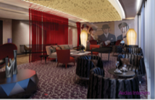  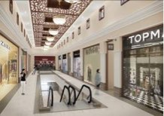  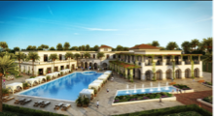
Project: Elements Hotel Apartment (Marriott)  Project Cost: Undisclosed Location: Dubai, UAE  Project type: Hospitality  No. of Rooms: 368 keys  Operated by Marriott Hotels, this 40 storey hotel apartment near Media City will offer a restaurant and amenities such as business centre, conference rooms, gym, pool, spa, and a health club.  Scope of Work:  - material review and selection  - review of shop drawings  - review and responses to RFIs (Request for information)  - site and field inspections  - attendance of progress and site meetings  - resolving site issues |  |  | October 2017 to November 2017  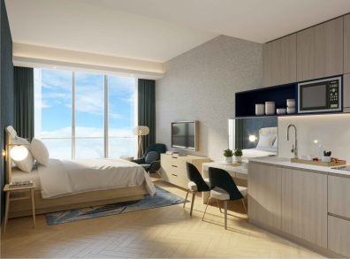
Project: Radisson Blu Hotel Apartment  Project Cost: Undisclosed Location: Dubai, UAE  Project type: Hospitality  No. of Rooms: 241 keys  Currently operating more than 260 hotels worldwide, Radisson Blu hotel is currently building a hotel apartment near Media City area primarily catered to the business traveller and as a corporate accommodation. The 29 storey hotel will offer a restaurant and amenities such as business centre, conference rooms, gym, pool, spa, and a health club.  Scope of Work:  - material review and selection  - review of shop drawings  - review and responses to RFIs (Request for information)  - site and field inspections  - attendance of progress and site meetings  - resolving site issues |  |  | October 2017 to November 2017  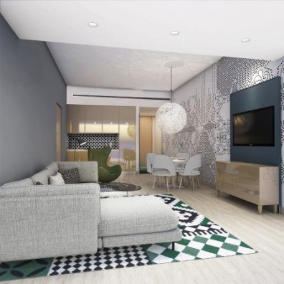
Project: Huawei Baygate Office - Interior Design Contract Administration  Project Cost: Undisclosed Location: Dubai, UAE  Project type: Corporate  GFA: 5,000 sq.m.  Located in one of Dubai’s tallest commercial buildings, the Huawei Baygate Office occupies 5 levels, overlooking an imposing 45 meter atrium. The office will be the main headquarters of the giant corporation in the UAE/Middle East. The space comprises of open and close offices, various-sized meetings rooms, phone booths, game room and support/administrative rooms. The overall theme incorporates the Huawei concept design found in the rest of the global offices, with a Middle Eastern twist.  Scope of Work:  - material review and selection  - site and field inspections  - attendance of progress and site meetings  - preparation of internal meeting notes |  |  | January 2017 to October 2017  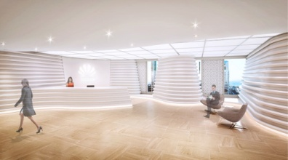  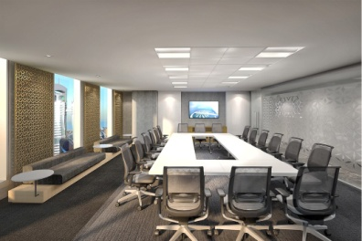
Project: Saraya Bandar Jissah - Interior Design Contract Administration and Site Supervision  Project Cost: Undisclosed Location: Oman  Project type: Hospitality Hotel Classification: 5 star  No. of Rooms: 106 keys - Hotel 1; 206 keys - Hotel 2  GFA: 30,000 sq.m. - Hotel 1; 20,000 sq.m. - Hotel 2  Saraya is developing a mixed-use real estate project which includes two five star luxury hotels currently named as Hotel 1 (Boutique Hotel) and Hotel 2 (Resort Hotel), and VIP villas. Nestled against the sweeping mountainside with stunning elevated views onto the beach and sea from its raised entrance and reception , Hotel 2 will offer an array of world-class facilities and services. Private serviced villas form part of the same resort complex that will enjoy private access and services for the most luxurious and secluded retreat.  Scope of Work:  - Client liaison including attendance of technical meeting, highlighting site issues  - Coordination of pending issues with design team, other consultants and contractors  - Resolving and responding to RFIs (Request for information) including issuance of additional details , sketches, drawings and specifications  - Review of contractor’s shop drawings, material submittals, document submittals against ID drawings and specifications  - Site/FFE/Work in Progress Inspections  - Preparation and Issuance of Monthly progress reports, work in progress and inspection reports  - Delegating to team members the quality control tasks such as drawing reviews, additional required checklists  - Anticipating and resolving site issues by preparing quality control documents  - Formulation, preparation and submission of design coordination and management documents including but not limited to Material submission, FFE , Sanitaryware, RFI and Room/Area Checklists, Recommendation Matrix based on EI (Engineer’s Instruction) impact. |  |  | November 2015 – Nov. 2017  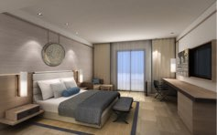  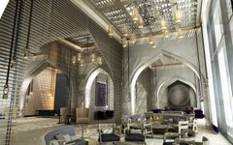
Project: Dubai Design District (d3)  Project Cost: Undisclosed  Project type: Corporate/Commercial  Designed for the needs of designers, the District’s offices will forge an active design community and meet contemporary business needs. Treating the three blocks, South, Core and North as 3 points along a journey, a narrative is formed that describes the process of creation from raw material to working prototype to finished product.  Scope of Work:  - review of shop drawing and material submittals  - responses to RFIs  - highlighting and resolving design/site issues  - work inspections and preparation of snaglist  - attendance of progress meetings |  |  | November 2014 – October 2015  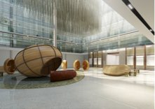  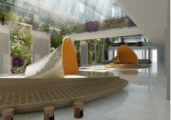
Project: Hard Rock Hotel (Interior Design)  Plot Area: 2,886 m2  Project Cost: Undisclosed Location: Abu Dhabi, UAE  Project type: Hospitality Hotel Classification: 5 star  No. of Rooms: 378 Rooms  This five star hotel will house an assortment of signature restaurants and leisure outlets and will be home to 378 luxury rooms and suites. A hub for entertainment, meeting and making connections, it will embody the spirit of Hard Rock with a distinctive Middle Eastern influence.  - Client liaison including attendance of progress meetings  - Coordination of pending issues with design team  - Resolving and responding to RFIs (Request for information) including issuance of additional details , sketches, drawings and specifications  - Review of ID drawings and specifications  - Coordination and review of 3d renderings against tender drawings and specifications  - Delegating to team members the quality control tasks such as drawing reviews  - Preparation of coordination matrices for RFIs |  |  | April 2014 – October 2014  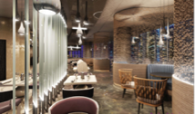  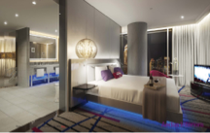
Project: Cleveland Clinic Abu Dhabi  Building Area: 409,234 sqm  Project Cost: estimated AED 7 Billion Location: Abu Dhabi, UAE  Project type: Healthcare  - Cleveland Clinic Abu Dhabi is a multi-billion world-class multispecialty hospital being built on Al Maryah Island , Abu Dhabi, UAE. Designed and developed by Abu Dhabi’s Mubadala Healthcare and leading US-based hospital, Cleveland Clinic, to address a range of complex and critical care requirements unique to the Abu Dhabi population. The facility will be a 364 (expandable to 490) bed hospital, with five clinical floors, three diagnostic and treatment levels and 13 floors of critical and acute inpatient units.  Scope of Work:  - review of RLOS (Room Layout Sheet) Drawings and shop drawings  - preparation of Field Observation Reports  - general site visits and raising site issues to team for clarification  - Consultant site inspections including CIR (Consultant Inspection Request) , CDRs (Consultant Desnag Request), and ICDRs.  - preparation of lighting studies for Royal Majlis and Royal Patient Room  - attendance of peer review and progress meetings  - preparation of meeting minutes  - coordination with contractor in resolving site issues  - reviewing and signing off Field RFIs  - coordination , review and advance approval of proposed access panels at site  - issuing NCR & SDRs (Non-compliance report; Surveillance Deficiency Report) via KEO |  |  | March 2013 – March 2014  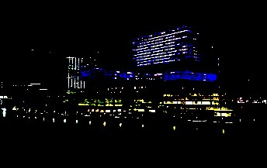
Design /Sustainability Architect/Project Coordinator  Conseco - Pell Frischmann (www.pellfrischmann.com)  Originally established as one of the UK's leading firms of consulting engineers, with major operations throughout Europe, the Middle East and Asia, Pell Frischmann’s establishment over 82 years ago have grown into a worldwide organisation with more than 1300 staff and a turnover approaching £50 million. Over the last 30 years the firm has been associated with many landmark projects all over the world and is proud to be known for Excellence Through Innovation.  Scope of Work:  - Involvement in contract administration including project setup eg. quality plan, project tracking, monthly/ weekly progress reports , field visit reports, design basis memorandum, design workshop notes and attendance of meetings with client  - Preparation of necessary submissions to UPC (Urban Planning Council) and clients including but not limited to concept reports, UPC Preliminary and Detailed Application reports, and Planning for Estidama document.  - Managing a team to produce elevations and required images ; managing and producing a tracking schedule which is issued to client on a regular basis  - Schematic studies  - Coordination (design and other technical requirements) between team members and subconsultants to submit deliverables required by client including integrating data received into the proper format required by the client eg. Comment Resolution Sheets  - Preparation, coordination and consolidation of schematic, concept and detail design reports  - Pre-contract enquiries and coordination such as specifications software acquisition with comparison matrix  - Preparation of design review report comments and meeting minutes  - Attendance of meetings involving UPC related issues and coordination  - preparation of Project Management Plan, Bid Management including coordination and preparation of Pre-qualification and Tender documents including project comprehension, methodology and project program/schedule  Projects include Ras Laffan Port Control Tower, Etihad Airways Training Academy, and ADNOC Branch offices. Heritage and sustainable projects include (but not limited to) such as ADNEC Souk, ADACH Souk, Qaryat Al Sarab, Falcon House , Desert Lodges, and Qasr Al Ain involving one or more of the points above. |  |  | November 2010 to March 2013  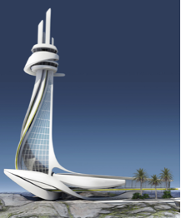  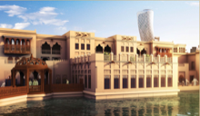
Design Manager  Hatch Design LLC (http://hatchid.com/)  Hatch Design is a retail and hospitality turn-key interior design and contracting company that specializes in retail and F&B shops.  Scope of Work:  Improvising and instilling systems for designated projects from start (design) until on site execution including:  - Creation/management of concept design, detailed design, MEP design and permit file in coordination with related team. This includes managing a design team involved in the production of concept, detail design drawings and drawings in preparation for Dubai Municipality submittal and/or retail management team.  - Preparation of BOQ (bill of quantities) and schedule for related projects.  - Invitation for tender for sub-contractors and comparison summary. This includes coordination with suppliers regarding proposed equipment supply.  - Coordination and liaison with the proposed shop’s Building/Mall Management involving design issues including issuance of TVR (Tenant Variation Request) |  |  | June 2010 to August 2010  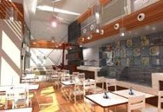  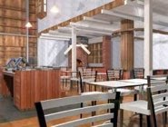
Architect  Emirates Sunland Group (www.emiratessunland.com)  Scope of work :  - CAD Documentation of Interior Design and Furniture Fit-out Packages for Palazzo Versace and D1 Tower; design development of artwork for D1 Tower corridor; review and preparation of finishes/furniture schedule for interior design/furniture packages  Project: Palazzo Versace Dubai  Building Area: 130,000 sq.m.  Project Cost: AED 2.3 Billion  Project type: Hospitality/Residential  - Palazzo Versace Dubai, a 5.5 hectare development by Emirates Sunland Group and Versace, will be one of Dubai’s most outstanding hotel and residential resorts, providing a collection of 169 private residences and 217 super-luxury hotel suites, all furnished exclusively with Versace Home furniture.  Project: D1 Tower, Culture Village, Dubai  Project Cost: AED 650 Million  Project type: Residential  - Measuring 284 meters tall, the stunning 80 storey tower has exclusive residents’ facilities including a skyrise lounge, private cinema, indoor pool, gymnasium and concierge services. D1 is uniquely positioned adjacent to the majestic Palazzo Versace. |  |  | February 2010 to May 2010  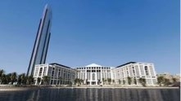  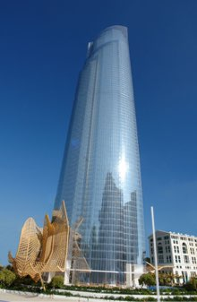
Site Architect/Design Architect  Benoy Limited  Abu Dhabi, UAE  Project : Ferrari Experience Building, Yas Island, Abu Dhabi, UAE  Building Area: approximately 178,000 sq.m.  Porject Cost: AED 3.2 Billion (2007)  http://yasisland.ae/FerrariWorld_en_gb.html  - Site architect for Ferrari Experience Building  - scope of work includes architectural and site coordination, schematic and design development studies, and contract administration  - Schematic studies/concept sketches/design development on undercroft louvers, bridge link, pedestrian bridge, column cladding, and ceiling package, taking into consideration sustainable design.  - Architectural/design coordination includes preparation and consolidation of Cost/Value Engineering documents including Cost Appraisal Report, and Potential Risk Exposure – Design Change Requests, Responsibility Matrix, Stage D/concept design report , DCR (Design Change Request) , DCR meetings with other consultants, Building Permit submittal & presentation to Municipality, and pre-contract enquiries for different packages.  - Contract administration includes (but not limited to) preparation and Issuance of site and compliance documents such as NCRs (Non-Conformance Reports), RFIs and RRFIs (Response to Request For Information), site observation visits and preparation of site observation reports and action list, attendance of weekly contractor’s progress meeting to liaise issues ) including blockwork and vertical penetrations coordination; attendance of other site meetings as required; preparation of the company’s quality plan with supporting documents  - Pls. refer to Architectural/Interior studies , Contract Administration , Architectural coordination, and Site experience under Skills for additional details  Project: Retail Center  Building Area: 300,000 sq.m.  http://yasisland.ae/YasMall_en_gb.html  - scope of work includes site observation visits and preparation of site reports  CPD (Continuing Professional Development) coordination and organization inviting RIBA and AIA-certified suppliers where possible |  |  | July 2007 to September 2009  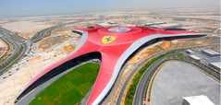  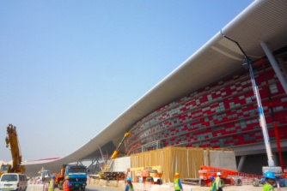  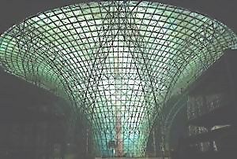
Architect  Ayanian Electrical Company L.L.C.(Lighting Division)  Dubai, UAE  - Lighting Concepts (freehand sketches)  - Preparation and tabulation of lighting data, specifications and summary  - Cataloguing/ preparation of database of lighting suppliers  - Preparation of lighting presentations to clients in AutoCAD 2D/3D, SketchUp, Adobe Photoshop, StudioMax and Relux  - Meeting with Clients together with the Lighting Division Manager  - Scope of work includes but not limited to lighting projects in UAE and GCC countries |  |  | February 2006 to July 2007  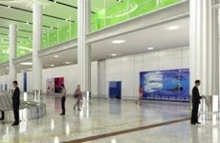
House Designer/Product Designer  Rattan Center Cebu/ Lamisa Ug Aparador  http://www.lamisaaparador.com/index.html  - Selects, designs and sources accessories, fabrics, hardware and exhibition booths for the furniture creations for local retail , local made-to-order markets , and foreign markets  - supervises prototyping of collections for the local market and subsidiaries of the company  - Market and represent the company and its subsidiaries  - Provide interior design advice in relation to the furniture the company and submit proposals to prospective clients. |  |  | January 2004 to February 2006  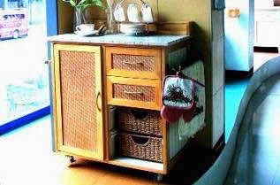
Project Architect  AD ABELLA ARCHITECTS  - Making schematic studies, interior design and doing project supervision , cost estimates, preparation of proposals, client coordination and meetings  - Projects include Southern Pacific Transport Corporate Interior and Brojan Mausoleum. Pls. refer to Architecture and Design Portfolio for details  - Drafting and modeling works |  |  | April 1998-Dec. 2001  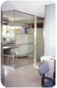
Architect/Interior Designer for Freelance and Studio Projects  - Scope of work includes schematic design, design development, detail design, contract documents and site superintendence experience  - for finished projects - pls. refer to www.rissakintanar.com. Details available upon request. |  |  | 1999 to present
Architectural Lecturer and CAD instructor  - Details available upon request |  |  | October 2000 – February 2006
s k i l l s a n d p r o f e s s i o n a l e x p e r i e n c e
Architectural/Interior Design and studies | - Pls. refer to work experience details under Aedas, Benoy Limited, Hatch Design, Emirates Sunland, AD Abella Architects and freelance/private projects |  | 1999 to present
 | - Space planning, interior designing and architectural designing of residential and commercial projects (private practice)
 | - Project supervision of residential and commercial projects
Detail Design | - Under Aedas, Benoy Limited, Hatch Design, AD Abella Architects, freelance/private projects, and Rattan Center Cebu/Lamisa Ug Aparador |  | 1999 to present
Contract Administration and Architectural Coordination | - Pls. refer to work experience details under Aedas, Benoy Limited, Hatch Design and Pell Frischmann |  | July 2007 to present
Site Experience | - Pls. refer to work experience details under Aedas, Benoy Limited and under freelance projects |  | 2008 to present
Presentation | - Preparation of layouts, documentation and reports through a variety of medium such as MS Office programs, Photoshop, In-Design, Publisher and other graphic programs as applicable |  | 1998 - present
Product Design | - Pls. refer to Work Experience under Rattan Center Cebu/Lamisa Ug Aparador and Portfolio for details |  | Jan. 2004 to Feb. 2006
Technical | - Plotting models in AutoCAD 2d and 3d, Architectural 3D presentation in SketchUp |  | 2005 to present
 | - Architectural drafting (manual and AutoCAD) and model making for AD ABELLA architects and other firms during apprenticeship  - CAD drafting works for Japanese firm KKS (Kanko Kikkaku Sekkeisha) A&I International |  | 1994 to 2001  2001
Organization | - CPD and DCR - pls. refer to work experience details under Benoy Limited |  | 2008 - 2009
Lighting | - Pls. refer to work experience under AEC and lighting presentation studies under Aedas |  | Feb 2006 - July 2007  April 2014
Sustainability | - Pls. refer to Pell Frischmann and Benoy work experience |  | 2007 to present
Site Superintendence | - Supervising construction of interior residential and commercial works for AD ABELLA Architects and private practice |  | 1998 - 2000
Teaching/Academics | - Teaching CAD and architectural subjects - details to be furnished upon request |  | Oct. 2000 – Feb. 2006

 |  | e d u c a t i o n
Tertiary | - Project Management Extension Certificate , Mount Royal University | 2014
Tertiary | - Graduate, University of San Carlos Technological Center, BS in Architecture | 1992 – 1998
 | - Undergraduate Thesis: “EXTREME ARCHITECTURE: Building a Structure in the Antarctic” | 1998
Secondary | - Graduate, St. Theresa’s College, 1st yr to 4th yr., Honorable mention | 1988 - 1992

p r o f e s s i o n a l a f f i l i a t i o n s
AIA (American Institute of Architects) | - International Associate Member | 2009 to present
PQP | - Pearl Qualified Professional for Estidama | 2011 to present
LEED GA | - Leadership in Energy and Environmental Design – Green Associate | 2015 to present
SOE-UAE | - Member, Society of Engineers - UAE | 2014 to present

w o r k s h o p s / c o n v e n t i o n s / e x h i b i t s / s e m i n a r s a t t e n d e d
Architecture/ Interior / Construction/Lighting Exhibits , Conventions and Workshops | - Architecture World Summit - Berlin Germany  - Facade Design and Engineering Summit, Index Dubai, Cityscape Dubai/Abu Dhabi, Lighting Exhibits in UAE and related exhibits in in other countries  - CPD and CPE Architectural workshops (including RIBA/AIA certified workshops) | November 2016  February 2006 – October 2009, 2012  1996- 2009
Other Workshops | - Alliance Francaise Dubai – French and Arabic | 2008 - 2009
 | - Web Design, Macromedia Flash Player, StudioMax, Photoshop, Digital Photography in Dubai, UAE | 2006 - 2007

a c c o m p l i s h m e n t a n d o t h e r p o i n t s
- Professional Registration: Licensed architect since August 1999 (under Professional Regulation Commission)
- Knowledgeable in Microsoft Office applications and Graphic/Drawing/Planning Programs such as AutoCAD, IntelliCAD, Sketchup, Photoshop, In-design, Relux, basic REVIT, and Microsoft Project
- UAE driver’s license

m i s c e l l a n e o u s
Other Skills: | Driving

