Curriculum Vitae
Wile

BIOGRAPHICAL DATA 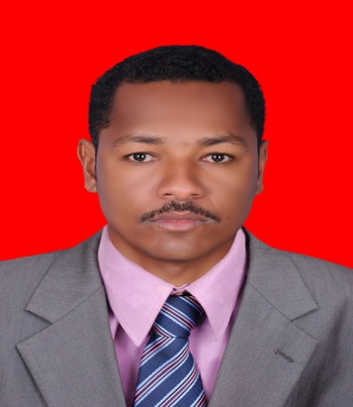
Name: Wile
Gender: Male
Date of Birth: 4 September 1978
Nationality: Sudanese
Address: Khartoum- Sudan
Email Address: wile.1698@2freemail.com
Languages: Arabic (Native)
English

EDUCATIONAL QUALIFICATIONS

Master in Business Administration (MBA):
(April, 2012)
Nelson Mandela Metropolitan University, Port Elizabeth, South Africa.

Bachelor Honours, Education and science (Biology &Chemistry) :
(1999 to 2005)
Khartoum University, Khartoum, Sudan.

High School certificate :(1995 to 1997)
Alamiria School, Khartoum, Sudan.
OTHER TRAININGS/SKILLS
- Various computer courses (MS Excel, MS Word, MS power point etc)
- English for international students (Nelson Mandela Metropolitan University) Port Elizabeth -South Africa
- IELTS –March 2015 with overall score (6.5)

WORK EXPERIENCE
1) Science teacher
School; Didy Anton memorial school
Period: August 2017 to current
Subject: Science

2) Science Teacher
School; Hikma PVT school (Muscat- Oman)
Period: September 2014- June 2016
Subjects: Science

3) Biology Teacher
School: Mustafa basher private high school (Khartoum – Sudan)
Period: September 2008 March 2013
Subjects: Biology and chemistry

4) Part time Teacher
Employer: Various High Schools (Khartoum- Sudan) (port Elizabeth- South Africa)
Period: (2000 to 2012)
Subjects: Biology, Chemistry , Science, Arabic and English

