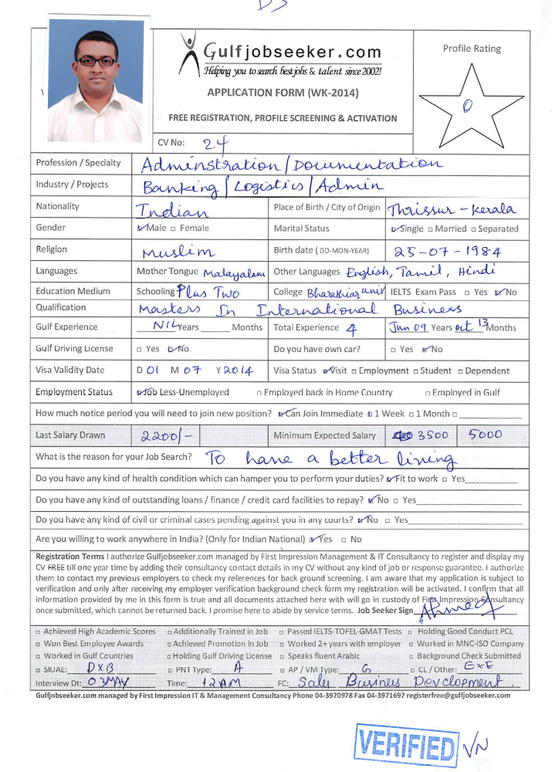

In quest of entry level assignments in Business Development / General Administration with an organisation of repute.

BRIEF OVERVIEW:

- An astute & result oriented professional with 2 years of extensive experience in Strategic Planning, Product Management, & Resource Management with profit accountability.
- An out-of-the-box thinker with a proven track record of increasing revenues, streamlining workflow and creating a team work environment to enhance productivity.
- Ability to formulate and implement tactical initiatives to achieve corporate strategic goals. A keen strategist with expertise in managing entire operations with focus on profitability and optimisation of resources.
- Adept at maintaining healthy relationship with Customers, Vendors, and Agencies. Ensuring ramp up of business assignments while working in coordination with clients and ensuring service deliverables.
- Proficient in developing & streamlining systems with proven ability to enhance operational effectiveness and meet operational goals within the cost, time & quality parameters.
- Comfortable interacting with multiple levels of organisation, management and staff from different locations.

SCHOLASTICS:

- Masters in International Business from Hindustan College of Arts & Science, Coimbatore in 2008 with 73% marks.
- BBM from Bharathiar University in 2006 with 55% marks.

ORGANISATIONAL EXPERIENCE

Jun’09- Nov’ 11
Manager

Key Deliverables:
- Creating business development procedures, service standards, operational policies and guidelines with clear understanding & operating each of the designated retail outlets as a separate profit centre.
- Managing business operations with focus on top and bottom line performances through retail sales & marketing strategies, business alliances, channel & distribution management for domestic and international markets.
- Driving growth, generating revenues, capturing market share of numerous retail store outlets and enhancing their value in domestic markets.
- Reviewing & analyzing market response/ requirements and strategizing business plans accordingly for accomplishment of goals.
- Organising promotional campaigns and evolving Media Plans, Awareness Workshops & Corporate Presentations for new product development; focussing on category establishment, market penetration and territory development
- Streamlining operations of the Product Teams for ensuring effective delivery of solutions keeping in consideration pre-discussed parameters for ensuring consistent achievement of the sales targets for different segments.
- Managing multiple clients, mapping different segments as well as delivering products & solutions for the client’s business problems.
- Managing activities pertaining to negotiation/ finalization of deals (techno commercial).
Glenn View Co. Pvt. Ltd., Malappuram, Kerala May’08 – May’09
ADMINISTRATION MANAGER

- Purchased printed materials and forms by obtaining requirements; negotiating price, quality, and delivery; approving invoices.
- Completed special projects by organizing and coordinating information and requirements; planning, arranging, and meeting schedules; monitoring results.
- Provided historical reference by developing and utilizing filing and retrieval systems.
- Hands -on in Improving program and service quality by devising new applications; updating procedures; evaluating system results with users.
- Achieved financial objectives by anticipating requirements; submitting information for budget preparation; scheduling expenditures; monitoring costs; analysing variances.
- Maintained continuity among corporate, division, and local work teams by documenting and communicating actions, irregularities, and continuing needs.

Ethans Academy, Coimbatore Dec’11 – Oct’13
EDUCATIONAL ADMINISTRATION MANAGER

- Administering the 'student lifecycle' from registration or admission to graduation or leaving;
- Providing administrative support to an academic team of lecturers, tutors or teachers;
- Drafting and interpreting regulations and dealing with queries and complaints procedures;
- Coordinating examination and assessment processes;
- Maintaining high levels of quality assurance, including course evaluation and course approval procedures;
- Using information systems and preparing reports and statistics for internal and external use;
- Participating in the development of future information systems and contributing to policy and planning;
- Managing budgets and ensuring financial systems are followed;
IT SKILLS:

Well versed with Office Automation & Internet Applications.
PERSONAL DOSSIER

Date of Birth : 25th July 1984
Nationality : Indian
Visa Status : Tourist Visa
Marital Status : Single
Languages Known : English, Malayalam, Tamil and Hindi.

Declaration:

I hereby declare that all the above furnished information are true best of my knowledge.

Yours faithfully,

