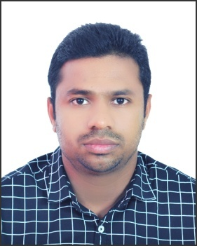
ANEESH
Email- aneesh.1296@2freemail.com
INTRODUCTION
I believe that my work requires a lot of attention and understanding for our patients and their families. We must insure that all our patients receive an excellent medical care taking into account their delicate health condition. The Emergency Care Nurse is trained to be the assistant of the Doctor if and when needed to perform complex medical procedures. I am HAAD Licensed Registered Nurse (License No: GN21197)
OBJECTIVE
To be a dynamic and professional in hospitality and motivation towards my career. Where I can make the use of opportunities, overcome through initiatives, is result oriented and commitment.
CAREER SUMMARY
- Extensive working knowledge in the use of life saving equipment
- Efficient in nursing procedures and process
- Expert in safety precautions
ACADEMIC QUALIFICATIONS

Course | Institute | University/Board | Year | Marks/percentage
BSc Nursing | Sruthi College Of Nursing, Andra Pradesh | DR. NTR University Of Health Sciences, Andra Pradesh | 2005-2009 | 77%
Higher Secondary School | SDVHSS, Alappuzha | Board of Higher Secondary Examination, Kerala, India. | 2002-2004 | 68%
Secondary School (10th) | SDVHSS, Alappuzha | Board of Public Examination, Kerala. | 2002 | 76%
PROFESSIONAL CERTIFICATION

HAAD Licensed Registered Nurse License No: GN21197

PROFESSIONAL EXPERIENCE
STAFF NURSE: 3 Years in ACCIDENT and EMERGENCY Dept.
AWARE GLOBAL HOSPITAL, STAFF NURSE From July 2010- July 2013
Hyderabad.
Job Responsibilities;

- Handled with Very Critical Patient like Cardiac, Pulmonary, and Neuro etc.
- Handled with Road Traffic Accidents with Head Injury and Burn Cases.
- Handling with Life Saving Equipment’s like Defibrillator, Ventilator etc.
- Emergency situation of intubation, Cardiac Arrest.
- Handled both Medical and Surgical client

UAE EXPERIENCE
STAFF NURSE: From Jan 2015-Till Date
Hala Medical Centre, Gayathi, Abu Dhabi

COURSE ATTENTED
- Emergency Care Aware Global Hospital 2010
- Critical Care Aware Global Hospital 2011
- ECG Aware Global Hospital 2011
ACHIEVEMENTS
- Participated in Pulse Polio program
- Participated in AIDS control program
- Participated in Filaria Eradication program
- Participated in Community Health Field Work
- Organized School Health program
- Organized Industrial Health program
PERSONAL TRAITS
- Commitment, Honest, Hardworking, Ambition and Dedicated.
- Ability to communicate in English, Hindi, Telugu, Tamil& Malayalam.
- Excellent in analytical, managerial, communication and problem solving skills.
- Ability to work in group and perform multiple tasks simultaneously.
- Practical knowledge of MS Windows, MS Office, Internet.
PERSONAL DETIALS
Date of birth : 07 July 1986
Gender : Male
Marital Status : Single
Nationality : Indian
Religion : Hindu, Nair

DECLERATION
I Hereby declare that the above given particulars are correct to the best of my knowledge and Belief

Yours truly,
Date:
Place : Abu Dhabi ANEESH

