Applied for Registered Nurse

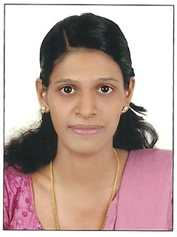 CURRICULUM VITAE

Gulfjobseeker.com CV No: 8406
Mobile +971505905010 / +971504753686

To get contact details of this candidates
Submit request through Feedback Link
http://www.gulfjobseeker.com/feedback/submit_fb.php

Dynamic kind hearted and highly focused staffnurse with DHA licence in UAE and 4 year experience in medical,surgical, gastroenterology and ENTward in India. Hands on experience in modern bio medical equipments.

STRENGTHS:
Strong interpersonal and communications skills with proven ability to contribute to the development and overall growth of an organization, hard work, determine and desire to succeed are strong assets.

QUALIFICATIONS
ACADEMIC:
    - Secondary School Leaving certificate (S.S.L.C)with first class.
    - (Board of Public Exam, Kerala, India).

    - Passed in vocational higher secondary with distinction, kerala education department,Kerala, India.
PROFESSIONAL QUALIFICATION:

- Diploma in General Nursing & Midwifery (Three &six months) from School of Nursing Lourds school of nursing, Holy cross hospital kottiyam, Kerala, India.

- Life member of Kerala Nurses and Midwives council,Trivandrum,

WORK EXPERIENCE:

    - Four year (07-2008 to 09-2012) experience in Medical,Surgical Gastro -entrology. and ENT department in Holy cross 550 beded multi speciality hospital kottiyam,Kerala, India.

Now working is INDIAN INTERNATIONAL SCHOOL DUBAI As a
Registered nurse

COMPUTER KNOWLEDGE:
    - M S OFFICE
    - EXCEL
    - POWER POINT

PERSONAL DETAILS:
Date of Birth | : | 20-05-1986
Place of Birth | : | Kottarakkara
Nationality | : | Indian
Marital Status | : | Married
Sex  Language known  Religion | :  :  : | Female  English, Hindi& Malayalam  Christian

Declaration

I hereby declare that the above mentioned details are true and correct according to my knowledge.

