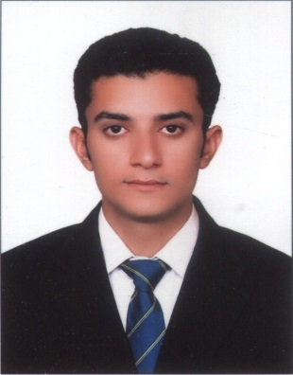
Gulfjobseeker.com CV No: 8652
Mobile +971505905010 / +971504753686

To get contact details of this candidates
Submit request through Feedback Link
http://www.gulfjobseeker.com/feedback/submit_fb.php

Profile

I pride myself on being an honest and a hardworking individual who enjoys his work. A great eye for detail and providing a high level service is something I strive to achieve everyday as if it was my first. I am reliable and take self-initiative to achieve my company’s objectives as well as my personal ones by utilizing the skills I have acquired over the years.

COMPUTER Skills

- MS-Office; Majors in Excel (Very good hands on experience), Word, PowerPoint
- Awareness of Various Accounting Packages, Full Hands on experience on OracleERP Accounts Receivable General Ledger Module
- Windows 2000, XP, Windows 7
- Internet Browsing, Email.

Career Summary

Wateen Telecom Ltd (Pakistan)- Abu Dhabi Group Apr 2008 –Present (6 Years)
Designation: Finance Executive

Wateen Telecom Ltdis one of the leading telecommunication companiesin Pakistan currentlybasedin more than 20 cities of Pakistanwith over a thousand employees working hard collectively to preserve the heritage of its parent company.

Duties Include:-

- Month end and year end reporting
- Reconciliation of ledgers with customers
- Bank and cash book reconciliation
- Dealing with vendors and customers of the company
- Issuance of invoices and bills to debtors & issuance of payments to vendors
- Liaison with auditors for statutory audit of Accounts Receivable and General Ledgers
- Variance analysis of budgeted and actual collection
- Preparation of daily, weekly and monthly receivable reports
- Preparation of daily, weekly and monthly collection reports of debtors
- Collection follow-up of outstanding invoices via email, telephone and letters
- Preparation and updating of debtors database
- Creating liaison amongst customers, billing department, sales persons and engineering team
- Recording of transactions in ERP

Raaziq International (Pvt) Ltd. Jan 2007 -Sep 2007
Designation: Accounts Executive

Raaziq Group is one of Pakistan’s largest logistics and auxiliary services provider established since 1974 With more than 600 people and a nationwide and overseas network. Raaziq’s Services include air and ocean freight forwarding, customs brokerage, transportation, distribution and value-added services.

Job Tasks

- Preparation of local and Int’l invoices against freight and custom clearance
- Preparation and send debit notes to company branches
- Preparation and reconciliation of fortnightly K.B report of airlines
- Preparation of fortnightly sales reports
- Reconciliation of fortnightly activity report with branches
- Reconciliation of balances with parties of the company
- Reconciliation of monthly bank statement

TAQ Logistics Sep2004 - Dec 2006
Designation: Accountant

The TAQ Organization (TTO) is Pakistan's leading group engaged in International transportation, forwarding and logistics business. The establishment that began its operations 40 years ago has evolved into an organization offering expanded range of services.

Job Tasks

- Preparation of Final Accounts of sister concerns
- Payroll and compensation of staff
- Preparation and reconciliation of Cash and Bank Ledgers
- Complete processing of Accounts Payables and Receivables
- Dealing with the banks of the company
- Book keeping in computerized environment
- Preparation of monthly and annual W. H. Tax Statements
- Assisting all corporate matters, like registration of new company and filing of periodic returns/statements of Security and Exchange Commission of Pakistan
- Assisting in preparation and filing the annual returns of the Group Companies

EDUCATION

Master of Business Administration

Bachelor of Commerce

KeY strengths

- Challenges Accepting Personality
- Self-Motivating
- Quick Learning
- Team Player

Personal Information

Nationality Pakistani
Religion Islam
Marital Status Single
Date of Birth 21st July 1982

INterests

I am an amateur creative writer in Urdu; I often publish articles on an amateur level on popular Urdu websites. I enjoy browsing the internet, reading and socializing with friends and family.

