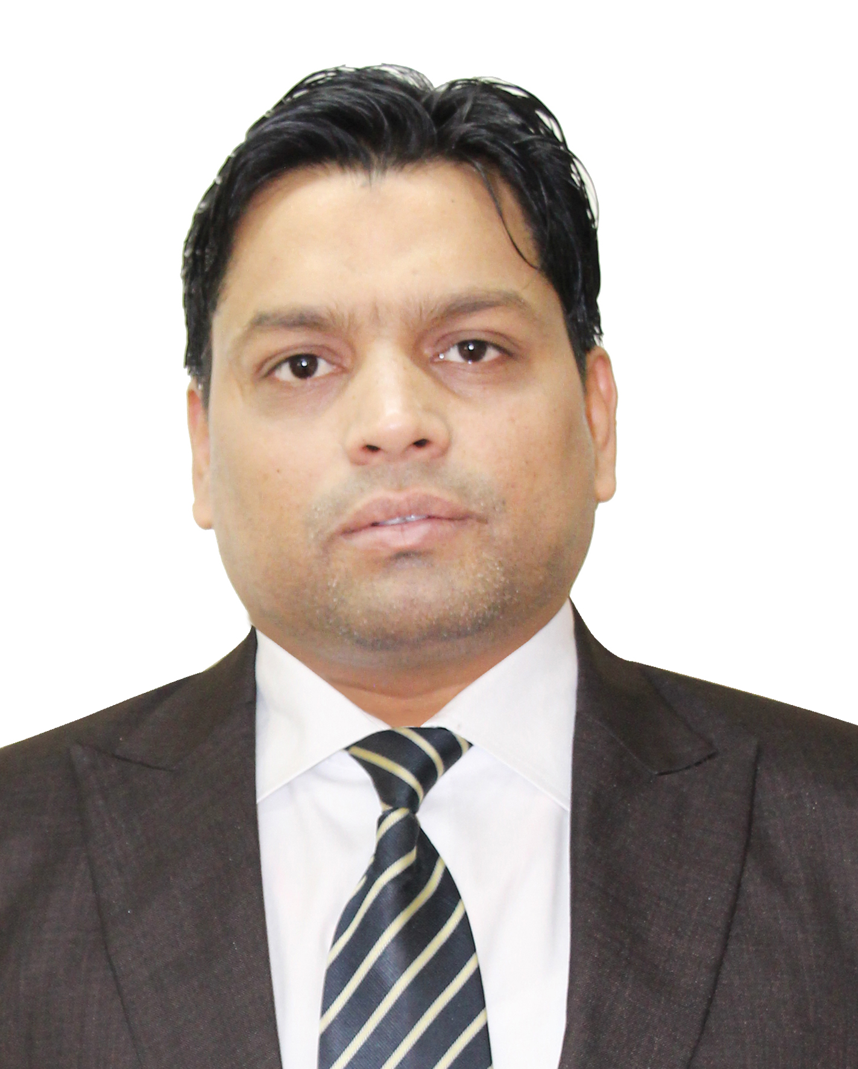
Mohsin

Accounts & Finance

E-mail: mohsin.102447@2freemail.com

Mobile: Whatsapp +971504753686 / +919979971283

PROFILE SUMMARY

Experienced accounts professional with 18+ years of strong exposure in accounting, finance and auditing roles in the UAE and India. Skilled in various areas including but not limited to: budgeting, financial analysis and planning, cash flow, accounts finalization, and bookkeeping. Achieved consistent growth through outstanding performance and competencies in working well under pressure, meeting deadlines, setting job priorities and organizing work functioning. Regarded as highly motivated and dedicated individual with excellent communication, problem solving, coordination, time management, leadership and IT skills with presentable personality and professional business style. Keenly interested to work ins accounts/finance within a forward-thinking organization to share and enrich knowledge and skills.
STRENGTHS
- Rich Accounts & Finance Background | - Strong Planning & Organizing Skills
- Outstanding Analytical Skills | - Accurate and Detail Oriented Worker
- Auditing Procedures Know-How | - Maintenance of Books of Accounts
- Effective Reporting & Presentation | - Skilled in MS Office & Accounting Software

CAREER HIGHLIGHTS
- Promoted as Finance Manager from Senior Accountant at Barakat Group of Companies for surpassing performance goals and contributing to continued business growth.
- Presented with an appreciation letter from the Auditors of the Co-operative Department for assisting in the company Audit.
- Consistently contributed to previous companies in safeguarding finances or frauds detection through preparing accurate final accounts, ensuring its reliability and worthiness.

EMPLOYMENT HISTORY

Finance Manager Nov 2012 – Jun 2017
Senior Accountant May 2010 – Oct 2012

Barakat Group of Companies, Dubai, UAE
Wholesale & Retail of 18 & 22 carat Gold & Diamond Jewellery

Senior Accountant Feb 2007 – Apr 2010
Accountant May 2005 – Jan 2007

Lifestyle LLC, Dubai, UAE
22 branches across the UAE for jewelry & watches.

Audit Coordinator Apr 2003 – Apr 2005
Prema Gopal & Co., India
A leading Chartered Accountancy firm.

Branch Officer Feb 1998 – Feb 2003
The Charminar Co-operative Urban Bank Ltd., India

AREAS OF EXPERTISE

Accounting & Finance

- Excellent competencies in managing all financial accounting activities of the relevant business.
- Highly experienced in consolidating financial statement and other management reports and handling complete books of accounts independently up to completion with zero error tolerance.
- Adept at reviewing accounting records and other financial reports to assess accuracy, completeness, and conformance with company policies and applicable reporting standards.
- Skilled in operating computers programmed with accounting software to execute accounting tasks.
- Delegate and oversee various accounting works assigned to staff and provide necessary guidance and instructions to meet deadlines and accomplish needed result.
- Exposed in interacting with banks, suppliers, auditors, and other third parties dealing with the company.
- Adept in collecting data and delivering effective and concise reports to management.
- Help in continually reviewing and setting up improvements to current procedures.
- Accomplished in performing audits that summarizes the organization's financial position.

PROVEN JOB ROLE

Finance Manager – Barakat Gold Jewellery Co. LLC
- Compile and analyze financial information to prepare financial statements including monthly and annual accounts.
- Ensure financial records are maintained in compliance with accepted policies and procedures.
- Ensure all financial reporting deadlines are met.
- Prepare financial management reports.
- Ensure accurate and timely monthly, quarterly and year end close.
- Resolve accounting discrepancies and irregularities.
- Financial audit preparation and coordinate the audit process.
- Analyze and advise on business operations including revenue and expenditure trends, financial commitments and future revenues.
- Establishing and maintaining effective business relations with vendors, clients and bankers.
- Ensures that training and development needs of Finance Personnel are met and provides assistance and support as needed.
- Establishing and maintaining effective communication and coordination with Company personnel, departments, and management

Senior Accountant - Lifestyle LLC
- Handling book of original entries to preparation and analysis of financial statements and other reports.
- Preparing and reviewing financial budgets including monthly and annual projection on the result of operations, Capital Expenditure and cash flows.
- Providing advice and reports to management to enable them to make sound business decisions.
- Supervising team and providing leadership towards achievement of maximum profitability and growth and ensure smooth functioning of day-to-day accounting transactions.

Audit Coordinator - Prema Gopal & Company
- Gained outstanding experience in conducting statutory and special audits for various industries.
- Assisted the Auditors in planning and carrying out audits for clients.
- Liaised with internal and external parties to ensure audit activities run smoothly.
- Coordinated the necessary audit procedures according to the given schedule.
- Performed general administrative tasks such as filing, preparing correspondences and reporting.

Branch Officer - The Charminar Co-operative Urban Bank Limited
- Responsible for managing entire front and back-office operations of the branch and ensuring accretion in deposits, effective cost control and audit excellence.
- Coordinated functions within Departments for smooth and resourceful operations.
- Developed and implemented systems and internal controls for day-to-day activities with key emphasis on increasing profitability and optimum productivity.
- Attended to customer inquiries about bank products and account information; ensured customer satisfaction through providing quality services and prompt assistance.
- Provided leadership to team and motivated them to deliver quality service and achieve targets.

AUDIT TASKS HANDLED

Took part in performing statutory audit for the ff. companies:
- Andhra Bank-Patamata Branch, Seetarampuram at Vijaywada, Krishna District and Dornakal branch at Warangal District
- Oriental Bank of Commerce – Secunderabad Branch, Chikkadapally Branch and Himmayatnagar branch in Hyderabad
- Prudential Co-operative Bank Ltd. R.P. Road Secunderabad-20 branches including Head Office.
- Vasavi Co-operative Urban Bank Ltd. Head Office at Malakpet, Hyderabad-17 branches including Head Office.

Participated in conducting Special Audit for the ff. companies:
- For Prudential Co-operative Bank Ltd. and Vasavi Co-operative Urban Bank Ltd. for State Government of Andhra Pradesh. Worked on Reconstruction/ Revival Packages.
- Investigation Audit of Hyderabad Co-operative Urban Bank Ltd., Yakutpura in Hyderabad.
- Pre-audit of Spectrum Power Generation Ltd., Saroornagar in Hyderabad.

EDUCATION – COURSE

Bachelor of Commerce, Osmania University, Hyderabad, India

Certificate in MS Office & Internet Concepts, Reputed Computer Institute, India

IT SKILLS

- Well versed with Accounting software like Matrix, Tally, Focus, Ace & Power Jewelry Software (PJS), Win gold, Suntech Business Solution and POS
- Proficient in MS Office (Word, Excel & PowerPoint), Internet, and E-mail applications

PERSONAL DETAILS

Indian National Born 27th August 1974 Married Visit Visa
Speaks English, Hindi, and Urdu References: Will be provided on Request

