AHMED
GRAPHIC DESIGNER

PERSONAL INFORMATION
Name: Ahmed
Nationality: Sudanese
Date of birth: 29 /1 /1989
Place of Birth: Abu Dhabi
Marital status: Married
PERSONAL SKILLS
Learning Quickly Continuous Research Work Under Stress

EDUCATIONAL QUALIFICATION
Nawras Secondary Private School high school
LANGUAGES ARABIC ••••••
ENGLISH • • •

COMPUTER SKILLS

WORK SUMMARY
I STARTED WORKING WITH MEDIA INTELLIGENT FOR ADVERTIZING CO.
A COMPANY OF THE 8IC ADVERTISING COMPANIES IN SUDAN
IT WAS MY BEGINNING WITH THEM VERY SUCCESSFUL WITH THEM A JOB WHERE
I WAS HIRED GRAPHIC DESIGNER
NOT ONLY THAT, I WAS SUPERVISOR OF THE PRINTING MACHINES OF ALL KINDS, TO ACQUISITIVE PRIOR EXPERIENCE TO WORK ON
AND I COMPLETED MY CAREER WITH THEM ON THIS WAY UNTIL MY WORK HAVE BEEN PROMOTED TO BECOME THE DIRECTOR OF DESIGN AND TECHNICAL SUPERVISION DEPARTMENT AND I'M STILL AT THE TOP OF MY WORK SO FAR
I WAS ACCEPTED TO HIRE ME IN ADDPRINT FOR PRINTING SERVICES CO.
IT IS THE BRANCH OF THE PARENT COMPANY IN ABU DHABI MY CAREER WAS CHARACTERIZED BY DIFFICULTY WITH THEM WHERE IT WAS MULTI-FUNCTIONAL TASKS AND WHICH LED TO THE ACQUISITIVE MORE EXPERIENCE IN THE FIELD OF DESICN, MARKETING AND DEPARTMENT STORES COMO AND HAVE DONE OUR BEST AS A TEAM TO ENSURE THE SUCCESS OF THIS COMPANY UNTIL MAY COD HELP IN THAT
WAS MY BEGINNING, WHERE STARTED IN YOUNG AGE HELPED ME TALENT I STARTED TO DEVELOP MY SKILLS BY GAINING MORE EXPERIENCE IN THE FIELD OF DESICN AND JOINING THE PRACTICAL FIELD
- STARTED TO WORK IN THE REEM FOR MODERN STAMPS & TICHNICAL CENTER THE CENTER HAS A STAFF OF DISTINGUISHED WORK, WHICH HELPED ME TO CAIN EXPERIENCE IN THE DESICN AND MARKETING
HAVE WORKED DILIGENTLY BECAUSE OF THE EXTREME MY PASSION FOR THIS WORK ASCENDING HAVE DEVELOPED MY SKILLS TO BECOME AN ESSENTIAL ELEMENT IN THIS CENTER
WHERE THE DEVELOPMENT OF THIS CENTER UNTIL THE COMPANY BECAME WELL-KNOWN COMPANIES IN THIS FIELD AND ESTABLISHED A MULTI BRANCHES

EXPERIENCE CERTIFICATE
- CERTIFICATE OF PRACTICAL EXPERIENCE FROM THE PERIOO 01.08.2013 UNTIL 01.01.2016 AS THE DIRECTOR OF INTELLIGENT FOR ADVERTISING SUDAN
- CERTIFICATE OF PRACTICAL EXPERIENCE OF THE PERIOD 1/5/2010 TILL 07/15/2012 COMPANY ADDPRINT FOR PRINTING SERVICES CO. - SUDAN, IN THE FOLLOWING ACTS:
- / DESIGN WORK: GRAPHIC DESIGNER
- / MARKETINC DEPARTMENT POSITION: PUBLIC RELATIONS AND MARKETING AND SALES SUPERVISOR
- / WAREHOUSE POSITION: STOREKEEPER AND FOLLOW-UP ORDERS
- CERTIFICATE OF PRACTICAL EXPERIENCE OF THE PERIOD 1/6/2004 TILL 1/4/2010 REEM FOR MODERN STAMPS & TICHNICAL WORKS CENTER IN THE FOLLOWING ACTS:
- / DESIGN DEPARTMENT POSITION: GRAPHIC DESIGNER
- / MARKETING DEPARTMENT POSITION: SALES REPRESENTATIVE
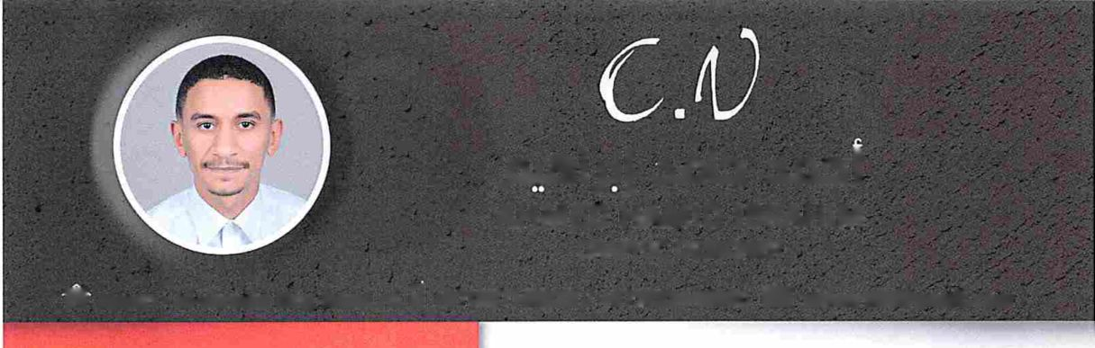
AHMED CV NO.688080

Click to send CV No & get contact details of candidate

