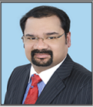
Pasupulaty
Pasupulaty.117992@2freemail.com

A Seasoned HR Strategic &Operations Professional with over 23 years of HR generalist expertise in Human Capital Management with broad based competencies in whole gamut of HR functions such as Strategic and Operational HR. A very Strategic, Analytic& a Cohesive thinker with an excellent track record of achievements within a short span. Conversant with all aspects of HR/Admin/PR and its emerging trends particularly in the Middle East Environment.

Possess strong Communication, Analytical, Leadership and Team Skills. A Seasoned Organizer, Planner & Executor of HCM Strategies. Exceptional skills in Problem solving & Crises Management, Decision making and Leadership skills. Multi-Talented and Multi-skilled with Cross-Functional abilities in driving HR directly into core Business Development strategies thereby harnessing the Human Capital of an organization to skill based Ideal performers with proven talent.

HR Quality Talent Acquisition OD & Planning
HR Interventions Employment Engagement Team Management
Training & Development Business Development Compensation & Benefits
Resource Management Statutory Compliance Liaison & Coordination
HR Operations Public Relations & Legal General Administration
Grievance Management Performance Management System Corporate Social Responsibility

- Highly skilled in Designand Implementation of HR Strategy / HR Initiatives as per business strategy of the Organization
- Employee Engagement: Acquainted with all the processes right from Manpower Budgeting to Exit Interviews
- Talent Acquisitions: Have worked on various Multi-Diversified and Multi-Lingual workforce for Multi-Divisional entities
- Performance Management System (PMS): Steering policies and initiatives for identifying high Potential / Performance / Talentwithin organization while providingaccelerated developmental work assignments & trainingopportunities
- Competency based Performance Management System (PMS): To devise and execute a comprehensive Performance Appraisal Process across all levels & establishframework for substantiating PAR linked to reward/incentive mechanism
- HR Quality: Design & Implementation of Training Modules, a Trainer on Soft Skills (Behavioral Traits) and Mapping
- Compensation & Benefits: Devised and successfully implemented wages for diverse industry and backgrounds

- Employee Engagement: Diverse exposure in handling Human Capital Management (HCM) in Group/Corporate HR functions in Multi-Diversified Industries in India and in GCC region
- Strategic HR: Integrate strategy into business processes resulting in increased profitability with low costs
- OD & Planning: Restructured organizations into strategic business units with high end profitability& nurturing talents
- Extensive Project Management experience in GCC region and handling it’s related implications with ease
- Human Capital Management of hired Talent across all levels from Blue Collar to CEO level
- Devised and Executed several performance linked compensation strategies for multi diversified industries
- Skills in handling Multi-Lingual workforce in Multi Diversified Industries in several organizations
- Exposure of Oracle HRMS applications & ERP solutions & brought about a simple procedural outputs
- Excellent exposure on all legal requirements both Labor / Civil matters and successfully represented cases
- Liaison with Immigration/MoL/Dubai Courts/Human Rights/Police/DeD/Real Estate/other departments

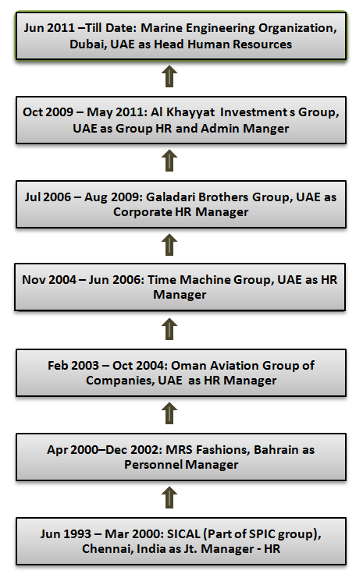
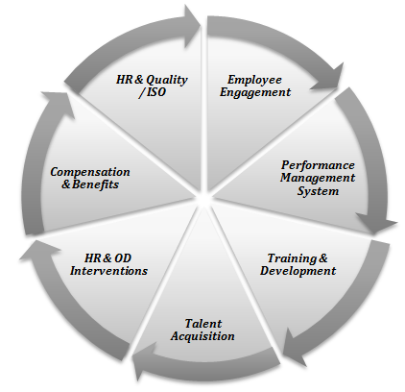

Company Wise/ Experience Profile
Jun 2011 – Till Date Marine Engineering Organization, Dubai, UAE as Head Human Resources

- Company Description: Indian based Group into Marine Engineering Industry with three major divisions in UAE with a diverse manpower of over 1,500 employees, with an estimated annual turnover of over AED.100 million, having establishments in India, Singapore and Oman. Reporting to Chairman & Managing Director.

- Business Activity: Indian based Group into Shipping, Ship Building, Ship repairing, Oil & Gas and Industrial Engineering and on the verge of establishing operations in Oman and Qatar as well.
Accomplishments:
- Spearheading corporate HR/ Unit HR from scratch, linked department’s objectives to organization’s vision & mission resulting in achieving the goals effectively resulting in effective Human Capital Management (HCM)
- Well presuming and implementing HR strategies for start-up divisions involved in Turn Key projects effectively
- Keen-eye on increasing production linked Performance Management System resulting in increasing profitability by 25%
- Handling the responsibility of recruiting industrial engineer and skilled diverse manpower
- Effectively restructuring HR, PR & Admin. Departments and its core objectives to suit business requirements
- Essayed a pivotal role in:
- Maintaining and controlling ERP system for the organization for all departments in line with QMS for ISO certification
- Functioning as MR in establishing QMS for ISO 9001, 14001 & 18001 standards towards re-certification audit
Oct 2009 –May 2011 Al Khayyat Investments Group, UAE as Group HR & Admin Manager

- Company Description: Locally owned group with six divisions having diverse businesses with work force of 2,000 employees and turnover close to AED 800 Million. Directly reported to Chairman of the Group & Managing Directors.

- Business Activity: Pharmaceuticals (Bin Sina Pharmacy), Medical & Laboratory, FMCG, Fitness, F & B, Contracting, Landscaping & Irrigation, Interior Décor, Modular Kitchens (JV), Facilities Management and Automobile.

Accomplishments:

- Meticulously formulated HR strategies in the group involved in different sectors such as construction, interiors, landscaping / irrigations and modular kitchens, some being turn key projects
- Gained merit in implementing QMS for ISO Certification as a MR & Internal Auditor
- Accountable for:
- Closing key operational positions for the group to diversify the business into profitable ventures
- Implementing HRMS for the group through an Oracle platform
- Presuming & executing successfully a PMS Module and brought performance based Comp. & Ben. System
- Essayed a stellar role in setting up Corporate / Group HR and worked successfully towards Organizational restructuring linking into PCs
Jul 2006 – Aug 2009 Galadari Brothers Group, UAE (Part of Dubai Holding) as Corporate HR Manager

- Company Description: A leading business conglomerate with twelve diversified divisions based in UAE having a workforce of 5,000 employees. Group turnover of over AED 2 Billion. Reported to Executive Board and later to Group CEO.

- Business Activity: Automobiles (Mazda), Industrial Trading ((JCB/Komatsu Trucks & AEB), Machinery, Engineering, Media (Khaleej Times), FMCG (Baskin Robbins / Dunkin Donuts), Tours & Travels, Manufacturing, Real Estate, IT (Fujitsu/Siemens), Retail, Trading, Entertainment (Plaza Cinemas) and Hospitality (Radisson SAS).

Accomplishments:

- Formulated Group and Unit HR from scratch and worked successfully towards organizational restructuring
- Successfully implemented the key HR initiatives & strategies for several business units in the group involved in turn key projects
- Efficiently proposed PMS and Comp. & Ben. strategies for diversified manpower and linked to productivity effectively
- Significantly hired several key positions such as CEOs / CFOs / GMs / BUHs / managerial positions for various BUs
- Steered efforts in OD & planning initiatives for the group and brought about a progressive change in HR orientation in all the BUs through consistent multi tied feedback mechanism
- Responsible for right sized human capital through talent mapping and resulted in loss making bus to become productive
- Actively created Oracle HRMS through ERP packages from age old system platforms
- Effectively closed several emiratization positions and mapped their Training & Development for excellence
Nov 2004 – Jun 2006 Time Machine Group, UAE as HR Manager

- Company Description: A Dubai based group of companies with six active divisions having diversified business interests with total staff strength of 1000 employees. Reported to President and CEO of the Group.

- Business Activity: Trading (Perfumery & Branded Cosmetic Products), Trading (Re-export of these products), Interior Décor, Spas & Saloons (PBSS), Hospitality, Real Estate and Retail.

Accomplishments:

- Essayed a stellar role in planning & executing key HR initiatives & strategies for several BUs in the group involved in Turn Key Projects resulting in productivity
- Significantly worked on proposed PMS & linked Comp. & Ben. System to productivity in all BUs having diversified manpower
- Radically involved in talent acquisition - closed key positions for the group to diversify into various other Businesses sus
- Efficiently drafted and implemented OD & prepared planning initiatives & obtained favorable results in CBM
Feb 2003 – Oct 2004 Oman Aviation Group of Companies, UAE as HR Manager

- Company Description: A Dubai based group having four divisions involved in Aviation, Freight Forwarding and related activities, handling of cargo & customs with work force of 600 employees; Reported to President of the Group.

- Business Activity: Air Cargo Chartering, Air Craft Leasing, Freight Forwarding and Tours & Travels.

Accomplishments:

- Set up the HR/Admin./PR Departments from scratch for Aviation / Freight Forwarding Industry in the GCC region
- Significantly worked on key recruitments in Aviation Sector including fight crew& Technicians
- Achieved PMS execution through HRMS for better operational convenience resulting in profitability
- Effectively managed QMS as MR & Internal Auditor and obtained certification for ISO 9001:2000 standard
Jun 1993 – Mar 2000 SICAL (Part of SPIC group), Chennai, India as Jt. Manager - HR

- Company Description: A conglomerate with a diversified workforce of 6,000 employees of diversified disciplines in a prepost-merger scenario of 18 SBUs into 37 Multi – Diversified divisions. Reported to Vice Chairman & Managing Director of the Group.

- Business Activity: Construction, Automobiles (Mitsubishi/Opel Cars), Automotive, Shipping & Stevedoring, Construction, Clearing & Forwarding, Manufacturing, Chemicals and Fertilizers, Process, Agri Business, Real Estate/Property Management, Commodity Trading, Estate Management and Hospitality (Radisson SAS).

Accomplishments:

- Successfully closed key recruitments for the group such as GMs, BUHs and other core Managerial positions
- Efficiently right sized human capital through effective Talent Mapping making 4 loss making BUs into profitable ones
- Steered efforts in designing schemes for succession planning & career progression for merged manpower
- Distinction of setting up a Training & Development Cell and implemented the MBO system effectively for the group

- Successfully spined off several loss-making businesses in organizations into profitable ventures through OD interventions
- Successfully devised several suggestion schemes accredited with ISO certifications for Quality Management Systems
- Earned success in completing assignment for SPIC Group and Galadari Brothers Group, brought about for the first time in the history of the organization as external Agency towards competency based assessment, as HAYS / Agencies was retained
- Honored by SPIC Group, Galadari Brothers and Al Khayyat Investments Group had designed and structured various Skill based / Target based incentive plans for Sales Teams with Monetary /Non-Monetary Awards
- Successfully defined succession planning in Galadari Brothers, Al Khayyat Investments Groups & my current organization
- Merit in achieving:
- Implemented Performance Management System (PMS) in all the organizations worked in line with various Businesses
- Minimum lead time for process-cycle in a Specified Time Frame for all HR systems in the organizations
- 100% Customer Satisfaction / Internal Customization achieved through effective channels of communication
- Masters Degree in Human Resources/ Personnel Management/ Industrial Relations from Madras School of Social Work, Madras University, Chennai, India in 1993
- Postgraduate Diploma in Systems Management from National Institute of Information Technology (NIIT), Chennai, India in 1992
- Bachelor’s Degree in Science (Mathematics) from Loyola College, Madras University, India in 1991

Other Accreditation:
- ICRA Certified QMS Internal Auditor (ISO 9001-2000 Standard), BVQI, Dubai in 2003

- Communication, Team Building, Leadership Styles, Motivation, OB, Group Dynamics, etc.
- Team Building and Leadership Development workshop organized by Spear Head Training, Dubai
- “Emerging Trends in Human Resources Management” from XLRI, Jamshedpur, India
- Various programs on Motivation, Team Building, Effective Leadership Styles,
- Time Management Skills, Communication Traits & Inter-Personnel / Intra -Personnel Relationships
- Group Dynamics Symposiums / Seminars organized by prestigious training institutes in India
- Attended several seminars and symposiums on human resource management in UAE and India

- MS Office and Internet Applications
- Oracle HRMS / ERP Solutions

Date of Birth: 15 September 1968
Driving License: GCC (Bahrain & UAE)
Languages Known:English, Hindi, Telugu (MT), Tamil & Malayalam
Hobbies Reading / Columnist for various HR Journals / Associate Member in Professional HR Forums in Dubai
Civil StatusMarried with Two Sons aged 14 years and 7 years

