Curriculum Vitae
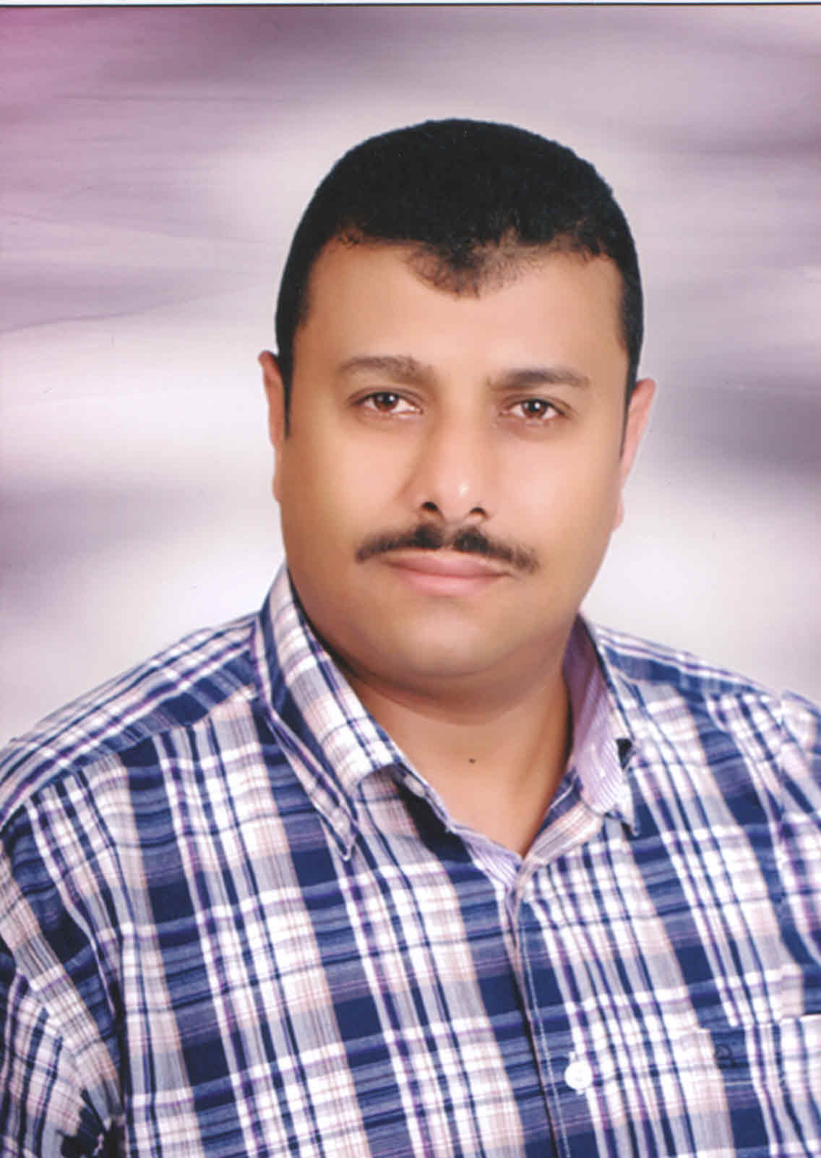

General information

- Name : Ibrahim Abd Elsayed Ibrahim
- Nationality : Egyptian
- Birth date : 26/03/1969.
- Place of birth : Alexandria, Egypt
- Marital status : Married.
- Language : Arabic Mother Tongue
English Fluent
- Military service : Completed
- Phone number : +2033900987
- Mobile number : +201001761281
: +971555490845
- Address : 5, Elrsafa St., Moharam bay,
Alexandria - Egypt

E-mail : ibrahim.bassry@yahoo.com

Professional Education

B. Sc. Electrical / Communications & Electronics 1992.
Alexandria University – Faculty of Engineering.

- Grade : pass.
- Graduation project : digital Communications.
- Project Grade : Very Good.

Professional Experience

June 1998 to date:

Transmission Engineer in Telecom Egypt Company – Alexandria Submarine Cables Stations / Submarine Transmission Department
(Fiber Optics)

Responsibilities:

  - Maintenance of (SDH & WDM) systems of National and International transmission
  - Maintenance of all International Projects (SMW3, FLAG, SMW4, IMEWE, TE NORTH, EIG & ALETAR)
  - Creation & activation of circuits and links through SDH Systems (software & hardware)
  - Troubleshooting of fiber- optic Cables & Equipment
  - Performing Transmission tests on Cables & Equipment.
  - Fiber optics cable (fault location - repair - analyses - maintenance - - span loss improvements

Jan. 2005 to Sep 2011:

Maintenance Transmission Engineer in Etisalat
Work in Dubai & Alex & Abu Dhabi

Jan. 1996 to June 1998:

Electrical Engineer in El Nasr Casting Company (Induction Furnace calibration, Commissioning & maintenance)
(PLC& CNC machines)

March 1993 to Oct. 1995:

Military service

Training

- Training for SMW3 System (WDM) In EGYPT for 1 month
- Training for 10G Up grade of SMW3 System In ALCATEL FRANCE for 1 month ( from July 2002 to Aug. 2002)
- Training for SMW4 System (WDM) In FRANCE for 1 month (from Nov. 2004 to Dec. 2004)
- SLTE Fujitsu Training in EGYPT for 5 Days (from Sep.11 to Sep.15 2005)
- Training for ALCATEL Transmission Equipments

Technical Skills

Hardware:

- PC’s assembly & maintenance.
- Instrumentation troubleshooting.

Software:

- Professional with Win, MS Office.
- Perfect Internet technical support.

Languages:

- Arabic Mother Tongue
- Fluent in English, both spoken and written

Personal Skills:

- Ability to work under pressure.
- Easy to learn.
- Fast to adapt.
- Ability to travel abroad.
- Ability to work in Shifts or on-call basis.
- Ability to work in team.
- Ability to work alone when required.

