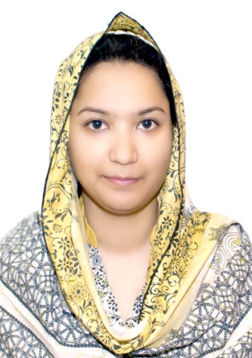
Attia (BSCE)
Attia.13951@2freemail.com

PERSONAL STATEMENT

Efficiently worked as System Administrator (Software) in Alborj Machinery (Sharjah), I gained valuable skill set and experience in networking and database management.

My future goal is to grow professionally, prove myself an asset to the organization with my sincere and dedicated work and get appropriate reward.

PERSONALITY AND ABILITIES
• Problem solving mindset and
 | attention to details
• Learn new technologies quickly
• Honest, Team oriented and friendly

TECHNICAL SKILL SET
• | Auto cad
• | Networking
• | C++
• | MS Office

EMPLOYMENT
System Administrator (Software), Al Borj Machinery (Sharjah) |  | Feb 2015-Till Feb 2016
Responsibilities

- Software development/Feature Enhancements (Save/upload pictures, Change password, Security/access management, System generated receipts/Transfer Letter/Remainders)

- Requirement gathering, propose solution and communicate with MIS department
- Participate in meetings and discuss different solution of a problem
- Testing and debugging
- Maintaining the system once it is up and running
- Support end users
- Documentation of completed tasks and new requirements
- Database management and data analysis (Verification, Analysis and rectification of data)

TEACHING EXPERIENCE

- 1 Plus year teaching experience in institute of Sharjah Excel and Aptech.(Subject Mathematics ,Chemistry, Physics and Auto cad)

Senior Subject Specialist Teacher in School of Professional Studies
Islamabad (SPS) Affiliated Skill Development Council Govt of Pakistan (1 Year Experience)

EDUCATION

BS Electrical Computer Engineering, COMSATS Institute of Information Technology | 2013

INTERESTS

Research and Academic Interests
- Management Information Systems

- Premises Security System

Hobbies
- Reading articles for interior decoration

- Playing badminton

Personal Information:

- Gender Female
- Religion: Islam
- Marital Status: Single
- Nationality: Pakistani

REFERENCES

References will be furnished if requested.

.

