Gulfjobseeker.com CV No: 745710
Mobile +971505905010 / +971504753686

To get contact details of this candidates
Submit request through Feedback Link
http://www.gulfjobseeker.com/feedback/submit_fb.php

Curriculum Vitae

Personal Details
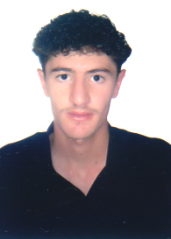
Birthday: 26.10.1984
Gender: Male
Marital status: Single
Nationality: Syrian

Objective
Seeking a position to utilize my abilities in the field of Veterinary Medicine to gain professional growth while being resourceful and innovative.

Education:

A Bachelor in Veterinary Medicine – Al Baath University, Hama, Syria - 2010

Experience:

Daraa Farm of cattle - Syria
- Veterinary treatment of cows.
- Supervision of milk production

Computer Skills

- ICDL
- PC Maintenance ( Hardware, Software )

Languages:

Arabic : Mother Tongue
English: Good

Skills:

- Good communication skills
- Reliable and hard working
- Ability to work under pressure and deadlines
- An absorptive learning capability
- Enthusiastic, self-motivated and a team player with an exceptional drive to achieve results in a competitive, fast-paced business environment.
- Ability to suggest practical solutions

Other Activities & Hobbies

- Reading
- Swimming
- Net Surfing

