curriculum vitae
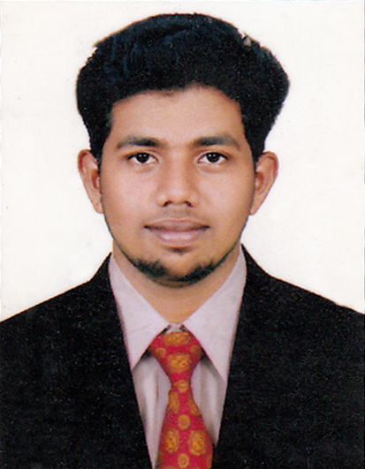

BASIL
DUBAI
Email: basil.130490@2freemail.com

OBJECTIVE

Intend to build a career in a committed and dedicated manner with a leading corporate firm, which will help me to explore myself and realize full my potential, willing to work as a key player in a challenging and creative environment.

PROFESSIONAL STRENGTHS:

More than two year of professional experience in hotel supplies filed

CAREER HISTORY

- ASST:PURCHAISING - METRO HOTEL SUPPLIES DUBAI- 2014-STILL CONTINUE
NATURE OF JOB
- Develop and execute procurement strategies for purchasing of manufactured items and raw materials.
- Plan and implement processes and procedures for company product purchases.
- Analyze vendor quotes and select products from suppliers based on price and quality.
- Negotiate shipping and receiving contracts ensuring on time delivery for critical inventory.
- Work with vendors to expedited delivery and resolving product issues.
- Certify and document products in receiving department in order to verify quantity and accuracy of shipments.
- Review purchasing agreements to find errors, detect commissions, identify price changes and eliminate duplication.
- Authorize and process invoices for automated payment of small high quantity supplies.
- Handle procurement documentation in order to maintain detailed records
- SHOP SUPERVISOR - ECP HOME APPLIANCES PVT. LTD KERALA -2012-2013

ACADAMIC PROFILE

- S.S.L.C 2008-2011 STAR JESUS high school
- PLUS TWO 2011-2013 GOVT. HIGHER SECOUNDERY
- B.COM 2015-2017 madurai kamaraj university

KEY SKILLS

- MS office
- TALLY ERP9
- NET SUFFERING

PERSONAL DETAILS

Name : BASIL
Date of Birth : 03-02-1995
Sex : MALE
Marital Status : SINGLE
Nationality : INDIAN
Religion : CHRISTIAN
Languages known : ENGLISH, HINDI, MALAYALAM,
TAMIL

DECLARATION

I hereby declare that the information given above is true to the best of my knowledge and belief.

