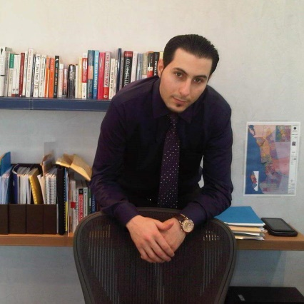 |  | Career Objective  A well-seasoned Industrial Engineer with extensive hands on experience in all associated aspects of Quality Management, business process reengineering, manufacturing operational excellence, six sigma, Enterprise Resource Planning (ERP), complex statistical analysis, and total quality management (TQM).  With 11+ years of practical experience, I am looking for challenging long-term position in a stable and progressive company wherein I can apply my knowledge, experience, and skills.  Professional Experience  QA Unit Head Apr. 2017 – Present  Saudi Bin Ladin Group, (KSA)  Quality Manager, Organization Excellence Feb. 2014 – Mar. 2017  Saudi Enaya cooperative Medical Insurance (KSA)  - Managed the Quality Assurance department and directing improvement initiatives to enhance the quality of service.  - Built the company’s Quality Management System and documenting all process flow and operating procedures.  - Organization transformation from quality to operational excellence.  Organization Excellence Consultant Feb. 2013 – Feb. 2014  Freelancer (KSA)  - Provided management consultancy services in the organization excellence (TQM, Six Sigma, Kaizen, HACCP, etc.).  - Provided training and coaching services in the quality areas.  Senior Business Consultant July 2010 – Feb. 2013  Sermon Business Solutions (KSA)  - Provided business consultancy services in the Supply Chain Management using Microsoft Dynamics AX ERP system.  Quality Assurance Engineer Oct. 2008 – July 2010  Kharafi National (Kuwait)  - Conducted periodic quality audits and prepared audit reports.  - Acted as quality consultant and help desk to assist departments and projects implementing QMS to attain maximum performance.  - Represented Kharafi National in all matters related to quality.  Management Representative for QHSE May 2006 – Oct. 2008  Arab Medical Containers – Pharmaceutical Industry (Jordan)  - Implemented, managed and maintained the quality, health and Safety, and Environmental Management Systems integrated with GMP.  - Implemented manufacturing operational excellence techniques such as lean manufacturing, Kaizen, and six sigma.  - Conducted internal audits covering the scope of all management systems.  Practical Training  Engineering Plastic Industries Aug. 2005 – April 2006  - Trained on the production of plastic pipes and fittings using different plastic forming techniques such as extraction and injection.  - Trained on all aspects of plastic manufacturing quality control and types of physical and chemical tests.  - Trained on plastic manufacturing quality assurance and operational excellence techniques.  Education  Hashemite University Oct. 2001 – Feb. 2006  - Bachelor of Science (B. Sc.) in Industrial Engineering.  knowledge of ISO and industry standards  - ISO 9001: Quality Management System.  - ISO 14001: Environmental Management System.  - OHSAS 18001: Occupational Health and Safety Management System.  - ISO 22001: Food Safety Management System.  - GMP: Good Manufacturing Practices.  - HACCP: Hazard Analysis and Critical Control Points.
Contact Information
Jeddah – Saudi Arabia

Email: alaeddin.135218@2freemail.cm

Personal Information
Nationality: Jordanian
Marital Status: Married
Birth: Amman, 15th Sep. 1983
Saudi Residency : Transferable IQAMA

Professional Certificates
Certified Six Sigma Black Belt
Professional Certified Trainer
Certified Quality Auditor
Certified HACCP Auditor
Certified Business Professional

IT Skills
Microsoft Office
Microsoft Dynamics AX ERP
Microsoft CRM and SharePoint
Minitab
SPSS

General Skills
Fluent in English Language
Professional presentation skills
Professional team management
Professional training skills

References available upon request

