EDWIN SANTHOSH GEORGE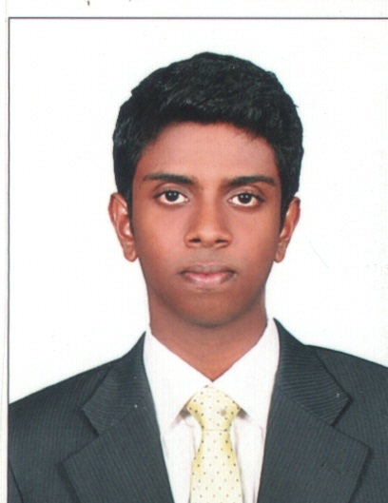
P.O Box 46625, Abu Dhabi
e-mail: edwinsanthosh123@gmail.com
Abu Dhabi: 056-4830093

Position applied for Assistant Project Management staff in Shipping/Sales/Tendering Departments

PROFILE

Creative, enthusiastic and resourceful Project Management graduate from the Bedfordshire University, UK. Experienced in recording accounting transactions, event management and fundraising events. Eager to undertake challenges and achieve goals by taking initiative and applying creative and innovative ideas. Strong communication and leadership skills combined with flexibility in team working.

EDUCATION

MSc in Project Management 02/2013 - 05/2014
University of Bedfordshire
Luton, UK

Modules: Project entrepreneurship, financial analysis, Human resources management, Contract and procurement, Risk and quality management

Bachelors in Commerce 06/2009 - 05/2012
Mahatma Gandhi University
Kerala, India

Modules: Business communication, Marketing management, Advertising, Corporate accounting, E-commerce, Management information systems

EXPERIENCE

Internship- Customer service

University of Bedfordshire

Luton, UK

- Developed and achieved an excellent customer service skill by understanding the issues and causes of the students and directing them to the right sections.
- Gradually developed a skill to analyze the issues of different students that came to the information desk and was able to provide the right information in financial and in other mitigation services.
- Was able to make a good relationship with the staff members and also guided the other junior interns in the Bedfordshire University.

Crew member 10/2013 - 07/2014

Burger King

Stevenage, UK

- Delivering a high quality of services even when working under pressure, dealing with cash transactions with accuracy and speed
- Gained and demonstrated excellent customer service skill by maintaining friendly relations with the customers
- Was able to identify the issues that were pertaining in dealing with the customer feedback and complaints.

Administration and Fundraising Assistant (Volunteer) 05/2013

Luton Carnival

Luton, UK

- Developed administration experience as an assistant by recording some of the preliminary transactions and providing customer services.
- As a part of the project, I was involved in the fundraising activity for the Revellers band, supporting their performance in the Luton Carnival. Conducted events and managed to raise £600.
- Gained people management skills by managing the crowd in the carnival.

Secretary 02/2010 - 03/2012

Cochin College

India

- Designed and maintained the college’s social media pages as a communication bridge between the staff and the students.
- Took the initiative to use social media to successfully promote events and trips organized by the college.
- Liaised with Art students and local events’ makers to conduct events and to collect entries.

SKILLS

Technical skills

- Certified in European computer driving license (ECDL), UK 01/2014
- Higher Diploma in Systems and Networking, India 09/2012
- Certified in N+ Network technician, India 02/2009
- Certified in A+ PC technician, India 02/2009
- Certified in Programming using C++, India 08/2008

Teamwork and Leadership

- As a secretary of the college I worked effectively in the Arts team, organizing events and ensuring the efficient running of the college team.
- As a team leader of the project team in college, I was responsible for making the relevant updates to our project and informing the team members. I was able to work effectively in our team and motivate everyone contribute their best; as a result, we were awarded a B+ grade for the team project.

Time Management

- I have successfully organized my time to complete all my assignments and group work at the right time through proper management. In the spare time I was also able to engage in the arts team and volunteer in various events.
- I also took the initiative as a team leader to ensure that all my group members have met their submission deadline for their assignments and for our group work.

INTERESTS

- Music: Interested in playing guitar; performing with the band in fundraising events

- Sport: Active player in football team, interacting and cooperating with people from various parts of the world.

PERSONAL DETAILS

- Date of Birth : 27/03/1991
- Martial status: Single
- Gender : Male
- Nationality : Indian
- Languages Known: English, Malayalam, Hindi
PASSPORT DETAILS
- Passport number : J5238707
- Passport Expiry date : 18 May 2021
- Visa status : Currently on visiting visa expiring on 18/12/2014
DRIVING LICENCE
- Holding Indian Light vehicle driving license with More than 5 years driving experience in India.

