Curriculum Vitae
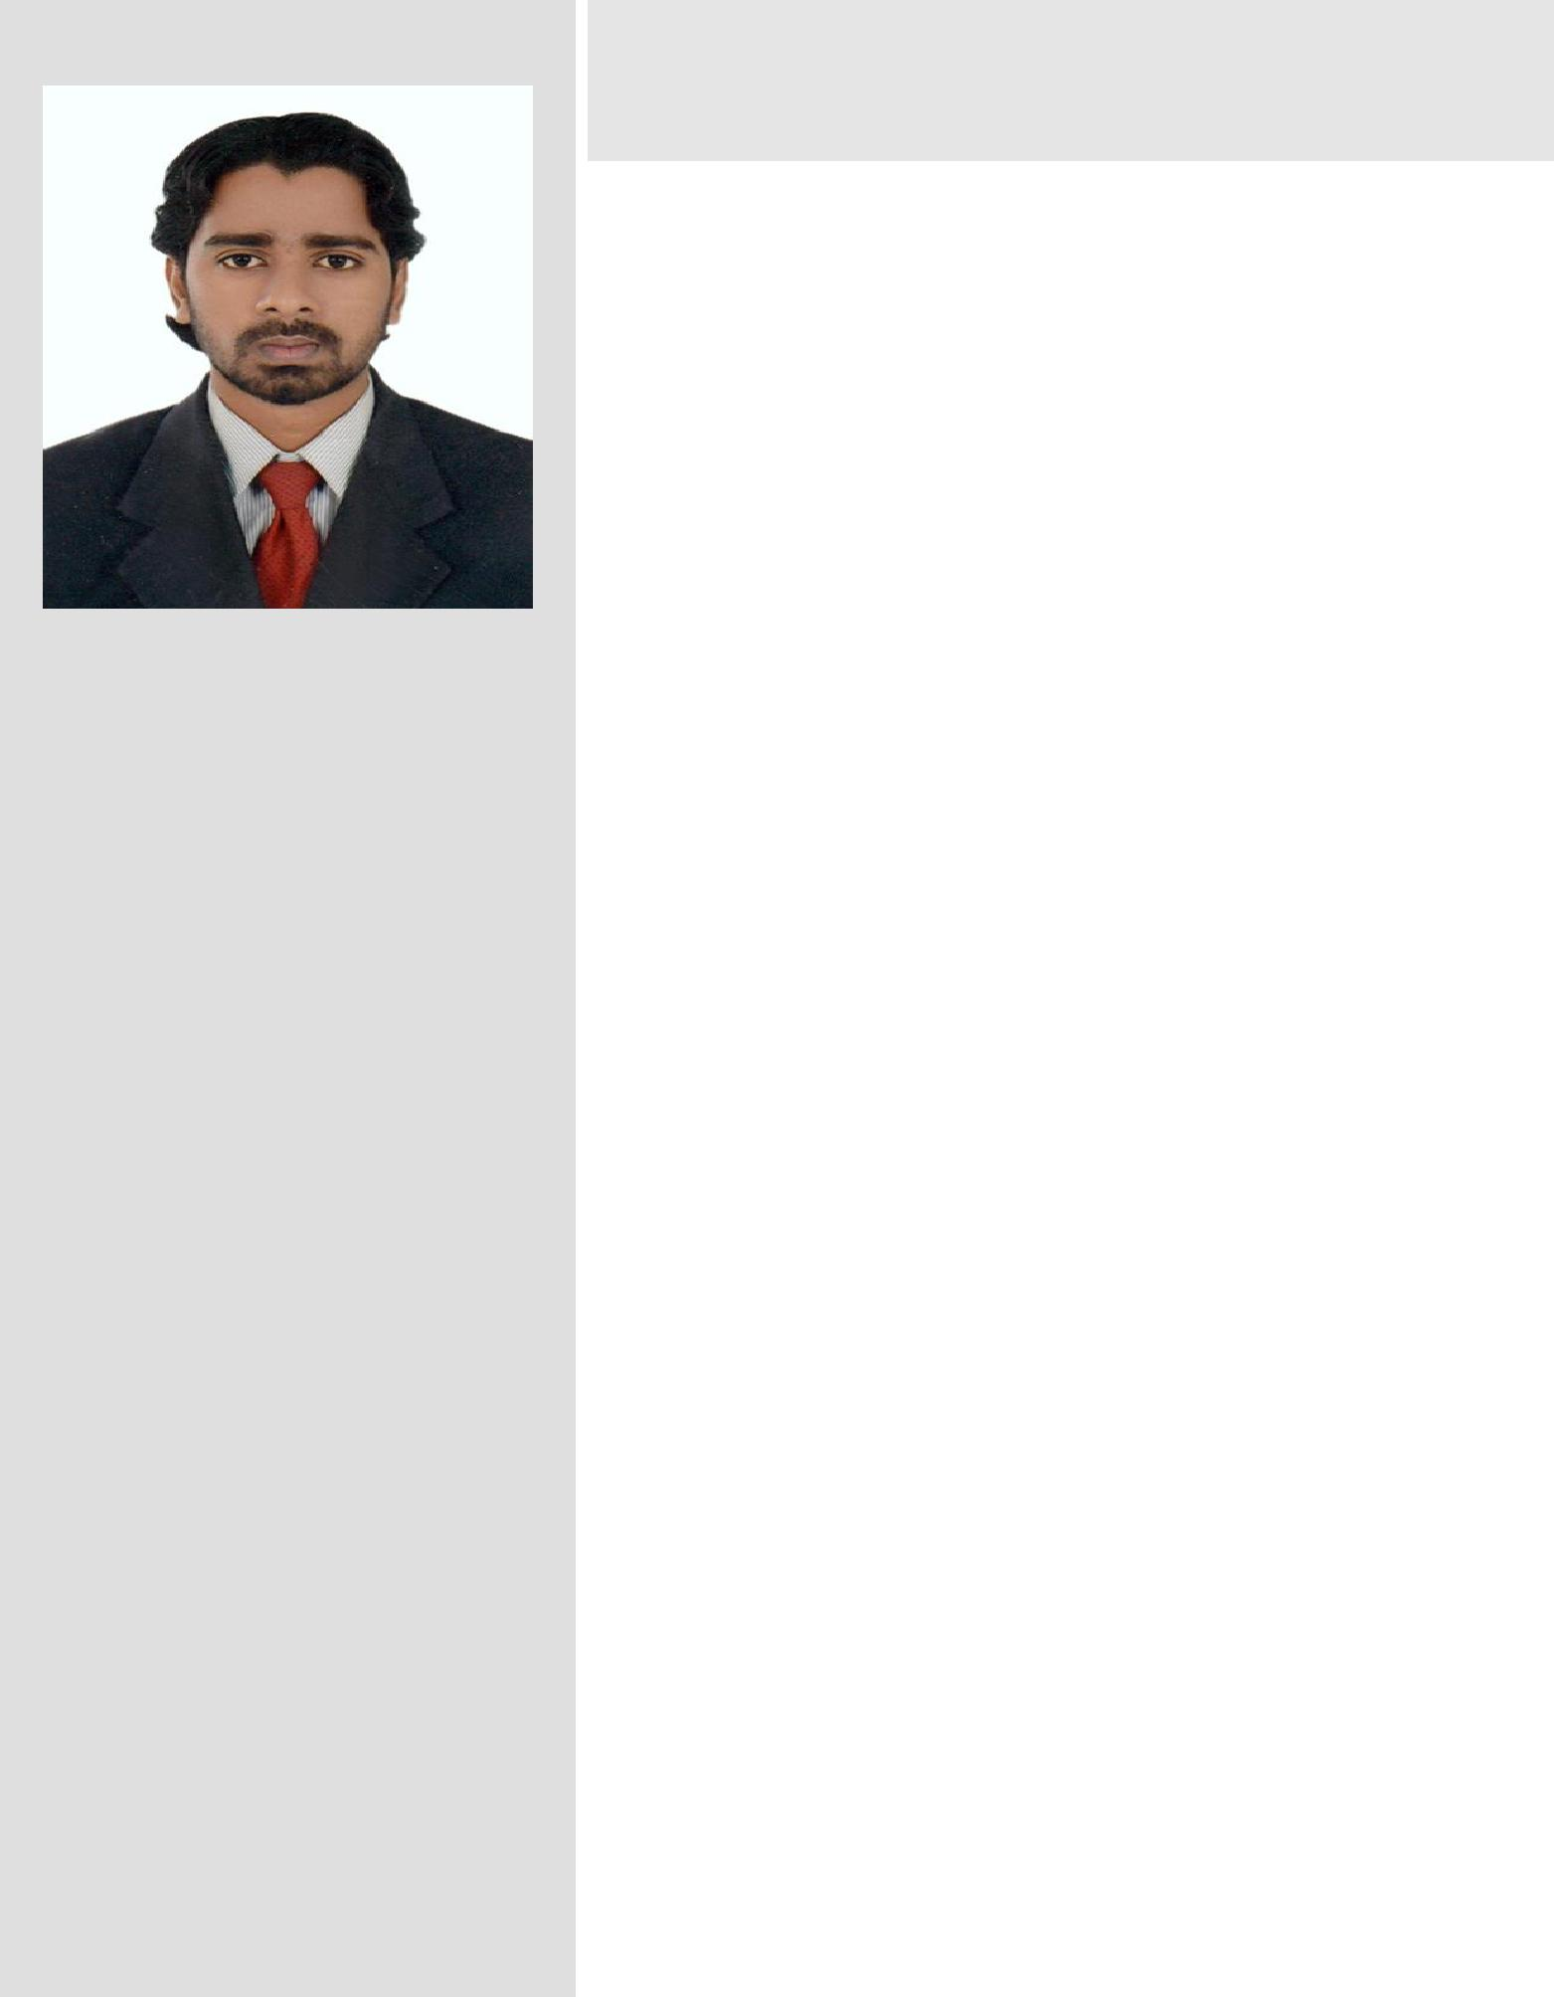

NAME
KEATS FELIX

Experience:

An astute performer with nearly 5 years of experience in B.P.O.IT field in Technopark.

Address:
Puthuval house,

Menamkulam,
Kazhakuttom p.o
Trivandrum,
Kerala,

India.
Pin :695582

Phone Number: 971-0559686459.

E-Mail: :rm.keatsfelix@gmail.com

Career Objectives
To work in a challenging environment which demands constant development of fresh skills and the maximum utilization of the existing skills.
Education
Graduation in B.A.
Pre Degree in Science.
Diploma in Animation.
SSlc.
Computer Knowledge
- MS Office,Autocad,Photoshop,Premiere.

- Data Entry Operation.

- B.P.O.

Professional Experience
BPO(data analyst) WORK IN REVENUEMED, TECHNOPARK..

Job Responsibilities
- Handling the recruitment activities.

- Processing the data required for the Performance

Based Incentives.

CAREER OBJECTIVE

To work in a healthy, innovative and challenging environment extracting the best out of me, which is conducive to learn and grow at professional as well as personal level thereby directing my future endeavors as an asset to the organization.

Page 1 of 2

Personal Data:
NAME | : KEATS FELIX
FATHER’S NAME | : FELIX PEREIRA
MOTHER TOUNGE | : MALAYALAM
CASTE & RELIGION | : CHRISTIAN

ADDRESS:Omanahouse,menamkulam,
kazhakuttom.P.o,

695582.

HOBBIES
ListeningMusic,Drawing,PlayingPCgames&

Reading.

LANGUAGES KNOWN :English, Hindi
and Malayalam.

Date of Birth | : 26-11-1987
Sex | : Male
Nationality | : INDIAN
Marital Status | : SINGLE
Extracurricular

➢ Video editing ,Data analyst.

Date :03-03-2014
Place :kazhakkuttom.

REFERENCE

Available upon request.

MINI PROJECT

B.P.O Work. Data capturing and editing .Non voice .

SKILL SETS

- Filled with passion and the ability to connect with team leaders.

- Team building experience.
- Ability to inspire people.

- Needs assessment.

- Knowledge of Data processing techniques.
- Can create courteous, friendly, professional work environment.

- Ability to evaluate alternatives and decide on a plan of action.

DECLARATION

I here by declare that all the above mentioned details are true and with best of my knowledge.

Page 2 of 2

