LISI VIJEESH
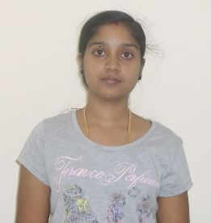Email: lisimp75@gmail.com
Contact No : 050 845 6621 , 050 802 8241.

OBJECTIVE

To be in a position within an organization where my ideas, inputs and level of responsibility are important to the direction, growth and success of the firm as well as to develop my technical, analytical, leadership and strong academic skills to achieve heights of excellence in professional career.

EDUCATIONAL QUALIFICATION

Diploma in Computer Engineering.
(2010-2013 ) from Govt. of Kerala State Board of Tech. Education , India.

TECHNICAL SKILLS

Tools & Packages : C, C++, Java ,SQL ,HTML ,Java Script, PHP, Tally 9,QuickBooks

.

MY STRENGTHS

- Flexible and adaptable nature.
- Honest and dedicated towards work.

PERSONAL DETAILS

Gender : Female

Marital Status : Married

Nationality : Indian

Date of Birth : 06th November 1992

Passport Number : L 9376076

Visa Status : Husband Visa ( Valid up to 24/08/2016 )

Languages Known : English, Hindi and Malayalam.

DECLARATION

I do hereby declare that all the particulars of information and facts stated above are true correct and complete to the best of my knowledge and belief.

LISI VIJEESH

