RESUME

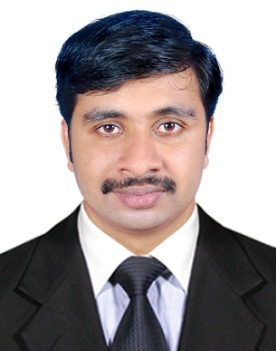
PHELIX MATHEW
Mobile No: +971569508407
+971502738905
E-mail:phelixdbc@gmail.com

Career Objective

Seeking a position as an Accountant where my experience and accounting skills will be further developed and utilized.
Career Summery

Worked as a Accountant with Brilliance College Pathanamthitta, from 1 June- 2013 to 20-
August-2014

Job Responsibilities: analysis and interpret financial statement, Clearing up
Misunderstanding, Prepare monthly report ,Book keeping.
Auditing accounting records such as daily account book, monthly
accounts ,prepare all assets details, calculate profit&loss account

Academic Profile

M.com (Finance& Control), from CMS. College Coimbatoor, BHARATHIAR UNIVERSITY.

Includes
- Cost accounting
- Management accounting
- Financial accounting
- Advanced accounting
- Managerial accounting
- Corporate accounting
- Functional management
- Banking and financial services
- Profitability and liquidity
- Book-keeping
- Ratios
- Auditing
- Direct and Indirect tax
- Business and company law
- Tally& Ecommerce
- Business statistics
Computer Proficiency

- Microsoft Office: Word, Excel, PowerPoint and Internet.
- Languages : C,BASIC JAVA,VB,SQL
- Computer accounting : TALLY
Key Strengths

- keeping accurate financial records
- Organization skill
- Knowledge in Bank reconciliation Statement
- Good in Journal Ledger and Voucher
- Good Communication and Presentation Skills
- Commitment to work
- Adaptability in performing work with changing priorities
- Good leadership Skills
- Analysis and interpret

Projects undertaken

- Project on “liquidity and profitability analysis “ in Western India plywood
- Mini Project on Thondernadu Service Co-Operative Bank Limited.

Achievements & Extra- curricular Activities

- Worked with NSS at Don Bosco College Angadikadavu.
- Worked as a leader representative of social activities in college.
- Represented in College Cricket team
- Comparer for major programmes conducted in the college
- Worked as a UUC OF Kannur university

Personal Profile

Date of Birth : 06-06-1990
Languages Known : English, Malayalam and Tamil
Visa Status : On Visit Visa
Passport Number : K8895159
Passport Expiry : 03/01/2023
Hobbies : Music, Travelling, Cricket

Declaration

. I hereby declare that the above-mentioned information is correct up to the best of my knowledge and I bear the responsibility for the correctness of the above-mentioned particulars.

Date:

Place:
(Phelix Mathew)

