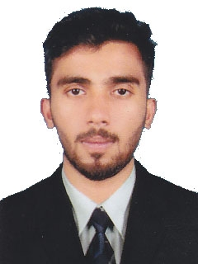

THASLEEM
B-E Mechanical Engineer
E-mail: thasleem.144180@2freemail.com

OBJECTIVE

To work in a firm with a professional work driven environment where I can utilize and apply my knowledge & skills which would enable me as a fresh graduate to grow while fulfilling organizational goals.

PROFESSIONAL QUALIFICATION

- Bachelor of Technology (B.E) in Mechanical Engineering (2015), from Visvesvaraya Technological University Belgham, India.

- Higher Secondary (2010), from B Y K VHSS Valavannur, Kerela.

SOFTWARE SKILLS

- Designing : Solid Edge V20, Auto Cad
- Analysis : ANSYS 11.0
- Others : CNC MILL, CNC TURN
- Operating system : Windows XP, Vista, Windows 7, Windows 8, Ubuntu
- Package : Ms Office

PERSONAL SKILLS AND STRENGTHS

- Good communication skills.
- Ability to learn and support new applications and systems.
- Optimism, Confidence, Leadership, Responsible and Adaptability.
- Amiable and Amicable nature.
- Zeal to learn emerging Technologies.

ACADEMIC PROJECTS AND SEMINAR

Main project title:
CFD Analysis for the cooling vent in Automobile
Over view of project: The main Objective of the Project is to improve the cooling inside the cabin of vehicle. It’s done by analysis of the air flow and Temperature distribution across the each vent inside the cabin. Soin order to obtain the better cooling vents are positioned at different levels, and the analysis is done by the CFD software which is used for simulating fluid behaviour which gives the results across each vents. Hence the better position of vents are selected which gives better cooling.

Seminar title:
“Design & Analysis on Scramjet Engine Inlet”

Over view of seminar: The objective of seminar is to analyze the performance of the scramjet jet engine which works at extremely high speed. Also discuss about the design of the engine where the design of scramjet engine plays a major role in the performance.

LANGUAGES KNOWN

- English (Read, Write and Converse)
- Hindi (Read, Write and Converse)
- Arabic (Read and Write)
- Malayalam (Read, Write and Converse)
- Tamil (Converse)
- Kannada (Converse)

PERSONAL INFORMATION

Date of Birth : 17 Aug1992
Marital Status : Single
Nationality : Indian
Passport Detail : Exp:29-10-2020

DECLARATION

I, Thasleem, hereby declare that all the details furnished above are true to the best of my knowledge.
Thasleem

