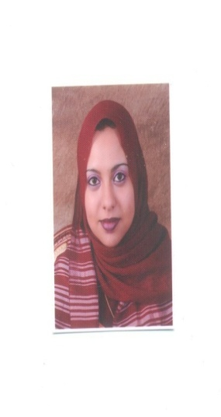

Gulfjobseeker.com CV No: 866448
Mobile +971505905010 / +971504753686

To get contact details of this candidates
Submit request through Feedback Link
http://www.gulfjobseeker.com/feedback/submit_fb.php

DATE OF BIRTH: 16 Oct, 1979

NATIONALITY: Sudanese

SOCIAL STATUS: Married

VISA STATUS : Resident Visa (Sponsor Husband)

ADDITION: Own an Americans Green Card.

EDUCATION:

B.Sc. Degree in Pharmacy, Graduated from SINDH University-Hyderabad, Pakistan (2003)

MBA Major in Marketing from American University of London (2007).

LICENSES:

1- M.O.H United Arab Emirates License.

2- M.O.H Saudi Arabia License.

3- M.O.H Sudanese License

EXPERIENCE:

22 September 2011 to 22 March 2012
Arabian Home Pharmacy,
Abu Dhabi, UAE

Job title: Pharmacist

Job description:

-Dispense drug for patients.
-Promote sale of medical equipments.
-Arrange and checking of expired medicine
-Issue purchase order for new medicines from suppliers
-Making list of medicines in “Excel” program sheet for sale of medicines.

1 April 2008 to 1 May 2010
Abbott Nutrition,
Abha - KSA.

Job title: Medical Representative

Job description:

-Sales promotion for nutrition products in hospital, poly clinics, pharmacies.
-Responsible for marketing and leading the team on sales promotion outside country.
-Arranging conference and meeting for doctors and nurses.

1 May 2005 to 1 March 2008
Gulf Medical Company,
Abha - KSA.

Job title: Medical Representative

Job description:

-Sales promotion of medical products.
-Sales promotion of medicines.
-Preparing list of doctors for sponsoring outside to attend medical conferences.

29 April 2003 to 27 April 2005
Al-Ahli Pharmacy
Abu Dhabi, UAE
.

Job title: Pharmacist

Job description:

-Dispense drug for patients.
-Promote sale of medical equipments.
-Arrange and checking of expired medicine
-Issue purchase order for new medicines from suppliers
-Making list of medicines in “Excel” program sheet for sale of medicines.

COMPUTER SKILLS:

-Well versed in Microsoft office, Word processing, Power point presentations and “Excel” program operation.

PERSONAL SKILLS:

Team works skills, welling to motivate, inspiration, creativity and ability to direct deal with patient and counseling skills, good knowledge of medicines (their indications, contraindication, and side effect, possible Interaction and Patient instructions).

LANGUAGE:

Arabic: Mother's Tongue.

English: Fluent.

Urdu: Fair.

