Gulfjobseeker.com CV No: 870438
Mobile +971505905010 cvdatabase[@]gulfjobseeker.com

To contact this candidate use this link
http://www.gulfjobseeker.com/feedback/contactjs.php

Objective
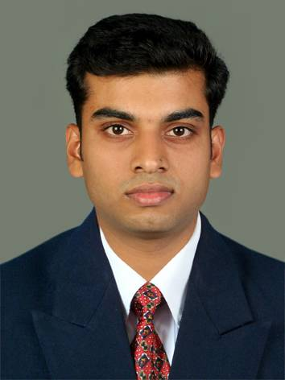
Personal details:
Date of Birth : 14th October 1986
Sex : Male
Nationality : Indian
Religion : Christian
Marital status : Single
Hobbies : Drawing, painting,
Reading

Languages known : English, Hindi, Tamil
and Malayalam

4
To be an eminent person in Pharmaceutical field where all of my knowledge and capabilities can be utilized and honed to ensure my performance meets or exceeds both personal and organizational targets.

Educational Profile

Qualification | Institution | University / Board | Medium of Instruction | Year of Passing | %
M. Pharm*  (Pharmacology) | Sri Ramakrishna Institute of Paramedical Sciences | The Tamil Nadu Dr. M. G. R. Medical University, Chennai | English | 2012 | 77.16
B. Pharm | Pushpagiri College Of Pharmacy, Thiruvalla | Mahatma Gandhi University, Kottayam | English | 2009 | 73.18
H.S.E  (Class XII) | S. N. D. P.H. S. S, Udayamperoor | Board of Higher Secondary Examination | English | 2004 | 81.33
S. S. L. C | Hail Mary E.M R.H.S, Perumpally | Government of Kerala | English | 2002 | 91.50
* - Waiting for II year result

Personal skills
- Consistent academic records throughout my education.
- Empathy, creativity & patience.
- An initiator with the ability to interact in a team
- Good organizational, planning and analytical skills with

comprehensive problem solving & managing abilities.
- Quick to learn and adapt to practical aspects & principles.
- Good communication skills.
- Interested in research activities.

Projects

M. Pharm : Evaluation of in vitro cholinesterase inhibitory activities and their kinetic studies in some selected Indian medicinal plants
Mini project : Computational evidence for the inhibition of acetylcholinesterase and butyrylcholinesterase by terpenoids and flavonoids from some selected Indian medicinal plants for Alzheimer treatment.
Industrial training : Quality control in spice and food industry – A report based on training at Synthite Industries Limited.
B. Pharm : Drug Delivery to Brain.

Training and exposure

- Has got training in the Quality Assurance/ Quality Control department of Synthite Industries Limited, Kolenchery, from 21st April 2010 to 21st May 2010.
- Has attended continuing education programme for pharmacy professionals, conducted by Pharmacy Council of the State of Kerala on 6th May 2010.
- Has worked as Trainee Pharmacist in Mediland Drug House, Tripunithura, from 24th May 2010 to 23rd July 2010.

Seminars attended

- National Conference on ‘Preclinical and Clinical Challenges in Drug Discovery’, held at, KMCH College of Pharmacy, Coimbatore, Tamil Nadu. (2011)
- National Seminar on ‘Phytonutraceuticals, Pharmacovigilance, CADD and Drug Development’, held at, Pushpagiri College of Pharmacy, Thiruvalla, Kerala. (2011)
- Seminar on ‘Emerging Frontiers and Challenges Ahead in Pharmaceutical Biotechnology’, held at, College of Pharmacy, SRIPMS, Coimbatore, Tamil Nadu. (2011)
- National Seminar on ‘Novel Approaches of Modern Analytical Techniques in Standardisation and Bioestimation of Herbal Drugs’, held at, College of Pharmacy, SRIPMS, Coimbatore, Tamil Nadu. (2011)
- 63rd Indian Pharmaceutical Congress, organized by Indian Pharmaceutical Congress Association, held at Bangalore International Exhibition Centre, Bengaluru.(2011)

Activities and Achievements

- Participant of 3rd State Pharmakalotsav, ‘Phasara 2006’, held at Dept. of Pharmaceutical Sciences, M. G. University, Kottayam.
- Winner of English Essay Writing Competition and Pencil Sketching Competition conducted during the 49th National Pharmacy Week Celebration 2010.
- Winner of Pencil Sketching Competition and PowerPoint Competition conducted during the 50th National Pharmacy Week Celebration 2011.
- Co-ordinator and participant of many arts, sport and science functions in college.
Practical skills

- Isolated Tissue Studies
- Basic Pharmacological Screening Techniques
- In silico docking studies
- DNA- gel electrophoresis
- UV-Visible Spectrophotometry
- Spectrofluorimetry
- High performance liquid chromatography
- Gas chromatography
Computer knowledge

  - Operating system : Windows
  - Other packages : Microsoft Office, AutoDock 4.2, ExPharm 2.0.0, Anaesthetised Cat V2.5.6, Rat Cardiovascular System V3.2.8, Abby fine reader 9.0.

Declaration

I do here by declare that the above stated particulars are true, complete and correct to the best of my knowledge.

