Gulfjobseeker.com CV No: 874254
Mobile +971505905010 / +971504753686

To get contact details of this candidates
Submit request through Feedback Link
http://www.gulfjobseeker.com/feedback/submit_fb.php
[Bilal Munir]
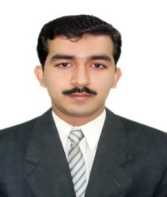
Date of Birth : 16 June 1985
Religion : Islam
Domicile : Peshawar
Marital Status : Married
Languages : Urdu, English, Pashto
Education : S.Sc (2000)
F.Sc (2002)
B.Sc (2004) Graduation from Peshawar University.
Objective
 | Seeking a challenging and rewarding position in a rapidly growing organization. Analytical team skills and able to work effectively and efficiently in a team with the ability to manage at all level.
Technical Skills/Proficiencies
- 1 Year Diploma in Advance MS Office.
- Networking LAN & WAN, Routers, Switches.
- Managerial Skills, I.T Professional, Administrator
- SQL, C++, MS Access. Oracle Database experience.
- Troubleshooting, Installation of All kind of Windows.
 |  | - More than 6 Year Experience of Selling Scientific Products. ( e.g Life saving drugs)
 |  | - Consistently achieved all the Year above YTD.
Experience
- Presently working in (SANOFI AVENTIS Pharmaceutical Company) since May, 2007.
- ATCO Pharmaceutical Company for 8 Months Sep 2006.

Awards/Accomplishments
 |  | [Upon National Highest YTD of 2010 Achievement I Received a Brand New Car in my Company] | [January 2011]

