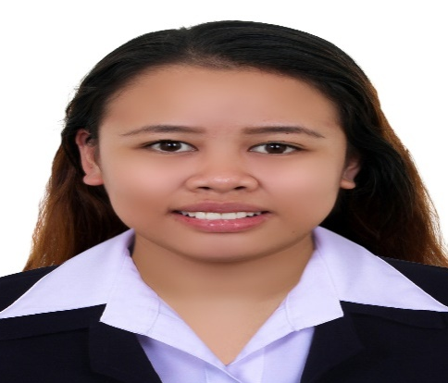

Ma. Niña
Email Add. : nina.148763@2freemaiul.com

Objectives : Bachelor's Degree in Business Administration holder and One year of experience in tellering. Wishing to leverage my experience to fill any of the position offered in your company.

Personal Information
Birth Date : September 06,1995
Place of Birth : Bacolod City, Philippines
Age : 21 yrs. Old
Religion : Protestant
Nationality : Filipino
Special Skills : Computer Literate (Microsoft Word, Excel PowerPoint)

Education

College: Colegio de Sta Rita de San Carlos Inc. ( 2012-2016 )
San Carlos City, Negros Occidental, Philippines
Course : Bachelor of Science in Business Administration
Major in Financial Management
Experience

On-The-Job Trainee :
Social Security System, San Carlos ( October – January )
Assist with mailings and Screen phone calls .
Assist the members in some inquiries .
Assist the employees in filing and organizing important documents.
Encoding and Organizing files .
Work Experience :
Planta Centro Hotels and Residences (F & B Cashier July 2016 –July 2017 )
Provide information about food queries .
Process customer bills in both restaurant and functions.
Full knowledge in point of sale system.
Customer service , sales and communication skills.

