RESUME

Ramish.149214@2freemail.com

RAMISH
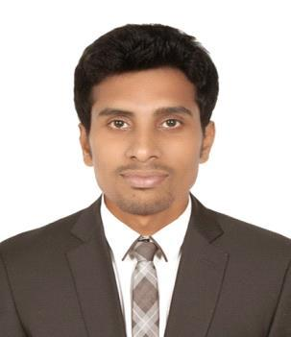

Nationality:

Indian

Gender:

Male

Marital Status:

Married

Languages Known:

English, Tamil, Malayalam,

Hindi

Hobbies:

Games, Internet, Watching gags

References:

Will be provided upon request

CAREER OBJECTIVES

Intend to structure my growth in pace with the ever-changing corporate environment. Make my learning curve to move in a linear fashion along with the growth of my functional skills coupled with overall personality development in order to face the challenging times ahead.

EDUCATIONAL QUALIFICATION
- BACHELOR OF BUSINESS ADMINISTRATION (BBA)

MS University - 2007

- VISUAL MEDIA

Chennai film school -2010

PROFESSIONAL EXPERTISE:

Customer Relation, Customer Service, Office administration, Assistance with HR, PRO, Interpersonal Skills, Leadership Skills, Ability to work under Pressure. Good Verbal & Written Communication, Strong Administrative skills.

PROFESSIONAL WORK EXPERIENCE (3 years)

Worked as Administrator in Pragathi and Skyler’s at alain road, Dubai, UAE

- Deal directly with customers Monitoring cash transactions and answer guest enquiry calls

- Arranging corporate calls to brings new customer and book party reservation and achieve target

- Making corporate sales agreements with corporate clients for usage of the facility (Parties & Health Club activities and achieve target.

- Administrate Corporate channel payment collection team to collect payment for parties

- Sale / Promote products to customer(including offer deal, choice of product)

- Constantly seeking new opportunities to improve and update knowledge about products & services

- Organize product demonstration and presentations for customer to bring bulk orders

- Responsible for Monthly report for home office

- Handle and resolve customer complaints and achieve target

- Obtain and evaluate information about products and Merchant food product through corporate line

- Maintain healthy report with customers and making strong relation with them to bring business

- Sustaining the cordial relationship with customers and receive rewards through business channel.

Technical Skills

- Expertise in MS-Office (Office Automation Package)

- Internet & E-mail

Personal Skills

- Good communication skills

- Able to get along well with others

- Self-confident and optimistic

- Systemic approach to situations

- Quick learner
MORE EXPERIENCE

- Sales and Marketing

- Store Keeping

- Office Assistant

- Media Network Systems

- Insurance and Market Strategy

- Participated in International F & B Service

- Sales Assistant

- Security Guard Service

- FNB Supervisor

TV & MEDIA

- Worked as an Naalaiya Iyakunar Kalaingar TV

- Vijay awards program management in Vijay TV

- Assistant director in super singer Vijay TV

- Anchor-person in why this kolavery show in Z-Tamil TV

DECLARATION

I, Mohammed Ramish M do hereby state that the information given above are true and correct to the best of my knowledge, information and belief.

RAMISH

