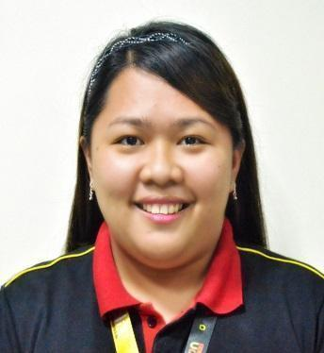
Laura

Laura.149245@2freemail.com

CAREER OBJECTIVE

To be able to contribute my positive and professional learning's in the achievement of corporation goals, and to grow more with confidence in adapting to new tasks & career-oriented working environment.

WORK EXPERIENCE

Office Staff - Aug.2016 - May 2017
Capricci Hospitality & Food Services

Near KFC, Aziz Petrol Station
Salwa Road, Doha – Qatar

Duties and Responsibilities:

- Assisted in the day-to-day operations of the Office functions and duties.

  - Provided clerical and administrative support to Human Resources executives;

  - Ensured proper and satisfactory operations of the computerized document management system at all stages;

  - Compiled and updated employee records (hard and soft copies);

  - Processed documentation and prepared reports relating to personnel activities (staffing, recruitment, training, grievances, performance evaluations etc.);
  - Coordinated HR projects (meetings, training, surveys etc.) and

took minutes of the meetings;

- Dealt with employee requests regarding human resources issues, rules, and regulations; and

- Assisted in payroll preparation by providing relevant data
(absences, bonus, leaves, etc).

- Maintenance and archiving of all internal and external documents and documentation;

  - Received files and maintained records (incoming/outgoing letters and faxes).
- Kept confidential agreements and documents.

- Handled office routine items.

- Communicated public services when necessary.

  - Properly handled complaints and grievance procedures;
  - Conducted initial orientation to newly hired employees; and
  - Provided supervision and job trainings to new employees.

Human Resource Officer - Oct. 2015 - Feb. 2016

Cagayan 168 Corporation
Corner Guillermo-Yacapin Street

Cagayan de Oro City, Philippines

Warehouse Supervisor - June. 2015 - Sept2015

Cagayan 168 Corporation
Corner Guillermo-Yacapin Street

Cagayan de Oro City, Philippines

Link Recon Associate - June 2014 - May 2015

RedLemon Digital Media
2nd floor, St. Gregory Building,

6th-17th Street, Nazareth, Cagayan de Oro City, Philippines

Cahier/SalesLady - Nov. 2013 – May 2014 Robinsons Supermarket
Lim Kit Kai Mall, Cagayan de Oro City, Philippines

Internship –Cagayan de Oro College - April 2013 - Aug. 2013 PHINMA Education Network
Max Suniel St. Carmen, Cagayan de Oro City, Philippines

EDUCATIONAL BACKGROUND

Graduate of
BACHELOR OF SCIENCE IN INFORMATION TECHNOLOGY - BSIT
Major in Web Development

Cagayan de Oro College-PHINMA Education Network Max Suniel St. Carmen, Cagayan de Oro City

Year Graduated: 2014

PERSONAL STRENGTHS

- Punctual, fast learner, and work well with others;

- Good communication skills (both written and oral);

- Good time management skills;
- Works with compassion and commitment;
- Dedicated and a goal-oriented professional;

- Admirable attitude in teamwork;
- Great sense of concern;

- Diligent and reliable;
- With integrity and honesty; and
- Very flexible with excellent time management.

PROFILE
Birth Place | : | MalayBalay City, Bukidnon, Philippines
Gender | : | Female
Marital Status | : | Single
Nationality | : | Filipino

CHARACTER REFERENCE

Saeed AlShamsi

Business Development Manager Bin Hamoudah Group +971-559070631

I hereby attest that the information given above is true and valid.

LAURA
Applicant

