CURRICULUM VITAE
PERSONAL DETAILS:
Catherine.149321@2freemail.com

NAME: CATHERINE
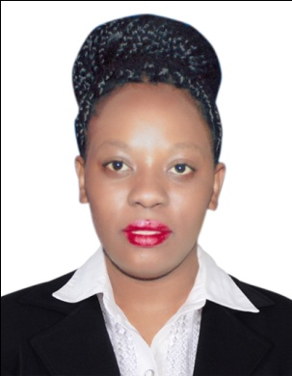
GENDER: FEMALE
NATIONALITY: KENYAN
MARITAL STATUS: SINGLE
RELIGION CHRISTIAN
LANGUAGES: ENGLISH SWAHILI ARABIC
VISA STATUS: VISIT VISA

PROFESSIONAL SUMMARY: ambitious and creative Barista with 3 years hands-on experience in coffee making and brewing. Substantial knowledge of various coffee types and their characteristics. Track record of increasing the ration of returning clients through friendly and warm customer service. Very punctual individual who has a neat and tidy appearance.

CORE COMPETENCE
- Coffee beans types and features
- Espresso Blends
- Coffee Brewing
- Latte Art
- Communication and Customer Service

PERSONAL ATTRIBUTES
- EXCELLENT COMMUNICATION SKILLS
- DEDICATED TO WORK AND TRUSTWORTHY
- RELIABILITY AND FLEXIBILITY IN TIME SCHEDULE
- FAST LEARNER AND READY TO TAKE UP NEW CHALLENGE

WORKING EXPERIENCE
JAN 2017- JUNE JAVA COFFE SHOP
POSITION BARISTA
2015 – 2016 BIG SQUARE RESTAURANT
POSITION BARISTA
2013 – 2014 WESTON HOTEL
POSITION WAITRESS
PROFESSIONAL EXPERIENCE
- Note orders and serve coffee, food and beverages to guests in a timely fashion.
- Make coffee using a number of brewing methods such as pour over, espresso and cold brew.
- Open and close the coffee station.
- Assist in menu setting and determining coffee of the week regularly.
- Communicate with customers, note their preferences and take feedback.
- Maintain cleanness of counter and bar.
PROFESSIONAL BACKGROUND
2014 AUG-SEP BARISTA PRO.
ATTAINED CERTIFICATE IN PROFESSIONAL BARISTA SKILLS
MAY 2003- MARCH 2005 UNIVERSITY OF NAIROBI
ATTAINED DIPLOMA IN HOTEL MANAGEMENT

SKILLS ACHIEVED
- LEADERSHIP
- TIME MANAGEMENT
- PROBLEM SOLVING SKILLS
- TEAM WORK PLAYER

HOBBIES
- SOCIALIZING
- TRAVELLING

