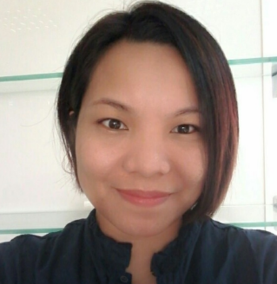

Glenda

Email Add.: Glenda.150124@2freemail.com

Objective:

I am seeking a Teacher Assistant position in a Child friendly Educational Institution to bring my dedication and passion for children’s development to the teaching role in order to enhance learning experience and mold their self- esteem. To be able to support the lead teacher using skills in managing school activities and perform secretarial tasks to create an effective and healthy classroom environment.

Summary of Qualifications:

High level of patience and love for teaching children
Excellent ability to understand children’s psychology and plan teaching materials.
Skilled in developing fun and learning activities for children

Technical Skills:
Office Equipment: Fax machines, photocopiers and general office equipment
MS Office: Word and excel

Work Experiences:

NAZIH Group/ Education Center
Dubai, UAE
Office Assistant cum Admin Support- July 2015- Present

- Provides administrative, secretarial and clerical support to the staff to maintain efficient working environment.
- Taking monthly inventory of the stocks
- Monitor and maintain office supplies and ensure that office equipment is properly maintained and serviced.
- Fax, scan and copy document
- Type documents and reports
- Assist with event planning and implementation
- Keep office clean and tidy

Jhun Encarnacion Salon
Ever Gotesco Mall/Pasig City, Philippines
Salon Receptionist/ Manager- December 2008- December 2014

- Budgeting, Finances and bookkeeping
- General overseeing of the salon staff duties and responsibilities
- Ensuring a high level of client satisfaction
- Licensing and operations
- Answering phones, booking appointments for clients and calling clients to confirm appointments
- Greeting Clients with a friendly smile and walking them to the proper station.
- Selling appropriate retail to the clients
- Opening and closing the salon
- Receiving and keeping payment records of the client

D-Sea Wall Trading
NSFV, Cainta Rizal, Philippines
Secretary- June 1999- July 2008

- Answer phone calls and redirect them when necessary
- Manage the daily/weekly/monthly agenda and arrange meetings and appointments
- Prepare and disseminate correspondence, memos and forms
- File and update contact information of employees, clients and suppliers
- Develop and update filing systems
- Document expenses and hand in reports
- Undertake receptionist duties occasionally

Educational Attainment

Bachelor of Arts in Mass Communication Major in Broadcasting
Centro Escolar University, Manila, Philippines
1995-1999/ Graduated

Personal information

Birthdate: February 6, 1979
Gender: Female
Citizenship: Filipino

