Ledwin
Ledwin.150196@2freemail.com

ENGLISH TEACHER TESOL/TEFL MASTER
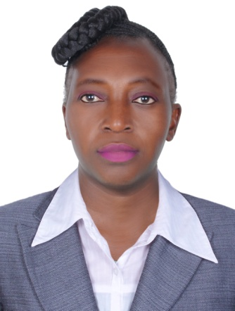
PERSONAL DETAILS
Languages English
Nationality Zimbabwean
Current residence UAE, Dubai
Visa status Tourist
Marital status Single
Personal objective
To find a challenging position to meet my competence, knowledge, skills and ethical values as an assistant teacher
BACKGROUND SUMMARY
A talented, and strong classroom performer, with 23 years experience, achieving excellent pupil attainment. I am passionate about raising standards across all age groups and subject areas. By using my natural air of authority to maintain discipline I can foster and maintain a positive school climate where pupils can reach their full potential. As an outstanding and inspirational teacher with very high personal standards I am committed to the learning and development of my students. I have high expectation of both myself and my pupils and show an interest in every student as an individual. I am now looking to further my career by working for school that provides a professionally stimulating and supportive working environment
KEY SKILLS
- Planning Lessons diversity and inclusion
- Teaching lessons marking exams
- Language development checking grammar
- Essay writing English history
TEACHING SKILLS
Ability to solve practical teaching problems
- Extensive subject knowledge
- Very alert and a good planner.
- Ability to create a loving and warm atmosphere for learning.
- Can use an interactive white board
- Producing typed documents
- Setting clear targets for future learning

PERSONAL SKILLS
Adaptable to shifting academic priorities
Highly developed written and verbal communication skills
Ability to multi-task in an ever-changing environment
Can work well under pressure
Strong sense of responsibility and desire to get things done properly
EMPLOYMENT PROFILE
DENMARK SCHOOL - 2001- 2016
Duties
- Establishing clear objectives for all students
- Regularly evaluating each students progress
- Giving out homework that is meaningful and appropriate
- Maintaining order in the classroom
- Developing course material that has a clearly defined structure
- Preparing students for Cambridge examinations
- Writing up end of term reports for parents
- Marking students oral and written work

QUEEN ELIZABETH GIRLS HIGH SCHOOL – 1996- 2000
POSITION L2 ENGLISH TEACHER
- Developing and implementing lessons and work schemes
- Preparing students for Cambridge examinations
- Preparing paperwork for audits and inspections by government bodies
TEMERAIRE HIGH SCHOOL -1993-1995
POSITION ENGLISH TEACHER

PROFESSIONAL QUALIFICATION
- DIPLOMA IN SECONDARY EDUCATION - BELVEDERE TECHNICAL TEACHERS COLLEGE ( UNIVERSITY OF ZIMBABWE) 1990-1992 MAJORING IN ENGLISH AND HOME ECONOMICS
- TESOL/ TEFL( Teaching English as a Foreign Language) LONDON MASTERS CERTIFICATE
Module1-12
- LCCI ( LONDON CHAMBER OF COMMERCE AND INDUSTRY EXAMINATION BOARD)
MARKETING -2003
- BUSINESS STRATEGIES FOR NEW MILLENIUM ( UNIVERSITY OF ZIMBABWE)
- STL MANAGEMENT COURSE (RANCHE HOUSE COLLEGE 1997)
- BUSINESS COMMUNICATION – SOUTHERN AFRICA INSTITUTION
ACADEMIC QUALIFICATIONS
GCE 5 ‘O’ Levels
REFERENCES: Available On Request

