NITHIN
Email: nithin-151638@gulfjobseeker.com

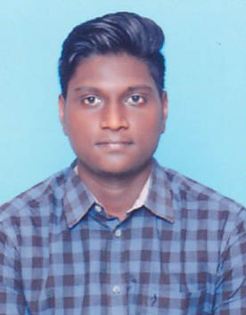
CAREER  OBJECTIVE | To Gain utmost competence in the field of Civil Engineering through enthusiasm, hard work, ethics, sincerity, and brilliance. Moreover, serve for the welfare of society, business and the economy through the assigned responsibility.

SCHOLASTIC  RECORDS | Degree  Department  University  Year  Percentage  School  Group  School  Year  Percentage  School  School  Year  Percentage | :B.E  :Civil Engineering  :Sathyabama University  :2013-2017  :66.4%  :HSSC (Higher Secondary School Certificate)  :Computer Science  :A.K.T Matriculation H.S.S  :March 2013  :69.6%  :SSLC (Secondary School Leaving Certificate)  :Jawahar Matriculation H.S.S  :March 2011  :67.2%

AREA OF  INTEREST | - Reinforcement  - Shuttering Work  - Pavement Management

SPECIAL  SKILLS | - Problem Solving abilities.  - Interpersonal relationship Skill.  - Ability to rapidly assimilate and implement new ideas,  - Willingness to Learn and explore things and a dedicated worker.

EXPERIENCE | Worked as Junior Engineer in Rising Star Engineer  For a period of Two Years (NNTPP-Neyvlei)
LANGUAGE  PROFICIENCY | Language Writing Reading Speaking  Tamil Good Good Good  English Good Good Good

PERSONAL  INFORMATION | - Underwent 10days of inplant training in Neyveli Lignite Corporation at Neyveli.  - Underwent Indiustrial visit at Jeppiaar Steel and Water Company.  - Underwent project based on Pavement Management System at Highway Research Station-Chennai.  - Underwent Inplant Training in U.R. Subramanian Construction in Chennai From 30.12.2014 – 07.

EXTRA CURRICULAR  ACTIVITIES | - Active member of NSS.  - District level player in Kabadi

