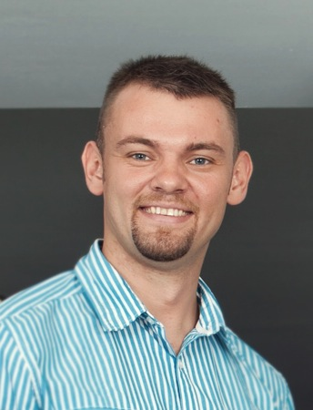
Vladimir
Vladimir.151890@2freemail.com

Education | Specialist in marketing  Program on Training Managers and Executives for the Enterprises of National Economy of the Russian Federation (2008-2009)  The Samara State University of Economics  University INHOLLAND (RIMA-А, МВА)  Psychologist  Specialization of Psychology of Management (2001-2007)  The Samara Municipal Institute of Management
Work Experience  October 2011  September 2012  Areas of Expertise:  - Market research  - Direct marketing  - Lead generation  - Competitor analysis  - Sales/ promotional material  - Event coordination  - Writing press releases  - Online marketing  - Copy writing | Marketing & Sales Executive  Railand Property International  Phuket, Thailand  Company Industry: Real Estate  Duties:  - Management sales representative control to follow sailing plan.  - Selling and reselling various properties, yacht and advertising in Magazine (provide by company).  - Do liaising with real estate agencies, build and develop relationships.  - Issuing contracts, actual agreements and ensure that these are fully adhered to.  - Solving problems and managing risk to ensure achievement of Real Estate Agencies targets.  - Providing reports and analysis as required, preparing presentations, proposals, plans for partner and co-agency.  - Preparation company brochures in terms of translation and compilation.  Achievements  - Increased profit from the deals with tourists by 80%  - Achieved quarterly issues of magazine  - Optimized a business processes
June 2010  September 2012  Areas of Expertise:  - Travel industry knowledge  - Luxury service  - Selling techniques Product knowledge Marketing  - Customer service | Sales Representative  ILVES Andaman Co. Ltd.  Phuket, Thailand  Company Industry: Tourism  Duties:  - Sale all company product which it purpose  - Organize tour program according to customer expectation  - Sales an excursions for customers  - Organize private charter programs for tourists  - 24/7 customer service by phone  - Working (customer tourist service) with tourists from 4-5 stars hotels  - Excursions quality control  - Translations for tourist  Achievements  - No personal and company complaints  - Monthly sales achievement goals was reached  - Optimized price for different category of hotels  - Optimized tour programs during tour guide
March 2007  June 2010  Areas of Expertise:  - Closing sales  - Brand management  - Marketing Territory management  - Account management  - Work scheduling  - Presentations  - Market research  - Direct marketing  - Lead generation  - Competitor analysis  - Sales/ promotional material  - Event coordination  - Writing press releases  - Online marketing | Marketing & Sales Executive  LLC “Civil Center “Older generation ”  Samara, Russia  Company Industry: Real Estate  Duties:  - Management of the organization  - Marketing management  - Management of sales  - Strategic and Market Planning  - Participation in working out of advertising and control at the stage of its manufacturing  - Planning of media in accordance with the features of the audience  - Coverage of actions conducted by the company in local mass-media  - Joint operation with journalists at placing of materials in mass-media  - Preparation and writing articles, scenarios for TV/ radio  - Analysis of advertising of competitors in mass media: its volume and presence in mass-media  - Organization of mass actions for customers of the company  Achievements  - Successfully implemented several major PR projects  - Formulate a clear strategy for positioning  - Formulated and established brand  - Established close contacts with the managers of leading media  - The successful launch of an advertising company Ulyanovsk branch  - Achieved all the objectives of anti-crisis management  - Made the rebranding  - Introduced new products and services  - Optimized the business processes
Additional Experience  September 2005 August 2006 | Member of European Voluntary Service program  Fürst Donnersmarck-Haus (Berlin)
Skills | - Successful experience in sales (more than 5 years);  - Excellent analytical abilities;  - Have the methods of self-regulation and anti stress;  - Have knowledge in the real estate;  - Successful experience in TV and radio on-line programs;  - Skills of NLP.  Responsible, purposeful, good decision making, organized, sociable, hard-working person, administrative, communicational and interpersonal skills.
Personal Information | Languages: Russian – native; English – intermediate; German – basic.  Computer: MS Office (for Mac and Windows), Photoshop, Corel & etс.  DOB: 30 jun 1984  Marital status: Single  International Drive License

