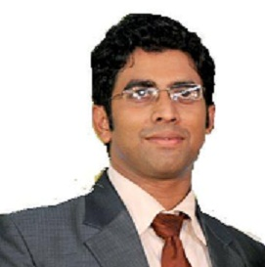

DENNIS

DENNIS.154049@2freemail.com

Career Objective:-
Acquires a dynamic and meticulous two years experience in Hospital Patient Insurance with highly acclaimed and reputed hospital.

Professional Experience:-
- Currently working in Dubai, in a medical center as a Insurance Cordinator.
- Worked with Anantshree Multi-Specialty Hospital, Bhopal, Madhya-Pradesh, India in the period of 01/12/2009 to 28/02/2012 Worked as Insurance Co-coordinator, responsibilities which included :
- Claim Verification.
- Invoice Re-checking.
- Claim submission.
- Re-submitting of Rejected Claims.
- Payment Collection.
- Delayed Payment Collection.

Professional Qualification:-
- B.Sc Nursing from Rani Durgawati Vishwavidyalaya Jabalpur - M.P July-2005 to July-2009

Educational Qualification:-
- Higher Secondary School Certificate (10+2) from Bhopal, MP, INDIA.

Computing Knowledge:-
- MS Office, Windows.
- Excel.
- Internet & Emailing.
- Page Maker.
- Documentation.

Additional Responsibilities:
- Reporting to Head of the Department.
- Preparing and Maintaining Records.
- Preparing Invoice.
- Participation in Teaching Program In service Education Programs.
- Management of other personnel in the Unit.
- Invoicing and payment follow-up for corporate accounts.

Declaration;

The above particulars are true to the best of my knowledge.

Place: Available for Interview - Immediate
Date:

