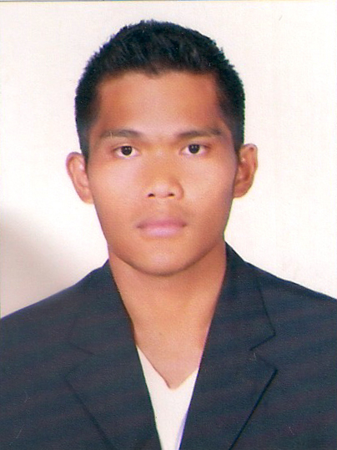
Gulfjobseeker.com CV No:959682
Mobile +971505905010 cvdatabase[@]gulfjobseeker.com

To contact this candidate use this link
http://www.gulfjobseeker.com/feedback/contactjs.php

OBJECTIVE
Seeking a position as a Clinic Nurse, Medical Surgical staff nurse or any related position in a renowned medical organization where my talents and experience will be of used for the benefit of the patients and growth of the industry.

SKILLS/QUALIFICATION
- Excellent decision-making and critical thinking skills.
- Familiarity with functioning of a patient care unit in accordance with Nursing Department policies and procedures.
- High attention to detail and excellent organizational skills
- Excellent Medical vocabulary and computer skills
- Computer literate, ability to type 60wpm
- Immense ability to handle critical and emergency conditions.
- Team leader with able to create a positive working environment that uplifts patients’ spirits.
- Excellent communication skills, fluent in English.
- Extended ability to promote compassion and a therapeutic environment.
- Knowledge of human behaviour and performance.
- Ability to actively seek educational opportunities to improve clinical practice and continuing education.
- Ability to maintain quality-working relationship with peers.

EMPLOYMENT
Medina General Hospital, Ozamis, Philippines 7200
(200 bed capacity tertiary hospital)
January 2008 – January 2012 (4 year experience)
Staff Nurse - Medical/Surgical
- Documented patient's plan of care using identified nursing diagnoses, expected patient outcomes, and selected nursing interventions
- Monitors, record and report symptoms and changes in patient’s condition.
- Record patients’ medical information and vital signs.
- Modify patient treatment plans as indicated by patients’ response and conditions.
- Consult and coordinate with the health care team members and assess, plan, implements and evaluate patient care plans.
- Educate patients on surgical procedures.
- Performed clerical and receptionist duties and maintained the physical environment of the area.
- Managed pain and documented patient's response to nursing and other interventions.
- Provided preoperative, inter-operative and post-operative care to patients.
- Direct and supervise less skilled nursing/health care personnel or supervise a particular unit on one shift.
- Prepare patients for, and assist with, examinations and treatments.
- Monitor all aspects of patient care, including diet and physical activity.
- Order, interpret, and evaluate diagnostic tests to identify and assess patients’ condition.
- Monitored safety and effectiveness of the environment and equipment.
- Modified plan of care according to evaluation, changes in medical plan of care, and effective and ineffective nursing interventions.
- Discharged patients and followed up.
- Assured adherence to strict safety procedures by all staff.

Le Meridien Mina Seyahi & Westin Mina Seyahi - Dubai
Starwood Hotels and Resorts
May 13, 2012 - present
Health Club – Guest Assistant
- Providing constant guest services and greeting guests in pool/beach area
using guests name during conversation.
- Promoting a professional image and give full co-operation to all clients with a prompt, caring and helpful attitude.
- To assist in the delivery of departmental service standards.

EDUCATION
Misamis University – Philippines
Bachelor of Science in Nursing
2003 - 2007

La Salle University – Philippines
Secondary High school
1999 - 2003

