Deepak.160866@2freemail.com 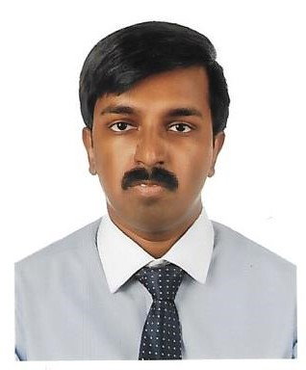
Deepak

PROFILE SUMMARY

Competent, highly motivated Professional eager to utilize formal education and developed skills for a rewarding solid career foundation with a positive attitude. Excellent written, oral and exceptional interpersonal communication skills and very good in customer and industrial service.
Possesses strong IT proficiency which can be utilized in handling delegated tasks as well as in streamlining processes to heighten efficiency of overall operation.
฀ Strengths
- LSCMP Certified Professional
- Strategic Planning - Operational Development
- Competency in Supply Chain Management
- Logistics Operation Know-how
- High Analytical & Problem Solving Aptitude
- Adaptable to New Concepts & Challenges
- Correspondence & Communication Skills
- Team Playing & Leadership Abilities

QUALIFICATIONS
Master of Business Administration – Logistics & Supply Chain Management
Emirates Aviation University, UAE (Affiliated to Coventry University, UK) 2016
Bachelor’s Degree in Computer Science 2012
St. Thomas College of Arts & Science, India
Certified Logistics & Supply Chain Management Professional
Zabeel Institute, UAE
Work Experience:

Site Secretary in General Electric Company Dubai - Nov 2016 to Jan 2017

• IT SKILLS
Operating System: Windows XP, Vista, 7
Applications: MS Office Suite, E-mail

• PERSONAL DETAILS
Nationality: Indian
Date of Birth: 22nd July 1989
Visa Status: UAE Residence Visa
Marital Status: Single
Languages: English, Tamil, Hindi
• REFERENCES
Will furnish promptly upon request with supporting documents

