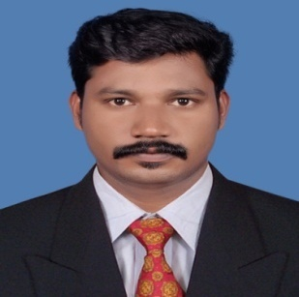
RESUME

RAJEEV

Rajeev.161993@2freemail.com

OBJECTIVE:
Intend to work in an environment which would continuously challenge my skills and technical knowledge. Willing to work as key player in a challenging and creative environment.

- Excellent Communication skills
- Confident in quality of work
- Good leadership skills
- Good presentation skills
- Determination, Dedication and Discipline
EDUCATIONAL QUALIFICATION
- T.H.S.L.C
- Diploma in Civil Engineering
Computer Knowledge
- Basic Knowledge
- Auto Cad
LANGUAGES KNOWN
Language | Read | Write | Speak
English
Malayalam
Hindi
Arabic

- As a young resourceful personality, I intend to build by career by working with an efficiently and better caring for the service of patients. I can put my efforts to see my growing and there by uplifting my skill and knowledge.

Fourteen years of experience in construction field in India as well as in Gulf countries.

- Site engineer (GRC) -M/s. Notredame Fibre glass, Sharjah, UAE from February2010 -Present

Major Responsibilities:-
- Execution of work as per client’s quality requirements and specifications.
- Supervising and executing erection works according to the approved drawing and progressive schedule.
- Familiar with the production of different designs and erection of GRC decorative products.
- Quantity of material takes off from drawings to place the order and preparing the program schedules.
- Preparing and submitting the quantity of the material which are totally completed the erection for the monthly invoice procedure.
- Optimum usage of material and manpower.

- 5 Years’ experience in Pranavam Constructions LTD as Site Suervisor .
- 2 Years’ experience in Al-Habsi Contracting and Trading as Site Supervisor.
- 2 Years’ experience in Noble Constructions as Site Engineer.
- Presently working as a Site Engineer in NOTREDAME fiber glass and Industrial Marbles UAE since 2010.

PROJECT COMPLETED
- Sports City UNEC Project, Dubai
- University building, Kalba, Sharjah
- P/15 International City,UNEC Dubai
- Kingdom of Sheba, DCC, Palm Jumairah, Dubai
- AlfuttaimCarrilion/585 & 559, Dubai

- Planetarium building, UNEC, Sharjah
- Faremont Hotel & Resort, DCC, Jumairah, Dubai
- Citywalk Project, AFC, Dubai
- MadinatJumeirah, AFC Jumeirah, Dubai
- Lamer Project, AFC Jumeirah, Dubai
- Bvlgari Resort & Residence, Alec, Dubai

DRIVING LICENSE DETILS

- License No : ATL/2285/02 (LMV License of Indian Union)

PERSONAL DETAILS

Name : RAJEEVMON.
Nationality : Indian
Father’s Name : N. Balakrishnan
Mother’s Name : P. Saralayamma
Marital Status : Married
Gender : Male
Religion : Hindu

DECLERATION
I hereby declared that the above statements are true and correct to the best of my knowledge and belief.

Place: Sharjah
Date:18/08/2017 RAJEEVMON

