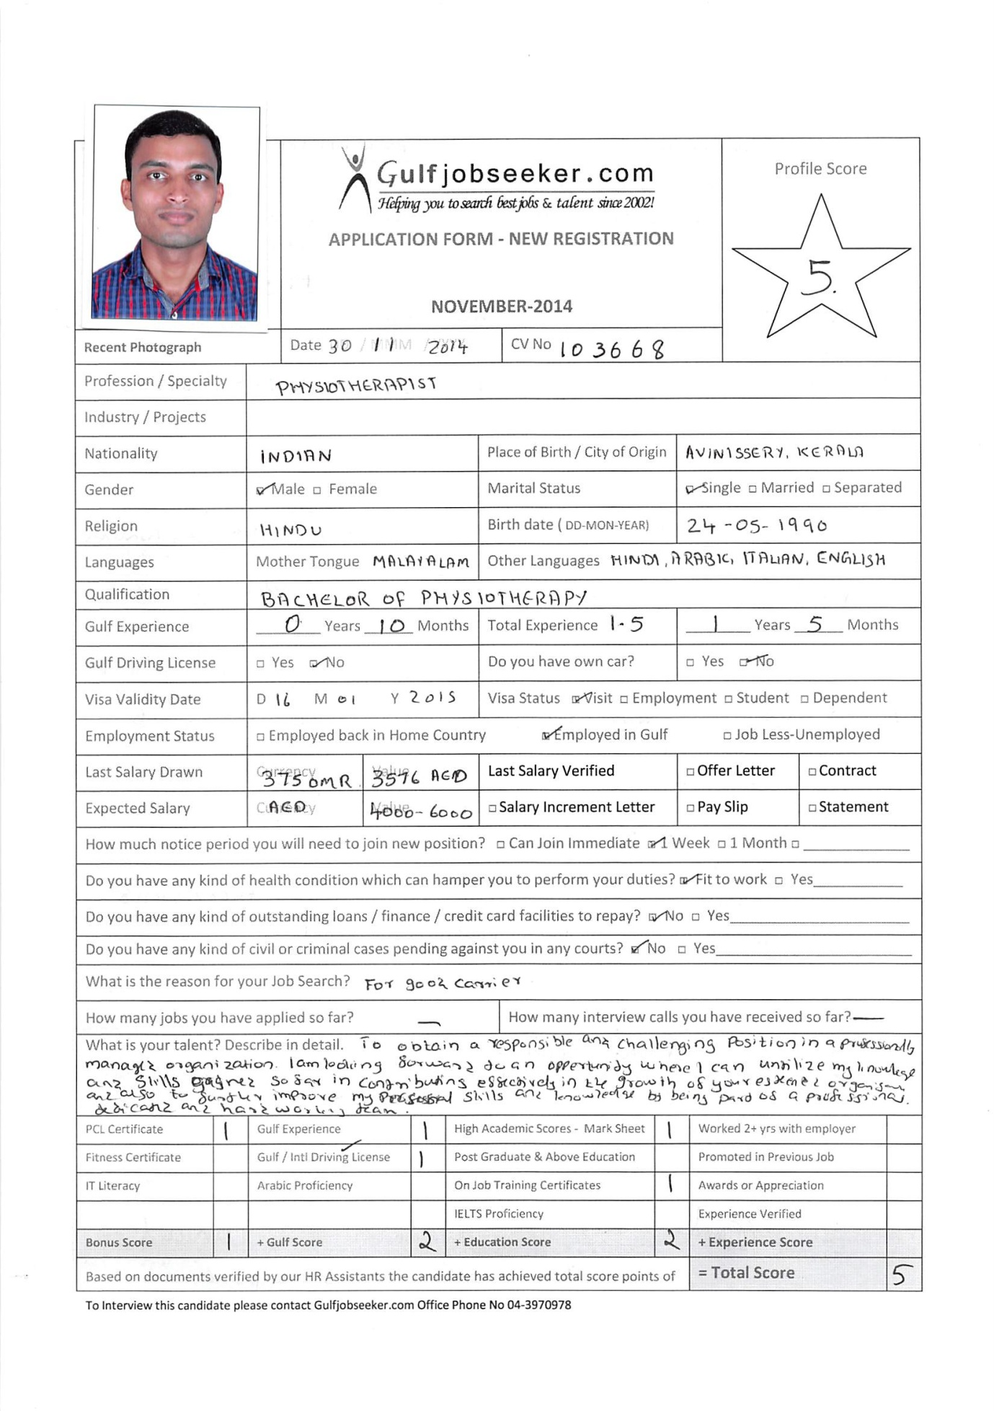

Post:PHYSIOTHERAPIST
Career Objective:
To obtain a responsible and challenging position in a professionally managed organization. I am looking forward to an opportunity where I can utilize my knowledge and skills gained so far in contributing effectively in the growth of your esteemed organization and also to further improve my personal skills and knowledge by being part of a professional, dedicated and hardworking team.
Summary of background:
I had good exposure to latest biomedical physiotherapeutic equipments, latest manual therapy concepts with special interest inmusculoskeletal and sports, neuro rehabilitation, spinal mobilization and vestibular rehabilitation.
Educational Qualification:
1. S.S.L.C (Govt. of Kerala) from St. Joseph’s HighSchoolAvinissery, Thrissur, Kerala, India with 60%
2. Higher Secondary (Board of Higher Secondary Education) from G.H.S.S cherppu, Thrissur, Kerala, India with 60%
3 B.Sc Physiotherapy from Mahatma Gandhi University, Little Flower Institute of Medical Science and Research,Angamaly, Kerala with 55.48%

Employment History:
- Dept. Of Physiotherapy & Rehabilitation
Reputed hospital Thrissur,Kerala
Working as a full time physiotherapist (Pre internship)
April 2012 to December 2012
Special interest in knowing ayurveda techniques

- Dept. Of Physiotherapy & Rehabilitation
Reputed Hospital Pvt LTD, Thrissur, Kerala
Working as a Full time Physiotherapist
Jan 2013 to31st June 2013 as a part of compulsory internship
- SPORTS PHYSIOTHERAPIST
Reputed Firm, Sultanate of Oman
From 16th August 2013 to April 2014
Presently doing MASTER OF PHYSICAL ACTIVITY AND HEALTH PROMOTION at UNIVERSITY OF ROME TOR VERGATA ITALY ROME.
Part time physiotherapist
Activities:
- Management of football team
- Management of Physiotherapy department
- Assessment and treatment of patients in the Physiotherapy department
- Attending clinical rounds with the consultant doctors
- Treating patients in the intensive care units

Modalities familiarized with:
Ultra sound, Inter ferential therapy, Short wave Diathermy unit, Microwave, Infra red radiation, Ultra violet radiation, Laser, Paraffin wax, Muscle stimulator, TENS, Micro currents, Moist heat and heating pads, Cryotherapy, Contrast bath, Whorl pool.
Others: Nebulization, ventilators, suctions apparatus.

Techniques and conditions familiarized with:
Neurologic- Vestibular rehabilitation, Neurodevelopmental approach, Stroke rehabilitation, Head injury, Spinal cord injury, Movement disorders, Parkinsonism, Neuro dynamics.

Orthopedic- Arthritic conditions, Back syndromes, Mobilization, Manipulation and manual therapy, Hand injury, Traumatology after care, arthroplasty rehabilitation, Orthotic and prosthetic support.

Sports- Strain and sprain, Taping and strapping, Stretching techniques.Sacroiliac joint dysfunction, Ulnar collateral ligament injury of the thumb (Thumb goalkeeper), Osteitis pubis, Distension / rupture of the hamstring, Ruptured ACL, O'Donohue's Triad (ruptured anterior cruciate ligament, medial collateral ligament and medial meniscus of the knee), Meniscal injuries, Lateral ligament injuries of the knee, Injuries to the lateral ankle ligaments, and Greater and Lesser Gluteal tendinopathy

Cardiothoracic-MI Rehabilitation, Post operative management.

Pediatric-Spina bifida, cerebal palsy, Post operative management.

Others- Burns, Hematogy, Oncology, Geriatrics, Dermatogy, Myopathy and Neuropathy.
Academic Qualification:
Project works:
- Sports injuries.
- Ergonomics.
- Importance of stretching techniques in sports rehabilitation.
- Fracture Patella and its management.
- Parkinson’s disease and its management.
- Stroke Rehabilitation
- Kyphosis management
Certificates and Specialized courses done:-
- CME on Sports Physiotherapy, Noval Physiotherapy Improving Motor Recovery.
- Certificate of Attendance in Seminar of Emerging Trends in the field of Disability.
- CME on Differential Diagnosis Of Spine
- CME on Interferential Therapy.
- CME on Differential Diagnosis In Orthopedic Evaluation.
- CME on Myo -facial therapy.
- CME on PNF, NDT, MRP.
- CME on Evidence Based Practice.
- CME on ICU Management for Chest clearance program.
- CME on Vestibular Exercises.
- CME on Parkinsonism
- CME on Peripheral vascular conditions and icu management
- CME on Physiotherapy on women health
- Workshop on Muscle energy techniques
- Workshop on Pune shoulder rehabilitation programme
- Workshop on Clinical Taping Techniques
- Workshop on Myofacial mobilizations
- Workshop on Learning strategies & Teaching in Autism.
- Workshop on Manual Therapy for Spine & Neuro Dynamics.

Personal Details:

Age : 24Yrs

Date of Birth :24.05.1990

Religion : Hindu

Nationality : Indian

Marital Status : Single

Language Fluency : English, Tamil, Hindi & Malayalam.

Communicative skills : Good

Computer knowledge : MS Office (Word, Exel, Power point)
Internet.

Driving license (Indian) : M/C with gear & LMV& International driving license issued on India
•HOD, Dept of Physiotherapy &Rehabilitation.Aswini hospital Thrissur
Ranjana Santhosh 0091 9847126963
•HOD, Dept of Physiotherapy & Rehabilitation, Sitaram hospital, Thrissur.

Declaration: I hereby declare that the information given above are true and correct within the best of my knowledge & belief.

