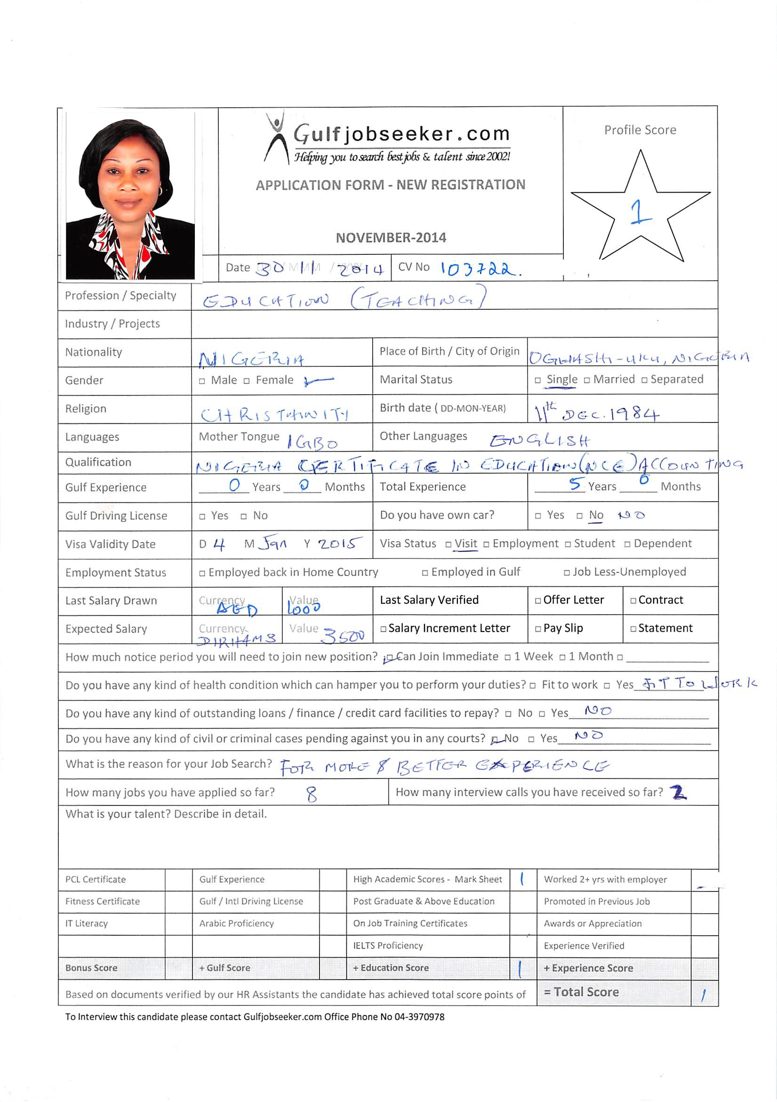

APPLY FOR THE POST OF RECEPTIONIST

Objective:
To work with integrity in a challenging environment that aims at obtaining the very best and to work with existing staff and facilities, contributing the best of my ability and quota, applying strategies to meet managerial objectives, and achieve organization goals and target.

summary of Qualifications

- Nigeria Certificate in Education (NCE) Accounting Education

RELEVANT EXPERIENCE

- Reputed Hotel 2013-till date
Post Held: Receptionist

- Equifix – Specs 2012-2013
Post Held: Sales Rep

- Anya Orhj & Co. 2011-2012
Post Held: Secretary

- Intercontinental Distillers Ltd. 2010
Post Held: Sales Rep

- Delta State Art and Culture Asaba (SIWES)

EDUCATION

- Nigeria Certificate in Education (NCE) Accounting Education
Federal college of Education (Technical), Asaba 2006-2009

- Senior Secondary School, Certificate
ST. Rose Girls Grammar School, Ogwashi-Uku 1993-1999

- First School Leaving Certificate
Anishi Primary School, Ogwashi-Uku 1986-1992

OTHER SKILLS

- I am highly analytical with good planning
- Organizing skills
- Proactive and energetic
- Good interpersonal and communication skills
- Initiative creative
- Maintaining sound integrity, a team player.
- Computer Appreciation. [ MS Office & Internet Explorer ]

REFERENCES
- Available on request

PERSONAL BRIEF:
- Gender : Female
- Nationality : Nigerian (African)
- Date of Birth : 11- 12-1984
- Marital Status : single
- Languages Known : English, African
- Visa Status : Visit Visa
DECLARATION:
I certify that the above information are true and correct to the best of my knowledge and ability. if given a chance to serve you, I assure you that i will execute my duties for the total satisfaction of my superior.

