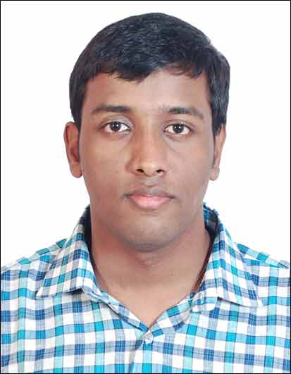
Gulf Job Seeker Executive Level CV No - 104076
http://www.gulfjobseeker.com/feedback/submit_fb.php
Mobile: 971505905010 / 971504753686

Summary

Fresh Mechanical Engineering graduate from Mumbai University with first class. The University Of Mumbai is one of the premier universities in India. Proficient in using Windows, MS office and Solidwork 3D modelling. Completed final year project based on designing of a die used in industries.

Career Objective

To be associated with a progressive organization which would give me the opportunity to enhance my engineering skills, professional expertise and integrate the same with the organizational development process.
Education
- Completed B.E. Mechanical from Mumbai University in May-2014 with 61.26%
- H.S.C (Science) From Maharashtra State Board in 2010 With 68.83%
- S.S.C from Maharashtra State Board in 2008 With 83.07%

Final year Electives
- Power plant engineering. (B.E. Semester I )
- Non-Conventional Energy Sources. (B.E. Semester II )

Final Year Project

Title: Design of molding die for improvement of productivity.
Description: It was a company project for design of a new molding die for increasing the number of products by adaption of a new die layout which suppresses some of previous die problems and increases the number of cavities.
Remarks: The project was completed within the time allotted i.e. a period of two semesters.

Computer Proficiency:

Operating Systems: MS Windows
Design: Pro engineer, SolidWorks, AutoCAD.
Others: Ms Office, C++

Co-curricular Achievements:
- Member, Core Panel of Alegria 2013 cultural festival.
- Volunteered in college festival ‘Impulse’ in both 2012 and 2013.

Strength:
- Working in a Team.
- Eagerness to Explore and Learn.

Personal Information
- Date of birth: 17/03/1993.
- Sex: Male.
- Nationality: Indian.
- Languages known: English, Hindi, Marathi.
- Visa status: Visit visa

