CURRICULUM VITAE
Personal  details | YASHWANTH  Email: yashwanth.17416@2freemail.com | 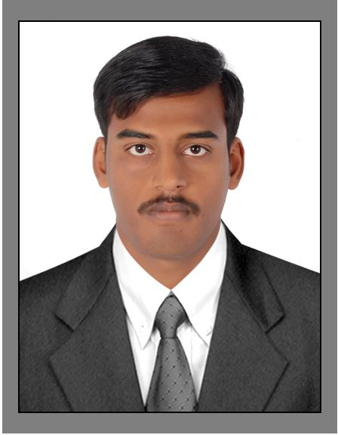

Date of Birth 13/07/1991
Sex Male
Marital Status Singl
Languages Known English,& Kannada, Taiml, Telugu, Hindi
Objective
I am friendly, loyal and clearly dedicated individual who has an ambition to succeed in any given environment.
Although I have extensive experience in the accounts field, I love to learn and am always up to a challenge,
Whatever the situations. I get along with others. Whilst also working efficiently on my own. I am seeking
Whatever position where I can develop and excel while giving my best to an employer.

Education
- SSLC (April 2007 ) Rural High School Bethamangala, Karnataka

- 12TH STD (March 2009 ) Sri BhagawanMahaveer Jain collage ,K G F ,Karnataka,
- Bachelor of commerce (May 2014) Frist Grade collage ,K G F ,Karnataka,

Work experience

- I worked as a marchindiser from Al ZYANI TRADING EAST,COMPANY .and
Worked in carrefour marchindeser form 1/9/2016 To Till date
Computers Skill
- Tally ERP 9
- MS Office
- Basic Computers
Personal Traits
Matured and ethical approached to business.
A good team leaders and team player.
Ability to interst with easy and confidence at all levels. A natural leaders with ability to lead by example. Infuses confidence in subordinates.
A quick learner with ability to accept and adapt to change. Hard working focused and goal oriented.
I hereby declare that the information provided is true to the best of my knowledge.
Place : Dubai Yours Truly,
Date : Yashwanth

