REGU

Mobile: +971 566224196
Email: regu1990@gmail.com

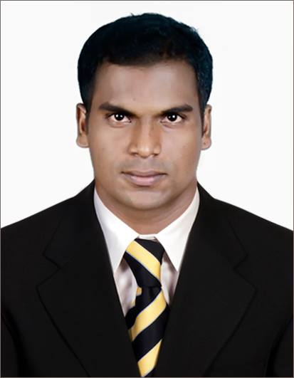

Objective
Position of a System Support Engineer with a growing organization, regional or transnational, in the field of information systems, where my skills, expertise and extensive experience would create value and growth and also contribute to attaining my aspirations for success and self-actualization.
Resume
- Extensive experience of 2 years in IT sector, System Analysis.
- Bachelor of Engineering in Electronics and communication from Anna University.
- Diploma in Electronics and communication from Sun institute of Technology.
- Microsoft certified system engineer (A+ N+ MCP).
- Proven expertise in system analysis, design and implementation techniques to provide strategic fit between information Technology and Businesses.
- Consistent in quality work, dedication, and eye for detail.
- Self-starter & proactive.
- Excellent judgment and planning skills, and ability to parlay my all-round knowledge into taking sound business decisions.
- Comfortable interacting with people with diverse cultures, strata and caliber.
- Outstanding communication, presentation, negotiation, and sales-closing skills.

Professional Experience
Company: Gateway Technologies Designation: System Supports Engineer
August 2012 to June 2014
Chennai, India

Company Profile
The company provides centralized IT Support, Service and Solutions provider. Services such as Server support, Desktop Support, Hardware Supplies, Faxing and Telex, Audio Visual & Cabling installations are provided by us.

- Expert system study and documentation of functional requirements
- Installation and configuration of routers.
- Configuration of network address translation.
- Installation and configuration of IP address, Variable length subnet masking and Classless inter-domain routing.
- Configuration of point to point and challenge-handshake authorization protocols

- Configuration of distance vector and link state routing protocols
- Installation and configuration of OS like win 98, win xp, win 2000 & win 2003.
- Installation and configuration of exchange server and server 2003.
- Plan, direct and manage the daily nitty-gritty of computer operations as well as establish department policies and procedures

- Develop, plan, and implement the overall strategic goals of the organization's network system

Projects Completed

- Partitioned bus invert code for power optimization in VLSI (VLSI based, VHDL language completed by May 2012)

Technology trends and especially portable applications drive the quest for low power VLSI design. Solutions that involve algorithmic, structural or physical transformations are sought. The focus is on developing low power circuits without affecting too much the performance like area, latency and period. For CMOS circuits most power is dissipated as dynamic power for charging and discharging node capacitances. This is why many promising results in low power design are obtained by minimizing the number of transitions inside the CMOS circuit.

In this project we proposed the partitioned bus-invert method of coding the input/output which lowers the bus activity and thus decreases the input/output peak power dissipation by 50% and the input/output average power dissipation by up to 25%. Also since we were partitioned the bus codes results the lower power dissipation on the data transmission.

- Telephonic operated Motor system (Electronic circuits-Microcontroller based, completed by May 2008)

The main idea of the project is to control the Electrical/Electronic device with the help of telephonic control.
Here we used the DTMF (dual tone multi frequency) decoder technique which is implemented by an embedded controller. We used mobile phone for the wireless communication and an induction motor as an applicant
DTMF signaling is used for telephonic signaling over the line in the voice-frequency band to the call switching center. Microcontroller is used for coding and based on the two types of rings (single ring and double ring) the motor were controlled in our project.

Professional & Educational Qualifications

- Microsoft certified system engineer (MCP) issued by Microsoft.
- Bachelor of Engineering in Electronics and communication from Anna University.
- Diploma in Electronics and Communications from Sun Institute of Technology Tamilnadu.
- Diploma in Hardware & Servicing.

Software skills

- Knowledge on chip designing tools includes Xilinx, Model Sim and Tanner.
- Knowledge on Cisco Network Simulator-Boson.

Personal Details

Full Name: Regu Mariadhasan
Date of Birth: 3 June 1991

Nationality: Indian

Marital Status: Single

Visa: Visit Visa (Until December’14)

Languages Known: English, Tamil and Malayalam

