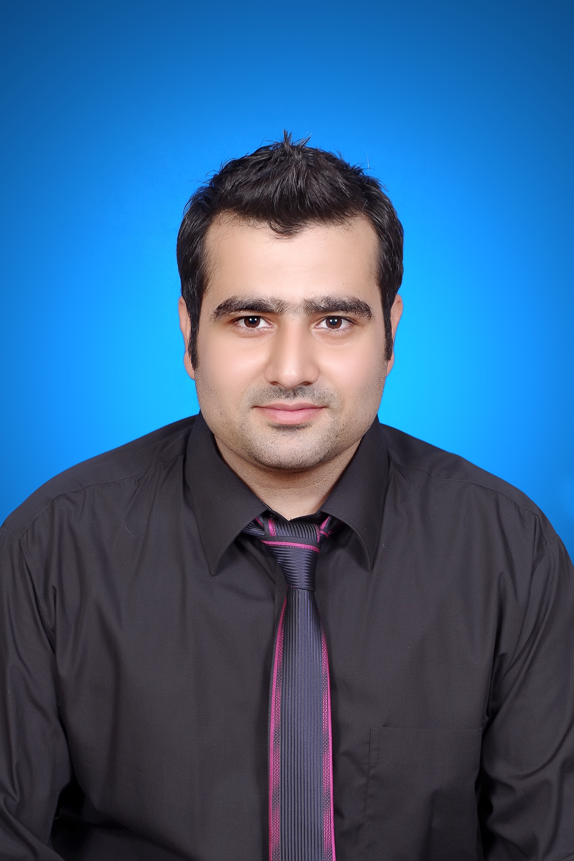
Gulfjobseeker CV No: 97116
To interview this candidate call 971505905010
Or email us back filled up Vacancy Form
http://www.gulfjobseeker.com/Free_Job_Posting_Form.doc

OBJECTIVE:
To work at my best in the challenging work environment of a reputable organization where my education, training, skills and abilities can be fully applied and provides learning opportunities for the fulfillment of corporate as well as personal goals.
EDUCATION:
BS Honor’s (Social Work) University of Sargodha Year 2010
FA University of Sargodha Year 2006
Matriculation Sargodha Board Year 2004

PRACTICAL TASKS:
Training and Workshops:
- Worked under the Banner of urban Community Development (UCD) Project for a year as trainee.
- Working as Asst. Manager at Zam Zam Hotel since 2010 up till present.
- Was involved in numerous Surveys under the wing of eminent NGOs of Pakistan.
COMPUTER SKILLS:
- Microsoft Office
- Basic computer knowledge
- Internet Applications
LANGUAGES:
- Urdu
- English
- Punjabi
PERSONAL INFORMATION:
- D.O.B: 20-05-1988
- Domicile: Sargodha (Punjab)
- Religion: Islam

REFERENCEs:
- Will be furnished upon demand.

