Gulfjobseeker.com CV No: 973896
Mobile +971505905010 cvdatabase[@]gulfjobseeker.com
To contact this candidate use this link
http://www.gulfjobseeker.com/feedback/contactjs.php
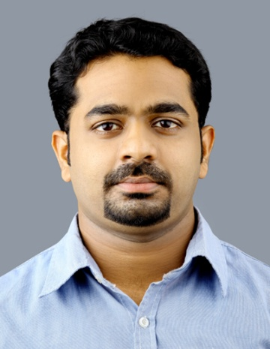
PERSONAL DETAILS

DOB:01/11/1985
Age : 27
Sex : Male
Nationality : Indian
Marital Status: Single.

AREAS OF EXPERTISE
Musculoskeletal physiotherapy
Orthopaedics
Stroke management
Sports injuries
Patient care
Neurological conditions
Multiple Sclerosis

OBJECTIVE
I’m looking for position in a physical therapy facility (HOSPITAL or REHAB CENTER) emphasizing neurological/ orthopedic problems of patients, which allow me to continue to develop my skills in neurodevelopment/ structural treatment approaches. Ready and qualified for the next stage in a successful career and looking forward to making a significant contribution as a physiotherapist.

DHA EXAM PASSED, REF NO. DHA/LS/2142013/324225

WORK EXPERIENCE
NIMS Hospital, Malapuram, kerala,India
Physiotherapist (Oct 2009 to Jan 2013)
Provide physiotherapy and treatment for both outpatients and inpatients. Responsible for managing a clinical caseload, providing physiotherapy assessment and treatment to the highest standard.

DUTIES:
- Providing a high standard of physiotherapy service to patients.
- Organising & prioritising own workload & delegating responresponsibilities accordingly.
- Involved in ward rounds, meetings and case conferences.
- Supervising and teaching recently qualified physiotherapist assist..assistants.
- Evaluating, planning and delivering care plans in response to comp. complex needs.
- Reporting all complaints/incidents to senior managers & documdocumenting them.
- Implementing relevant standards and policies.
- Involved in a patients pre-admission and follow-up care.
- Prioritising urgent referrals and emergency cases.
- Working with respiratory, orthopaedic, acute neurological and multi-pmulti-pathology patients.

TRAININGS & WORKSHOPS
- CME on Shoulder Physiotherapy.
- Workshop on Modern Trends in Sports Medicine.
- CME on Practical Concepts of Physical Fitness Evaluation & Training.
- Mutli-Disciplinary Conference on Stroke.
- Workshop on Myofascial Pain Syndrome.
- Workshop on Mc Kenzie’s Approach and Spinal Taping.
- Workshop on Lung Expansion and Bronchial Hygiene Therapy.
- Conference on changing trends in Respiratory Physiotherapy.

PROFESSIONAL MEMBERSHIP
Country | Authority | Validity
India | The Indian Association of Physiotherapist | Life Membership
India | Kerala association for Physiotherapist’s co-ordination | Life Membership

ACADEMIC QUALIFICATION
- BPT From College Of Physiotherapy, Thalassery Affiliated to Calicut University (2004- 2009)
- 10th & 12th From C.B.S.E S.N.Vidya Bhavan, Thrissur, kerala, India.

DECLARATION
I hereby acknowledge that the information given above is true to the best of my knowledge and belief.

