Faisal

Email: faisal-162333@2freemail.com

SENIOR PROFESSIONAL

Banking Operations | Customer Service Operations

PROFILE SUMMARY

~Banking Operations | ~ Customer Service | ~Client Servicing
~Team Leading | ~SWIFT Settlements | ~Global Documentation
~ Quality Assurance | ~Card Operations

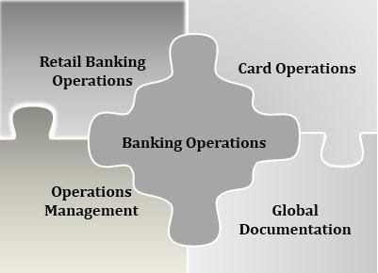
- Experience with Card Operations and Compliance, Quality Assurance, SWIFT Settlements, ATM/CDM Operations, Global Client Documentation process and Project Implementation.
- Instrumental in maintaining MIS reports and evaluating them for facilitating decision-making process
- Expertise in handling banking operations and accountable for increasing profitability with achievement of business objectives within budgeted parameters
- Proficient in coordinating with internal/ external customers for running successful back-office operations with sound exposure in implementing procedures & service standards for business excellence
- Excellence in card maintenance & managing various card operational activities like (and not restricted to) demographic
maintenance, card blocking, fee and charge reversals, reward management, duplicate statement and pin generation and card account related maintenance as well as worked on coordinating with ATM / CDM reconciliation team for settling disputes, reconciling EJ, reviewing CCTV footages for dispute incidents, preparing incident reports for key control failures during ATM/ CDM transactions
- Excellent interpersonal, analytical skills with proven track record of spearheading numerous cost innovation projects during the career span.
- Team Leading and providing Level One support to Banks across multiple products.

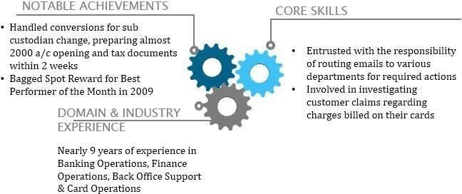
ORGANISATIONAL EXPERIENCE

April’19- Dec’19 in Manufacturing of Medical Uniform as Operations Specialist at Pune, India

- Handled Customer Support for Emails, chats and calls for the brands clients worldwide.
- Support for tracking packages in coordination with UPS, UPS I-Parcel and USPS for customer packages and raise disputes.
- Reversal of charges like shipping handling fee overcharge etc to the customers.
- Processing refunds and exchange orders for customer returns.
- Processing Quotes and Purchase Orders and handled customers on account with the company.
- Investigating chargeback cases.

June’18- Dec’18 with Financial Software and Systems (P) Ltd as Team Leader (Level- One Support) Chennai, India.

- Identifying issues/requirements and co-ordinate and communication for issues/ requirements with team members and Site-In charge.
- Improve efficiency of products – like identifying the defects in the software and taking up with concerned for rectification.
- Coordination with customer (banks) for Change Requests and maintenance activities.
- Shift Roster and Attendance management
- Understanding customer requirements/issues and escalation/resolution of the same through appropriate channels
- Conducting regular meetings with the team members on latest updates
- Assisting Shift Resources in terms of resolving client inquiries
- Monitoring the effectiveness of incident management and making recommendations for improvement
- Driving, developing, managing and maintaining the major incident process and associated procedures
- Performed the DR ownership/coordination on regular intervals for respective application

Handled 4 products effectively maintaining an uptime of 99.4% across 7 banks.
- Escalate performance issues with internal and/or external providers to minimize adverse impact of systems availability on business continuity
- Working with Internal team for the installation/upgrade/refresh projects.

June’13-Mar’18 with Innovations Direct Employment Services (on Location for First Abu Dhabi Bank- formerly National Bank of Abu Dhabi), Abu Dhabi as
Cards Administration/ Customer Response Executive June’13-March’18

Department 1: Card Operations and System Integration Team (June ’13- Sept ’14)

- Various function related to the Card Operations and Card Maintenance were handled leading a team of executives for conventional Banking customers as well as Islamic Banking (ADNIF)
- Accountable for routing emails to various departments for actions required
- Part of the system integration team wherein migration of cards data was done to the First Data system from the PRIME system.
- Worked on enhancing the loyalty point system in coordination with Vendor (Zafin Labs).
- Worked in coordination with the CC-Marketing team for smooth roll out of various promotions and offers of the bank.

Department 2: Customer Response Team (Sept ’14- Mar ’18)

- Looked after investigating customer claims regarding charges billed on their credit cards and ATM/ CDM disputes.
- Part of the Customer Response Team in order to resolve complaints and escalations received through the Contact Center.
- Handled complaints received from the CEO’s office, Newspaper and Social Media (Facebook, Twitter etc).
- Monitored Quality for the Contact Center calls and provided feedback to the respective agents.

Highlights:
- Part of the team to win the Customer Excellence Award for the Best Engaged Media Channel for the year 2016.
- Played a key role in improving the ATM/ CDM dispute settlement processes by taking getting the CCTV footage function to the Customer Experience team from the IT previously.
- Bagged 2 rewards in the months of January 2014 and May 2014 for undertaking the project of creating 50k mails through mail merge for customer notifications.
- Essayed a key role in handling ATM/ CDM transitions for migration of the machines to First Data and the keeping in control the issues related due to the same.

Sep’09-Jan’13 with The Bank of New York Mellon, Pune as Best Practices Officer (Grade F)

Department 1: Global Client Documentation

- Looked after Client Services Business Practice (Global Client Documentation)
- Handled a set of entities for which documentation to invest in various global markets are required including complex markets
- Formulated market opening documents for the clients as well as tax reclaim and proxy documents
- Oversaw both FIIs as well as Tax-exempt entities
- Made use of various applications based on Citrix, MS Access, Mainframe, etc.
- Accountable for processing check fees on Boston Mainframe System for Legalization, Consularization, Apostillization, etc.

Department 2: Global Trade Processing (Settlements)
- Worked for the Global Trade Processing Team on CMS application
- Looked after settling of trades and FXs which do not go through STP matching them via SWIFT messages
- Involved in reconciling the reports from the system with the inbound SWIFT messages and settled the Trade/ FX
- Updated fail codes with reasons on Trades/ FXs failing to process or delayed
- Followed up on clients for Trades/ FXs pending after settlement date

Highlights:
- Played a key role in handling one of the biggest conversions for sub custodian change in the month of Nov–Dec’11 within a record time preparing almost 2000 a/c opening and tax documents within 2 weeks

Aug’08-Jun’09 with eClerx Services Ltd. (on Location for Credit-Suisse Services), Pune as Financial Analyst
Sector: Investment Banking

- Done Drafting of Agreements for Equity Vanilla Option, Equity Vanilla Swap, Equity Variance Swap, Cliquet Options and IRS.
- Conducted Training for the Team members on drafting of various products.
- Prepared Drafting Rule book.
- Discussed Drafting External as well as Internal Errors with the Team on Daily basis.
- Attending Daily Client Calls to resolve the queries which we get in Drafting of Certain Documents
- Attending Conference Calls to learn new products from Clients.

Highlights:
- Bagged Spot Reward for Best Performer of the Month in 2009

OTHER ASSIGNMENTS

- Successfully qualified as an Insurance advisor from Insurance Regulatory & Development Authority of India in 2006

ACADEMIC DETAILS

2008 Master of Commerce from the University of Mumbai
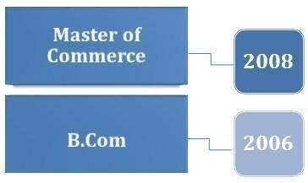2006 B.Com (Accountancy & Finance) from the University of Mumbai
IT SKILLS

- MS Office (Word & MS Excel)
- Windows
- SQL

PERSONAL DETAILS

Date of Birth 6th November 1985

Languages Known English, Hindi, Urdu and Arabic (Basic)

