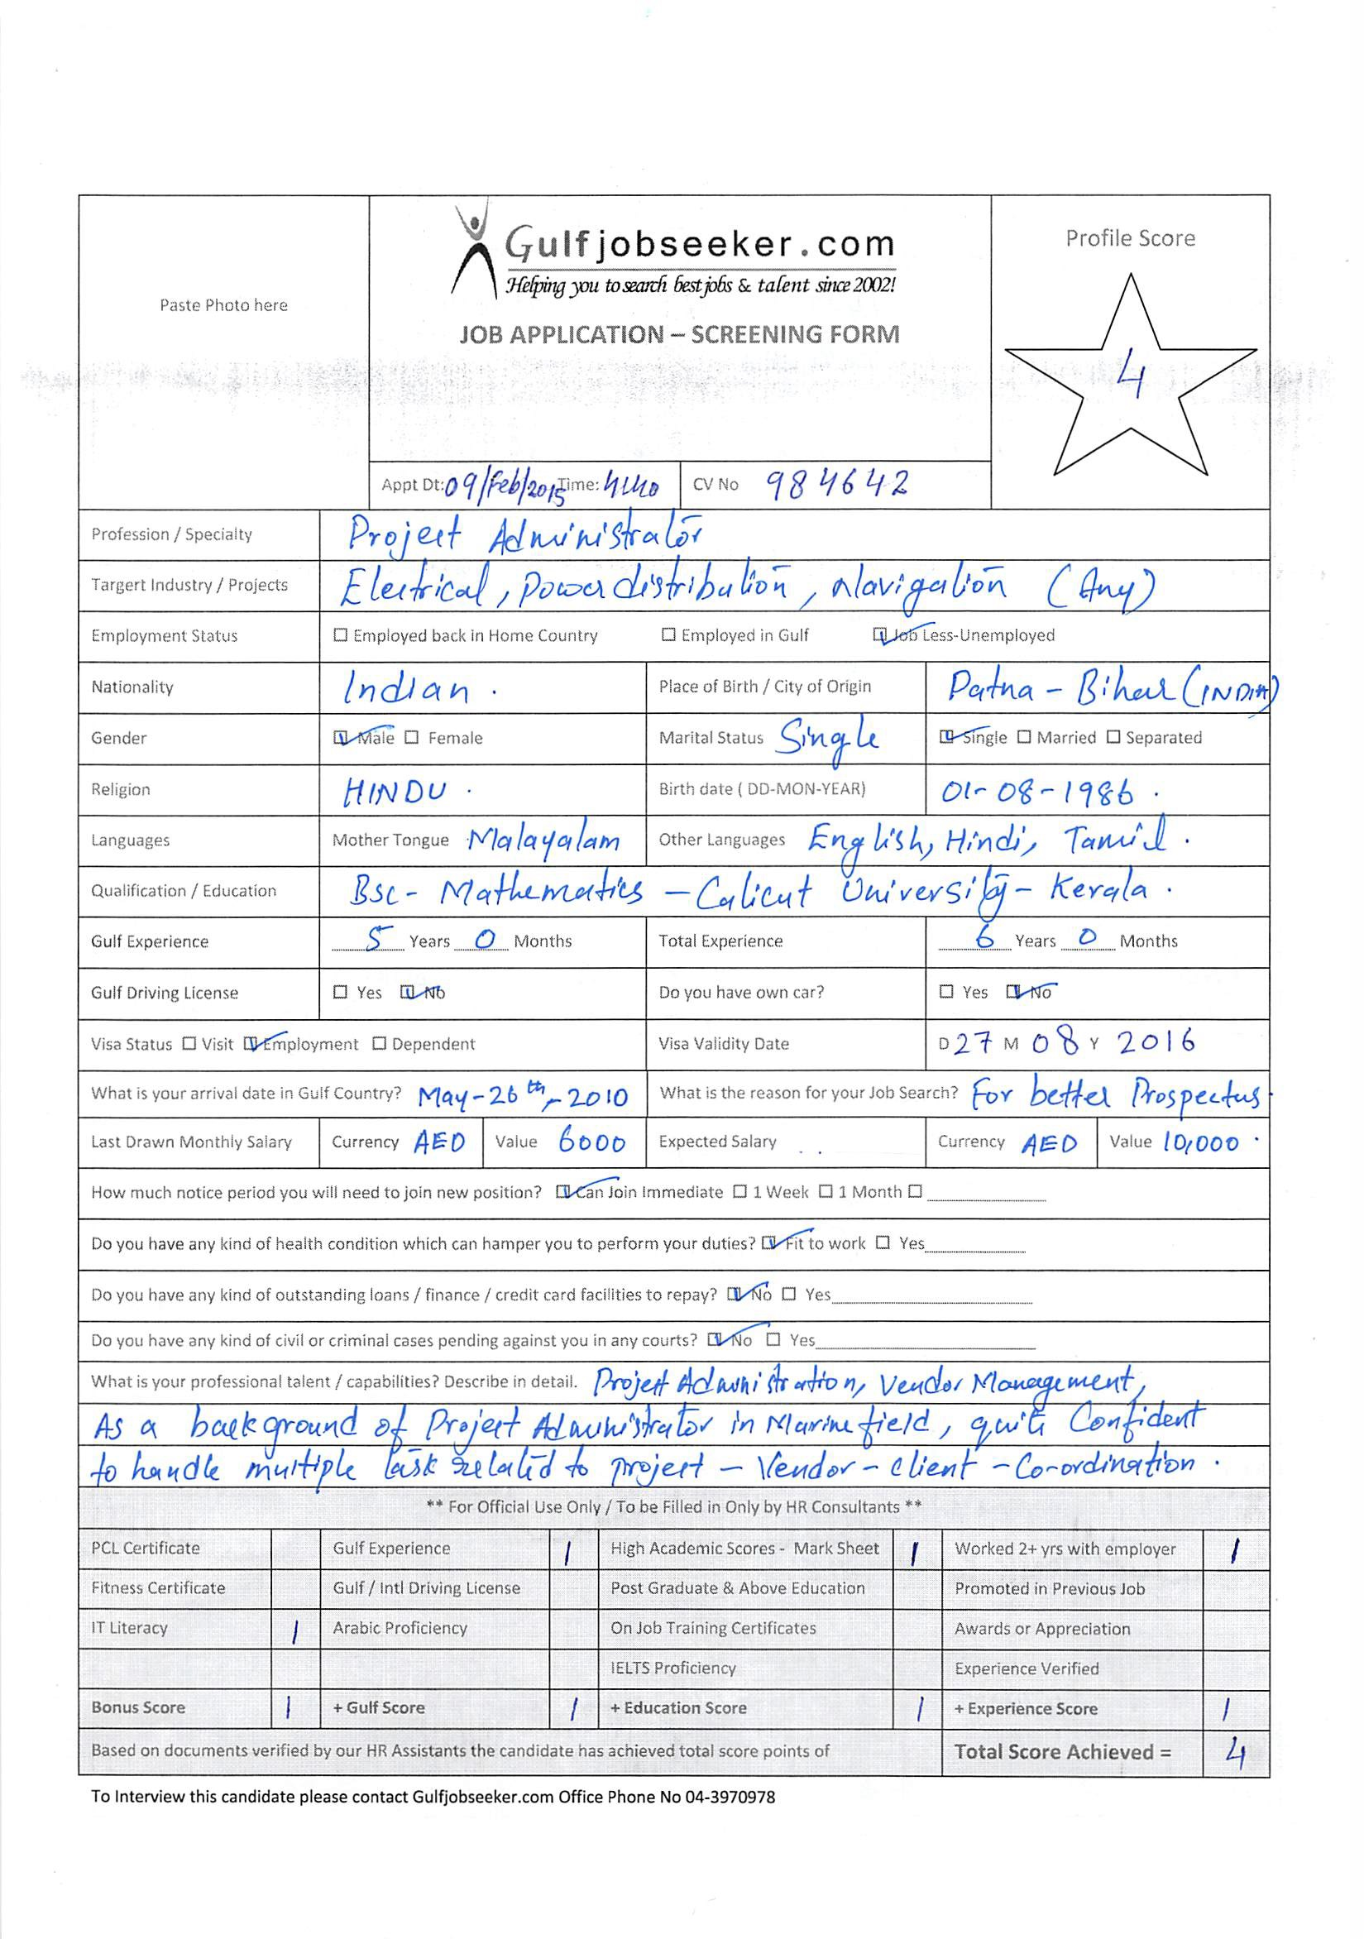
Jaikanth
Jaikanth.164107@2freemail.com

JOB OBJECTIVE

Seeking middle level assignments in Business/Project Administration with an organisation of high repute preferably in Dubai.

PROFILE SUMMARY

- A result oriented professional with 5 years of experience in Reporting & Documentation, Inventory Management and Secretarial Operations along with thorough knowledge of ERP-Orion /Maximizer & Oracle reports.
- Presently associated with Dubai as Project/Business Coordinator-(Marine)
- Skilled in providing sales support to the sales team by preparing proposals on sales and inventory and networking with sales coordination team to collate data about market movement
- Deft in interpreting and communicating market information to facilitate the decision making process by the top management
- Comprehensive understanding & experience of purchasing strategies, inventory management and vendor management
- Experienced in evaluating, establishing & maintaining development policies and procedures
- Expertise in handling ERP procurement based on oracle and preparing purchase order online in Oracle system
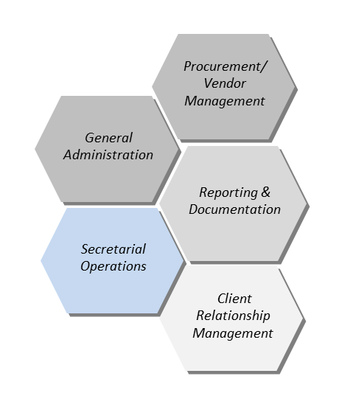
- A keen communicator with excellent relationship management skills
CORE COMPETENCIES

General Administration
- Scheduling and coordinating meetings, interviews, appointments, events and other similar activities for supervisors; managing travel facilities as well as lodging arrangements for the company personnel
- Scrutinizing and ensuring timely payment of all office administration bills such as electricity, annual maintenance contract of equipment; ensuring smooth execution of operations by sorting, reviewing, screening and distributing incoming & outgoing mail

Procurement/ Vendor Management
- Efficiently identifying and developing potential vendors locally for the right sourcing, achieving cost effective purchases of raw materials; implementing systems for enhancing operational efficiency
- Developing and implementing key procurement strategies and purchase schedules and ensuring that these strategies and schedules are aligned with organisational objectives

Reporting & Documentation
- Managing the monthly, weekly & daily report creation through in-depth analysis and producing the actionable information
- Submitting financial reports to the finance manager about the quarterly revenue report generated by the department to facilitate decision making by the senior management

Client Relationship Management
- Developing strong relations, as well as maintaining constant business communication with key opinion leaders
- Addressing all queries put forth by customers in a satisfactory and timely manner
EMPLOYMENT DETAILS

Since Jul’13 Project/Business Coordinator-(Marine Navigation & Communication)

Key Result Areas:
- Liaising with personnel from other departments for assisting the internal staff in planning and executing recognition events, program outreach and promotion, and facilitating cross departmental communication and services and operating units in the resolution of day-to-day administrative and operational problems
- Assisting the Business Head with administrative & sales support in a timely manner and thereby contributing in improving organisational efficiency
- Observing the performance of suppliers and providing feedback based on the same
- Maintaining & updating files, databases, records & other documents, conducting routine analysis and generating recurring internal reports based on the same
- Ensuring timely responses to the routine written inquiries
- Maintaining files of sales invoice, Performa invoice and purchase orders for further review & analysis by the senior management
- Handling inquiries from vendors and purchasers and providing speedy resolutions to the same
- Maintaining all types of financial statements, reports & invoices
- Providing complete administrative support to Business head
- Negotiating with suppliers regarding prices and thus minimising the costs
- Undertaking documentary operations such as data entry operations, updating accounts and compiling reports
- Conducting market research and procuring required items
- Ensuring selection of right vendors for the requested materials by client, & correct and timely procurement of required materials
- Preparing bids and proposals, making recommendations for award and creating purchase orders for local suppliers as well as International suppliers
- Planning and conduct competitive negotiations, maintaining records on purchase price information on both open market and contract purchases
- Maintaining supplier data base and administering vendor performance to evaluate the best suppliers with respect to delivery performance, pricing and quality of materials supplied etc.
- Providing status reports to management on overall purchase of material

Highlights:
- Modified and improved system of dispensation of monthly expense reports which saved time and company resources which could be used to find where the expense is high while procuring, identify the most suitable vendor, check quality of materials, and develop cost effective methods

May’10 – Jun’13 Dubai as Administrative Assistant

Key Result Areas:
- Drafted documents such as invoices, reports, memos, letters and financial statements using various documentary tools like word processor, spread sheets, etc.
- Handled the administrative functions such as providing all support functions to the supervisors, but not limited to strong written and communication skills on all correspondence (proposals, contracts, form letters, emails, internal forms etc.) for sales manager and the sales team
- Coordinated the scheduling of trade shows and meetings of trade organization efficiently
- Took up follow-up meetings with clients to measure the effectiveness of the business plans
- Drafted quarterly business activity statements to facilitate decision making by the senior management
- Organised various company hospitality functions and projects such as welcoming and looking after the basic needs of guests mainly in relation to food, drink and accommodation, lodging, recreation, and travel arrangements

Highlights:
- Received the ‘Best Staff’ Award in handling outstanding accounts of the client, accurately payment follow-ups & reporting the same to the senior management

Jun’09 – Apr’10 Administrative Assistant

Key Result Areas:
- Handled operations regarding word processing collation of official company documents such as annual reports, prospectuses, executive summaries, contracts, etc.
- Examined existing documents and ensured they are thorough, accurate and up-to-date
- Handling client relations by answering phone & direct calls efficiently, responding to email enquiries from the general public and forwarding the requests to the concerned departments
- Managed capital purchases, handled direct vendor relations and maintained equipment tracking records

EDUCATION

B.Sc. (Mathematics) ----- Calicut University, Kerala, India

PERSONAL DETAILS

Date of Birth: 1st August, 1986
Languages Known: English, Hindi, Malayalam and Tamil
Marital Status: Single
Notice Period: Available to join immediately.

