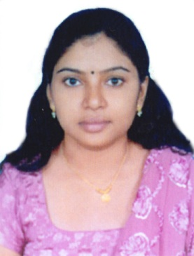
RESUME
Gulfjobseeker.com CV No: 992418
Mobile +971505905010 cvdatabase[@]gulfjobseeker.com

To contact this candidate use this link
http://www.gulfjobseeker.com/feedback/contactjs.php

ELANGUM VILA VEEDU TKD ROAD MUTTADA PO TVM 25 KERALA INDIA
Current Registration:
- Council :The Karnataka nursing Registration Council, Bangalore
- Council The Indian nursing council.

Objective: Registered nurse seeking a full time staff nurse position in any area where my skills and experience can be fully utilized
Professional Profile:
- Experienced in medical and surgical unit.
- Exposed in different areas including medical surgical and nurse educator.
- Trained in individualized multidisciplinary care in accordance with hospital standards
Experience:
Nursing Tutur
Oct 2008-Sep 2009
Staff Nurse
Medical and surgical unit
Jan 2011 – Feb 2013 (Archana Hospital , India)
- Delivered competent and efficient nursing care to up to 10 patients with different medical and surgical conditions in the area
- Provided patient education as to condition ,options, health maintenance and discharge instructions
- Assessed patients status and notify physician of clinical changes
- Coordinate with other members of the health team to provide a holistic, organized care
- Performed clinical tasks (wound dressing, vital signs monitoring, suctioning, hygienic procedures, medicine administration includes chemotherapy ,finger stick glucose monitoring , ABG monitoring , IV cannulation , blood transfusion , blood collections , inserting Foleys catheters , inserting nasogastric tube and nasogastric feeding , tracheostomy care)
- Assisted physicians for diagnostic procedures and aseptic procedures like lumbar puncture , bone marrow aspiration and sterile dressings
- Maintained records and reports
- Participated in staff in –service competency – based trainings and seminars
Academic Qualification
Qualification | Institute | University/Board | Year | Remarks
Secondary School Leaving Certificate | St marry’s higher secondary school Pattom tvm | KeralaState Board | 2002 | 86%
Plus Two | G H H S  Pattom TVM | Board Of Higher Secondary Examination | 2004 | 70%

Professional Qualification
Qualification | Institute | University/Board | Year | Remarks
BSc Nursing | Diana College Of Nursing.Bangalore | Rajivgandhi University Of Health Science. Bangalore | 2008 | 65%

