omonye.169827@2freemail.com

CURRICULUM VITAE
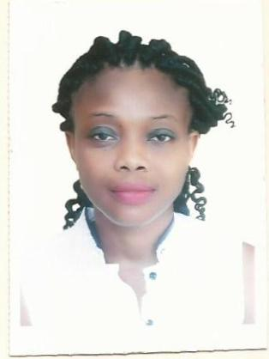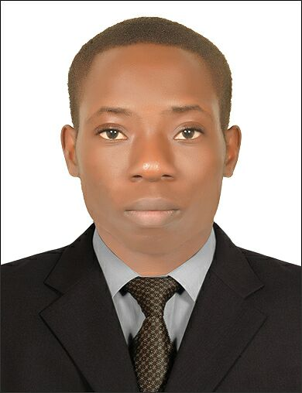
Name: OMONYE
Sex: Female
Nationality: Nigeria
Resident: Dubai, UAE
Civil status: Single
Visa Status: Visit Visa
Position: Insurance coordinator

SUMMMARY

Organised insurance coordinator with the aim to serve the organisation better with honesty, integrity and confidence; To make use of the opportunities and facilities for the development of organizational and individual goals while learning and harnessing my personal potentials in the process.

JOB EXPERIENCE

MERIDIAN HOSPITAL LTD - G.R.A Port Harcourt, Nigeria. 06/2011- 07/2017

- I attend to all insurance customers in the clinic.
- I coordinate, liaised and network between insurance companies.
- I maintain files and records of all insurance cases.
- I processed insurance and disability claims in a timely manner.
- Handled patients queries regarding unpaid balances.
- Circulated documentation as needed for reviewing.
- Prepared insurance forms and associated correspondence
- Submission of insurance claims on a monthly basis.
- Resubmission of rejected claims.
- Determined the reasons for denied claims.
- Provide customers related claims and billings
- Followed up with insurance companies to propriety and medical necessity of services by the facility.
- Review all claims for accuracy.
- Works closely with patient relations, managers, customers, care representatives, nursing staff, insurance managers and providers to ensure claims accuracy and processing.
- Taking verbal and written approvals from insurance companies.
- Taking tariff and agreements for procedures from the insurance company.
- Maintained strict confidentiality related to medical records and other data.

KNOWLEDGE, SKILLS AND ABILITIES
- Comprehensive problem solving abilities.
- Good verbal and written communication.
- Ability to deal with people.
- Organizing and coordinating skills.
- High level of listening skills.
- Work independently and demonstrate good judgement.
- Willingness to work in a team.
- Time management.
- Computer literate

EDUCATIONAL BACKGROUND

- B.Sc. in Human Physiology, Ambrose Alli University, Ekpoma Edo State, Nigeria.
- WAEC Certificate in Emado Secondary School, Ekpoma Edo State, Nigeria.

LANGUAGES
- English

HOBBIES
- Travelling, Reading, Music, Surfing computer, Motivating People.

