RESUME

ROBIN 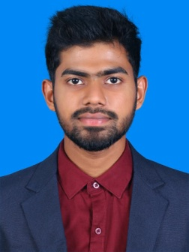
Robin.173696@2freemail.com

CAREER OBJECTIVE
To secure a challenging position where I can effectively contribute my skills and innovative ideas to gain knowledge in the work oriented environment.

EXPERIENCE

- Visual merchandiser: Splash fashions Bangalore (under of Landmark group) from August 2015 to December 2016.
- Internship :
Internship at Venkateswara Enterprises, Bangalore - titled “Consumer perception towards brand ADIDAS in Bangalore” in specialization on Sportswear.

EDUCATIONAL PROFILE
COURSE | INSTITUTION | BOARD/  UNIVERSITY | YEAR OF PASSING | PERCENTAGE
MBA (Fashion Designing and Business Management) | VIFT | Karnataka University | 2013 - 2015 | 68%
B.Sc. COSTUME DESIGN AND FASHION | Nehru Arts And Science College | Bharathiyar  University | 2010-2013 | 65%
Higher secondary  education | MMHSS, Upoodu, Kallada | Kerala State | 2009-2010 | 61%
SSLC |  | Kerala State | 2008 | 61%
 | M. G. D. BHS, Kundara

OTHER QUALIFICATIONS

- Undergone a workshop on fashion illustration
- Undergone an ADD ON course in fashion art and craft
- Undergone an ADD ON course in pattern making
- Completed ADD ON program on ORBITO CAD software organized by Nehru Arts and Science College and Mehela Machines India Limited from June 2012 to February 2013.

SOFTWARE SKILLS
- Programming language : CAD
- Operating System : Windows
- Package : Microsoft Office
PERSONAL SKILLS
- Good communication skill.
- Good in sketching.
- Good in dancing.
- Good leadership quality.
- Time management quality.

ACHIEVEMENTS

- Participated in Inter College Fashion shows
- Participated in painting competitions
- Participated in Pencil sketch.
- District level dancer.

EXTRA CURRICULAR ACTIVITIES

- Good in cricket
- Good in table tennis.

LANGUAGES KNOWN

English, Hindi, Tamil, Malayalam

PERSONAL DETAILS

Name : Robin

Age : 26
Gender : Male
Religion : Christian
Nationality : Indian
Blood Group : B +ve
Mother’s name : Mariyamma Thomas
Father’s name : M. L Thomas
Marital status : Single

DECLARATION

I hereby declare that the information furnished above is true to my knowledge and belief.

PLACE: Robin DATE:

