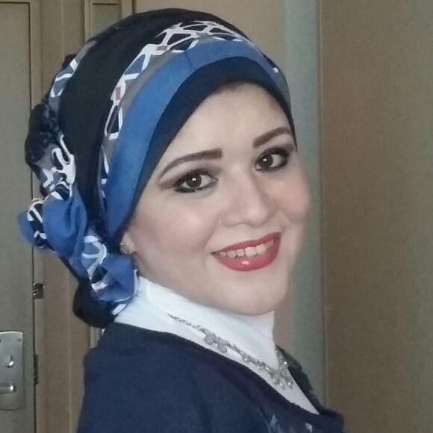

Dr. Asmaa
E-mail: asmaa.178784@2freemail.com
UAE Driving License, Own a car

Overview

A highly motivated individual, Creative and dynamic personality, Self motivated and inspiring character, with excellent track record.
strong communicator, strategic thinking, initiative, willingness to challenge with total of 12 years combined experience working with Multinational Pharmaceutical Companies in KSA , Egypt & a leading Trading Company in UAE with diverse experience in Pharmaceuticals sales & office works.

Objective

To make a positive contribution in your dynamic and well reputed organization in a position where my abilities, decision making, marketing & communication skills will be appreciated and enhanced with sincerity, dedication and smart work. ,also to further develop my skills and abilities necessary in achieving Company’s ultimate goal.

Employment History
Principal Mena MPC ,
JLT. , Dubai , UAE
Key Account Manager
Jan 2016 – Current
Launch and Branding Unique Liquid Protein Supplement all over Governmental and Private Hospitals
Build effective strategies for assigned brands / geographies. Responsible for delivery on revenue & marketing budgets
Providing the Field Force periodically with the promotional collaterals, product presentations and necessary training on products
assess the response of the field force to promotional meetings and materials.
Analyse, evaluate and report the market conditions for existing and potential markets and make recommendations to the senior management.

Ultramed .UAE
pharmaceutical Company for Homeopathic products
international City, Dubai, UAE
Product Line Manager
November 2012 – Jan 2016
- Achieve or exceed affiliate business unit annual revenue, profitability, market share and other targets
- Work with regional and global partners and stakeholders to set the business unit marketing and sales vision and strategy
- Develop and drive aligned business unit brand lifecycle strategies, plans, tactics, financial and resource planning for all Pharma products across the assigned business unit
- Oversee and ensure timely, high quality and within budget execution of affiliate business unit strategies, plans and tactics
- Inspire team, recruit, develop and retain talent; ensuring a strong succession plan for key positions
People Management/Leadership:
- Hire, develop and oversee the work of direct and indirect reports
- Create an environment of strong team spirit, timely and effective communications, sense of urgency, high motivation and inspire teams to achieve goals in the immediate- and longer-term
- Act as part of the affiliate Leadership Team and play a key role in cross-functional planning and decision-making
- Develop/lead organizational design, resource requirements, compensation, expense budgets, immediate-, medium- and long-term capacity for the assigned affiliate Business Unit
- Provide vision and strategic direction to the team
Business Unit Strategy/Planning:
- Develop targeted and robust affiliate brand lifecycle strategies, business plans, tactical plans and budgets in accordance with annual Brand Plan and Business Plan Processes. Includes pricing, brand marketing, national sales, communication and other commercial strategies, plans and tactics
- Ensure affiliate brand and business plan alignment with global and regional business unit strategies and objectives
- Establish and set quarterly and annual metrics for all products across the affiliate business unit to measure and report on Brand Plan/Business Plan progress, effectiveness and ROI
- Ensure, where appropriate, cross-brand alignment of relevant strategies, plans, tactics and budgets for a cohesive and robust business unit strategy and overall plan
Business Unit Management: Work with the team and others to:
- Determine business unit priorities and timing
- Conduct regular reviews of individual brand and business unit performance against strategies, plans and budgets
- Identify growth opportunities, threats or other risks to the business and develop and implement solutions to address these
- Drive ongoing innovation and growth for assigned business unit and the overall affiliate
- Oversee implementation and ongoing management of affiliate marketing, sales and related initiatives for all business unit products to ensure appropriate alignment to regional and global business strategies and seamless local market execution
- Monitor affiliate sales and trend analyses to ensure brand strategies, plans and tactics will achieve or exceed revenue, profit, market share and other targets and goals
- Review and approve affiliate commercial and supplier tenders/contracts for assigned business unit
- Review and approve affiliate forecasting, month-end, quarterly and annual reporting of sales, supply, profitability and spend and ensure affiliate revenue and expense are in line with agreed variances
Communication/Other:
- Identify, lead, or assign special projects that further the success and effectiveness of the business unit or the overall affiliate
- Act as a primary advisor to affiliate leadership, regional and global partners/stakeholders regarding assigned business unit and related matters
- Conduct periodic field visits to work with sales and other field teams to remain abreast of customer interactions, issues and opportunities
- Lead affiliate national conferences, marketing and sales strategy meetings
Tabuk , Egypt
Professional Senior Medical Representative
March 2010 - Oct 2012

- Promoting Antibiotic Line ( Triaxone ,Foxime 3rd Generation Cephalosporines ) & Analgesic (Rapidus)
- Best Achiever over Nasr City Territory in 2011
- Responsible for bringing business to the company by effectively promoting products to Healthcare Professionals to prescribe the product to their patients.
- Plan, organize and execute product presentations to physicians regarding the therapeutic use of the product, mode of action, features and benefits.
- Plan each call through the proper identification of appropriate product or products to promote, which sales tools to use and the right schedule to execute the call.
- Meet with pharmacies to create awareness and educate clients on products and sell to target accounts.
- Observe, record and report competitor activities executed in the territory and identify appropriate counter strategy.
- Constantly endeavor to improve product knowledge and selling skills at company standards in order to deliver appropriate information to physicians effectively and professionally.
- Attain assigned sales, prescription and market share goal
- Effectively manage expenses and maintain desired sales to expense ratio.
Boheringer Ingelhime
Riyadh, KSA.
Professional Medical Representative
November 2005 – November 2009

- Promote Mobic (Analgesic) ,Micardis
- Visit Health Care Professionals & Pharmacist to present and make negotiations about the product.
- Provide samples & information to clients.
- Promote pharmaceutical products during trade shows & conventions.
- Inform clients about the product’s price, dosage, benefits, side effects, and other important information.
- Organize activities with clients to effectively promote and create awareness of clients with regards the product.
- Make a routine visit to different hospitals, clinics and community centers to present the products.
- Managing budgets (for catering, outside speakers, conferences, hospitality.
- Regularly attending company meetings, technical data presentations and briefings.
- Develop strategies to increase opportunities to meet and talk to contacts in the medical and healthcare sector.
- Analyze sales statistics and prepare monthly sales reports.
- Make presentations to Healthcare professionals.
- Insure to meet monthly & annual quota.

Modern Int. Exhibition Co
Egypt.
Regulatory affair specialist .
July 2000 to Nov 2004

- Register Veterinary Products with Ministry of Agriculture and Veterinary Medicine authority
- Collecting all Data from USP And British Pharmacopeia
- Best achiever in Registering 8 Vet. Products in 2003

TRAINING AND SEMINARS

- Training launch of the new line pediatrician products MamaNatura in Francoforte Germany 2014 With DHU Germany
- Advance Selling Skills- 2006 Boheringer Ingelhime
- Product Presentation Skills Training - 2005
- Core Selling Skills- 2006 Boheringer Ingelhime
- Performance Management Training- 2011 Tabuk- Egypt.
- Communication &Negotiation Skills Course in Tabuk-Egypt pharmaceutical Company.

Educational Background

Tertiary Cairo Uinversity.
Cairo, Egypt .
B.S. Veterinary Medicine. Grade : Good

Skills

- Excellent interpersonal skills dealing efficiently and professionally with colleagues of different ranks and race.
- Ability to work as part of a team and on own initiative.
- Has the ability to absorb and convey highly technical information.
- Recognized for outstanding achievement and leadership roles in the given market place.
- Expert in communication skills, excellent presentation ability.
- High enthusiasm and ability to work under pressure.
- Keen on work to be done with analytical oriented ethics.
- Able to work in minimum supervision and under pressure.
- Good time management skills and ability to prioritize tasks
- Self-driven and committed on professional growth, productive and fast learner.
- Licensed driver in UAE

Computer Skills/Experience

- Software Applications
(Microsoft Office: MS-Word, Excel, Power Point & photoshop)

Hobbies: Drawing, Chess playing.

